Name: __________________________________________ Date: _______________________ Class: _______
Explain: Chemical Reactions Practice

Guided Practice: Identify the following chemical reactions as synthesis, decomposition, single replacement, double replacement, or combustion.

- Pb + O₂ PbO₂

- KBr + HCl HBr + KCl

- 2 C₁₀H₂₂ + 31 O₂ 20 CO₂ + 22 H₂O

- Mg + 2 H₂O Mg(OH)₂ + H₂

- 2 H₂O 2 H₂ + O₂

Independent Practice: Identify the following chemical reactions as synthesis, decomposition, single replacement, double replacement, or combusti.

- Na₃PO₄ + 3 KOH 3 NaOH + K₃PO₄
Reaction Type _______________________

- MgCl₂ + Li₂CO₃ MgCO₃ + 2 LiCl
Reaction Type _______________________

- C₆H₁₂ + 9 O₂ 6 CO₂ + 6 H₂O
Reaction Type _______________________

- Pb + FeSO₄ PbSO₄ + Fe
Reaction Type _______________________

- CaCO₃ CaO + CO₂
Reaction Type _______________________

- P₄ + 3 O₂ 2 P₂O₃
Reaction Type _______________________

- 2 RbNO₃ + BeF₂ Be(NO₃)₂ + 2 RbF
Reaction Type _______________________

- 2 AgNO₃ + Cu Cu(NO₃)₂ + 2 Ag
Reaction Type _______________________

- C₃H₆O + 4 O₂ 3 CO₂ + 3 H₂O
Reaction Type _______________________

- 2 C₅H₅ + Fe Fe(C₅H₅)₂
Reaction Type _______________________

- SeCl₆ + O₂ SeO₂ + 3Cl₂
Reaction Type _______________________

- 2 MgI₂ + Mn(SO₃)₂ 2 MgSO₃ + MnI₄
Reaction Type _______________________

- O₃ O. + O₂
Reaction Type _______________________

- 2 NO₂ 2 O₂ + N₂
Reaction Type ___________________

Cartoon | What type of reaction is the cartoon like? | Why? What is the Connection?
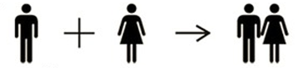
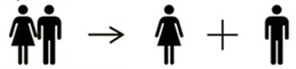
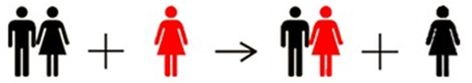
 | combustion
Chemical Reactions: They’re Like Dating

