Document A:
Excerpt from the Stasi Files of 1973 for the conduct of the Berlin Border Guards

It is your duty to use your combat … skills in such a way as to overcome the cunning of breach. Don’t hesitate to use your weapon even when border breaches happen with women and children, which traitors have often exploited in the past.

Source: Crossland, David. (2007) “Letter from Berlin: New Find Evokes Horrors of the Berlin Wall”. Retrieved from: http://www.spiegel.de/international/germany/letter-from-berlin-new-find-evokes-horrors-of-the-berlin-wall-a-499626.html

Photo Below: Berlin Wall 1973- Checkpoint Charlie, the Allied forces gate to West Berlin. A few feet away are the East Berlin tower guards.

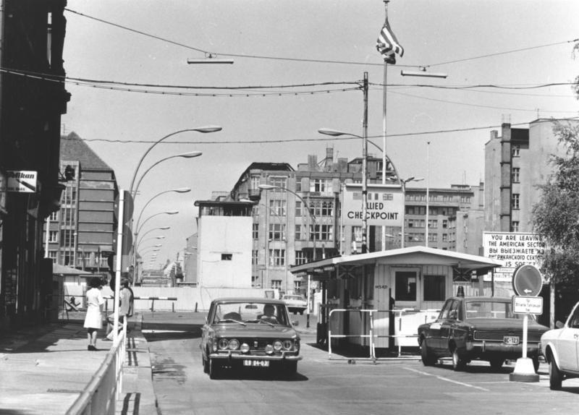

Source: Elfman: History of How Stuff Happened in the Twentieth Century (2016). Retrieved from: http://elfman.co.uk/the-berlin-wall-seriously-important-concrete/
Citation: Safire, W. (2004). Lend Me Your Ears: Great Speeches in American History. New York City: W. W. Norton & Company.

Document B: Kennedy Speech

President John F. Kennedy

West Berlin, West Germany

June 26, 1963
I am proud to come to this city as the guest of your distinguished Mayor, who has symbolized throughout the world the fighting spirit of West Berlin.
And I am proud to visit the Federal Republic with your distinguished chancellor who for so many years has committed Germany to democracy and freedom and progress, and to come here in the company of my fellow American, General Clay, who has been in this city during its great moments of crisis and will come again if ever needed.
Two thousand years ago the proudest boast was Civis Romanus sum. Today, in the world of freedom, the proudest boast is Ich bin ein Berliner.
I appreciate my interpreter translating my German!
There are many people in the world who really don't understand, or say they don't, what is the great issue between the free world and the Communist world. Let them come to Berlin.
There are some who say that Communism is the wave of the future. Let them come to Berlin.
And there are some who say in Europe and elsewhere we can work with the Communists. Let them come to Berlin.
And there are even a few who say that it is true that Communism is an evil system, but it permits us to make economic progress. Lass' sie nach Berlin kommen. Let them come to Berlin.
Freedom has many difficulties and democracy is not perfect, but we have never had to put a wall up to keep our people in, to prevent them from leaving us.
I want to say, on behalf of my countrymen, who live many miles away on the other side of the Atlantic, who are far distant from you, that they take the greatest pride that they have been able to share with you, even from a distance, the story of the last 18 years.
I know of no town, no city, that has been besieged for 18 years that still lives with the vitality and the force, and the hope and the determination of the city of West Berlin.
While the wall is the most obvious and vivid demonstration of the failures of the Communist system, for all the world to see, we take no satisfaction in it, for it is, as your mayor has said, an offence not only against history but an offense against humanity, separating families, dividing husbands and wives and brothers and sisters, and dividing a people who wish to be joined together.
What is true of this city is true of Germany - real, lasting peace in Europe can never be assured as long as one German out of four is denied the elementary right of free men, and that is to make a free choice.
In 18 years of peace and good faith, this generation of Germans has earned the right to be free, including the right to unite their families and their nation in lasting peace, with good will to all people.
You live in a defended island of freedom, but your life is part of the main.
So let me ask you as I close, to lift your eyes beyond the dangers of today, to the hopes of tomorrow, beyond the freedom merely of this city of Berlin, or your country of Germany, to the advance of freedom everywhere, beyond the wall to the day of peace with justice, beyond yourselves and ourselves to all mankind.
Freedom is indivisible, and when one man is enslaved, all are not free.
When all are free, then we can look forward to that day when this city will be joined as one and this country and this great continent of Europe in a peaceful and hopeful globe.
When that day finally comes, as it will, the people of West Berlin can take sober satisfaction in the fact that they were in the front lines for almost two decades.
All free men, wherever they may live, are citizens of Berlin, and, therefore, as a free man, I take pride in the words Ich bin ein Berliner.

Document C: Europe After World War II

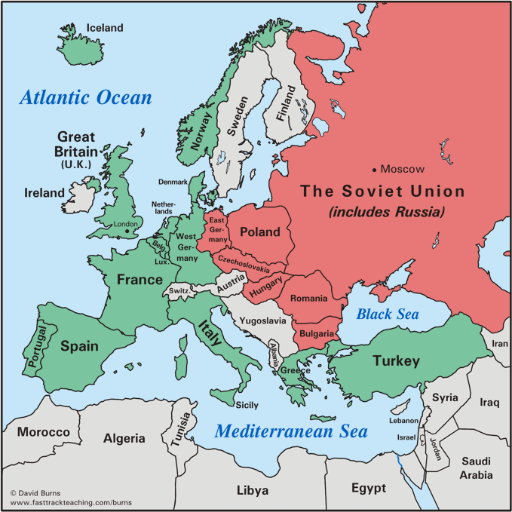

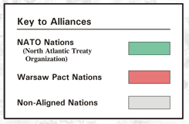

Source: Burns, David. (2012). Europe after World War II: Frameworks of America’s Past.
Retrieved from: http://www.fasttrackteaching.com/burns/Unit_11_Cold_War/U11_Europe_After_WW_II.html

Document D:
Excerpt from a speech by John F. Kennedy campaigning for the U.S. Senate (1952)
“But In our efforts to contain the tide of Communist expansion, it would be a mistake to judge the Communist threat as primarily military, although it is Russian military prestige that has force & gives persuasion to the beliefs of its political & economic doctrines.
Certainly we must stand and devote all our available energies to the task of rebuilding our military strength and we should use every means at our disposal to persuade our friends in the West to do likewise.”

Source: The Gilder Lehrman Institute of American History. (2016) “JFK on the containment of Communism” retrieved from: https://www.gilderlehrman.org/history-by-era/fifties/resources/jfk-containment-communism-1952

Document E: Nikita Khrushchev hugging Fidel Castro, leader of Cuba at United Nations 1960
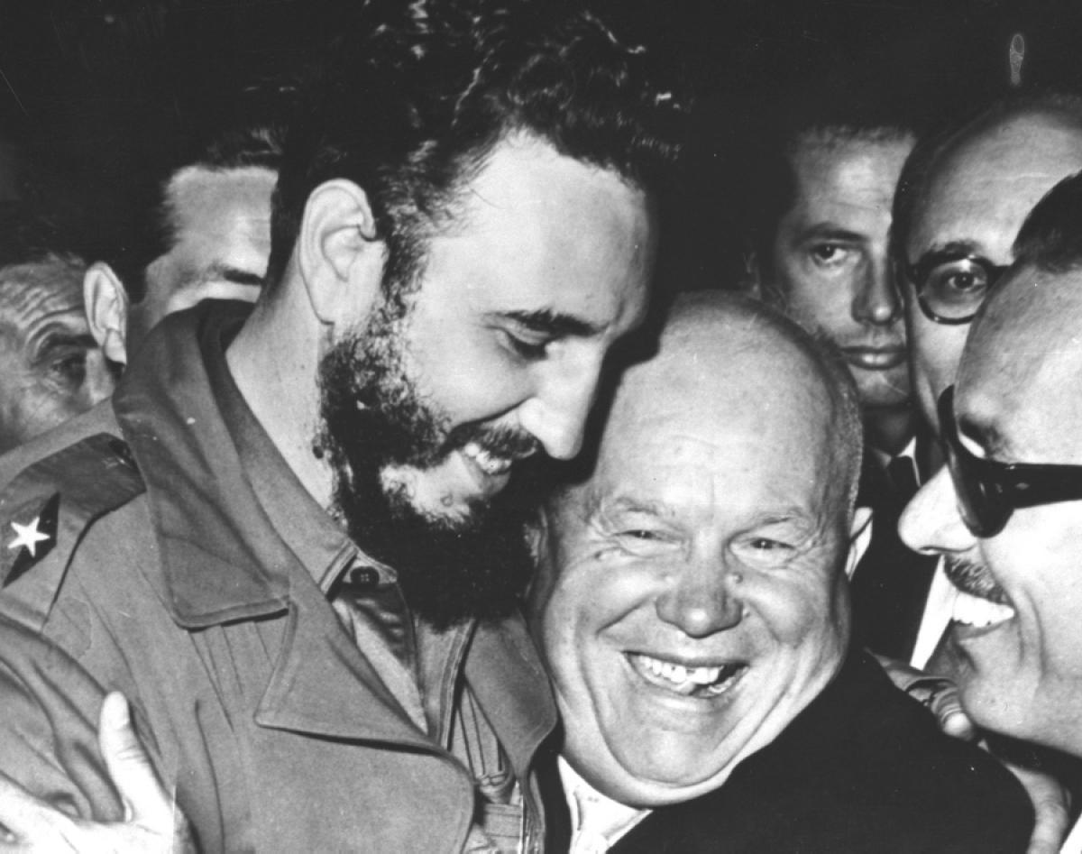
Castro allowed Khrushchev to place Russian defense missiles in Cuba in 1961. The missiles prompted the Cuban Missile Crisis, a US response to Soviet missiles being close to US southern borders.
Source: ABC News. (2016) “Timeline of US and Cuba Relations” retrieved from: http://abc7ny.com/politics/timeline-of-us-and-cuba-relations/440448/

Document F: Pilot Francis Gary Powers trial

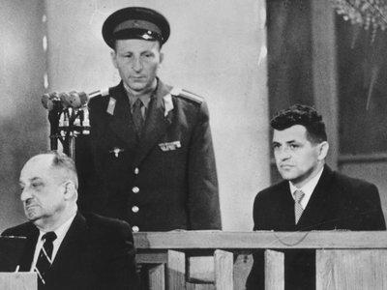

Pilot Francis Gary Powers on trial for espionage in Moscow. Pilot Powers’ release to the US occurred two years later (1962) in exchange for a Russian spy, Rudolf Abel, who was discovered spying in New York. Fredrick Pryor, an American student who was held in East Berlin, was also released to the U.S.
Source: Greenblatt, Alan. (2012). “Spy Exchange would be a Cold War Flashback” National Public Radio website. Retrieved from: http://www.npr.org/templates/story/story.php?storyId=128381620

Document G: A political cartoon about the Domino Theory

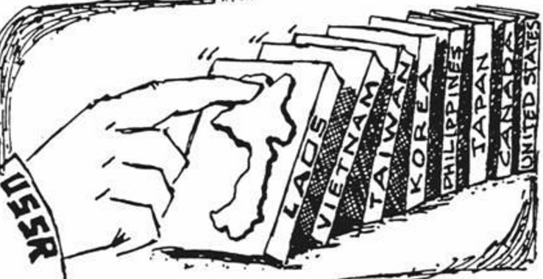

US troops entered the Vietnam War to contain the threat and spread of communism in Southeast Asia. As the war dragged on, more Americans at home became disillusioned with the war efforts. South Vietnam eventually fell to communists’ troops, the Viet Cong in the summer of 1975.

Source: Sibilla, Chris. (2016). “Vietnam: A Look Back” Association for Diplomatic Studies and Training website. Retrieved from: http://adst.org/2014/11/vietnam-a-look-back/

Document H: The Polish Solidarity Movement and Lech Walesa, 1981
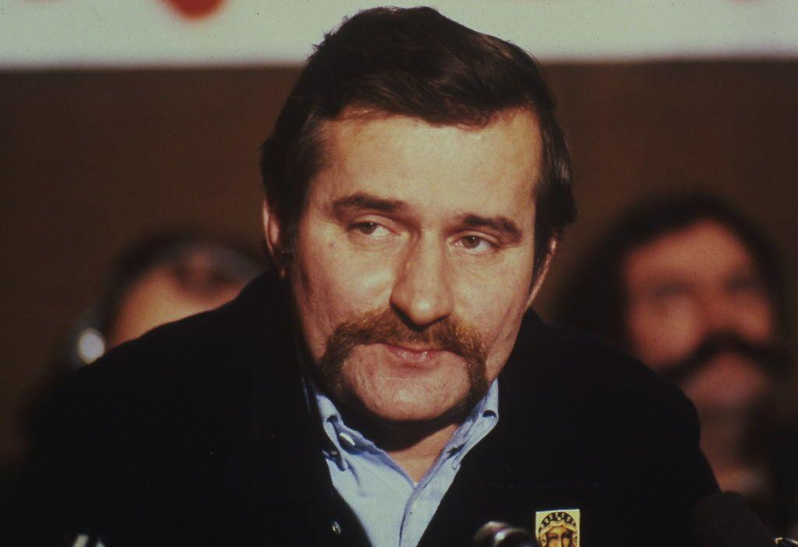
By the late 1970s the Polish economy is on the brink of collapse. In July 1980, when the government more than doubles meat prices, a series of nationwide strikes ensues. Workers realize that they can escape reprisals by holding the shipyards and factories hostage.

Striking employees at the Lenin Shipyard in Gdansk remain true in their demands. The authorities try to seal off Gdansk to drive the workers out. Shipyard workers fan out across the city and sympathetic students and professionals slip through roadblocks, bringing news of the strike to other regions. The workers elect Lech Walesa, a shipyard electrician, as their leader. By late August 400,000 workers are united in striking.

Ignoring rumblings from the Soviets and squeezed by growing economic pressures, the controlling power agrees to free unions, wage increases, and limits on censorship.

Calling itself "Solidarity," the movement decides to expand its reach. At its first national congress in the fall of 1981, an Action Program promotes "self-management" in all areas of society including the establishment of democratic local governments, independent judges, and equal protection under the law.

After several years of underground resistance by Solidarity, the Communists are forced to invite Solidarity to help them reconstruct the Polish nation on the basis of a different, multi-party democratic model.
Source: Ackerman, Peter & Duvall, Jack. (2000). “A Force More Powerful”. Retrieved from: http://www.aforcemorepowerful.org/films/afmp/stories/poland.php
Document I- Explanation by Mikhail Gorbachev, General Secretary of the USSR regarding perestroika (restructuring) and glasnost (openness) excerpt:
Perestroika is an urgent necessity arising from the profound processes of development in our socialist society. This society is ripe for change. It has long been yearning for it.
In the latter half of the seventies--something happened that was at first sight inexplicable. The country began to lose momentum. Economic failures became more frequent. Difficulties began to accumulate and deteriorate, and unresolved problems to multiply. Elements of what we call stagnation and other phenomena alien to socialism began to appear in the life of society. A kind of "braking mechanism" affecting social and economic development formed. And all this happened at a time when scientific and technological revolution opened up new prospects for economic and social progress....
An absurd situation was developing. The Soviet Union, the world's biggest producer of steel, raw materials, fuel and energy, has shortfalls in them due to wasteful or inefficient use. One of the biggest producers of grain for food, it nevertheless has to buy millions of tons of grain a year for fodder. We have the largest number of doctors and hospital beds per thousand of the population and, at the same time, there are glaring shortcomings in our health services. Our rockets can find Halley's Comet and fly to Venus with amazing accuracy, but side by side with these scientific and technological triumphs is an obvious lack of efficiency in using scientific achievements for economic needs, and many Soviet household appliances are of poor quality.
This, unfortunately, is not all. A gradual erosion of the ideological and moral values of our people began…. An unbiased and honest approach led us to the only logical conclusion that the country was verging on crisis....
It was not something out of the blue, but a balanced judgment….. There are people in the West who would like to tell us that socialism is in a deep crisis and has brought our society to a dead end. We have only one way out, they say: to adopt capitalist methods of economic management and social patterns, to drift toward capitalism.
We will proceed toward better socialism rather than away from it. We are saying this honestly, without trying to fool our own people or the world. Any hopes that we will begin to build a different, nonsocialist society and go over to the other camp are unrealistic and futile. We want more socialism and, therefore, more democracy....
Source: Gorbachev, Mikhail (1987). Excerpts from: Perestroika: New Thinking for Our Country and the World: New York Harper and Row. Retrieved from: https://college.cengage.com/history/west/resources/students/primary/perestroika.htm

Citation: The Air University. (2011). Ronald Reagan Speech, Tear down This Wall. Retrieved from http://www.au.af.mil/au/awc/awcgate/speeches/reagan_berlin.htm

Document J: Reagan Speech (excerpt)
President Ronald Reagan
West Berlin, West Germany (Brandenburg Gate)
June 12, 1987
Thank you very much.
Chancellor Kohl, Governing Mayor Diepgen, ladies and gentlemen: Twenty-four years ago, President John F. Kennedy visited Berlin, speaking to the people of this city and the world at the City Hall. Well, since then two other presidents have come, each in his turn, to Berlin. And today I, myself, make my second visit to your city.
We come to Berlin, we American presidents, because it's our duty to speak, in this place, of freedom. But I must confess, we're drawn here by other things as well: by the feeling of history in this city, more than 500 years older than our own nation; by the beauty of the Grunewald and the Tiergarten; most of all, by your courage and determination. Perhaps the composer Paul Lincke understood something about American presidents. You see, like so many presidents before me, I come here today because wherever I go, whatever I do: Ich hab noch einen Koffer in Berlin. [I still have a suitcase in Berlin.]
Our gathering today is being broadcast throughout Western Europe and North America. I understand that it is being seen and heard as well in the East. To those listening throughout Eastern Europe, a special word: Although I cannot be with you, I address my remarks to you just as surely as to those standing here before me. For I join you, as I join your fellow countrymen in the West, in this firm, this unalterable belief: Es gibt nur ein Berlin. [There is only one Berlin.]
Behind me stands a wall that encircles the free sectors of this city, part of a vast system of barriers that divides the entire continent of Europe. From the Baltic, south, those barriers cut across Germany in a gash of barbed wire, concrete, dog runs, and guard towers. Farther south, there may be no visible, no obvious wall. But there remain armed guards and checkpoints all the same--still a restriction on the right to travel, still an instrument to impose upon ordinary men and women the will of a totalitarian state. Yet it is here in Berlin where the wall emerges most clearly; here, cutting across your city, where the news photo and the television screen have imprinted this brutal division of a continent upon the mind of the world. Standing before the Brandenburg Gate, every man is a German, separated from his fellow men. Every man is a Berliner, forced to look upon a scar.
President von Weizsacker has said, "The German question is open as long as the Brandenburg Gate is closed." Today I say: As long as the gate is closed, as long as this scar of a wall is permitted to stand, it is not the German question alone that remains open, but the question of freedom for all mankind. Yet I do not come here to lament. For I find in Berlin a message of hope, even in the shadow of this wall, a message of triumph.
In this season of spring in 1945, the people of Berlin emerged from their air-raid shelters to find devastation. Thousands of miles away, the people of the United States reached out to help. And in 1947 Secretary of State--as you've been told--George Marshall announced the creation of what would become known as the Marshall Plan. Speaking precisely 40 years ago this month, he said: "Our policy is directed not against any country or doctrine, but against hunger, poverty, desperation, and chaos."
In the Reichstag a few moments ago, I saw a display commemorating this 40th anniversary of the Marshall Plan. I was struck by the sign on a burnt-out, gutted structure that was being rebuilt. I understand that Berliners of my own generation can remember seeing signs like it dotted throughout the western sectors of the city. The sign read simply: "The Marshall Plan is helping here to strengthen the free world." A strong, free world in the West, that dream became real. Japan rose from ruin to become an economic giant. Italy, France, Belgium--virtually every nation in Western Europe saw political and economic rebirth; the European Community was founded.
In West Germany and here in Berlin, there took place an economic miracle, the Wirtschaftswunder. Adenauer, Erhard, Reuter, and other leaders understood the practical importance of liberty--that just as truth can flourish only when the journalist is given freedom of speech, so prosperity can come about only when the farmer and businessman enjoy economic freedom. The German leaders reduced tariffs, expanded free trade, lowered taxes. From 1950 to 1960 alone, the standard of living in West Germany and Berlin doubled.
Where four decades ago there was rubble, today in West Berlin there is the greatest industrial output of any city in Germany--busy office blocks, fine homes and apartments, proud avenues, and the spreading lawns of parkland. Where a city's culture seemed to have been destroyed, today there are two great universities, orchestras and an opera, countless theaters, and museums. Where there was want, today there's abundance--food, clothing, automobiles--the wonderful goods of the Ku'damm. From devastation, from utter ruin, you Berliners have, in freedom, rebuilt a city that once again ranks as one of the greatest on earth. The Soviets may have had other plans. But my friends, there were a few things the Soviets didn't count on--Berliner Herz, Berliner Humor, ja, und Berliner Schnauze. [Berliner heart, Berliner humor, yes, and a Berliner Schnauze.]
In the 1950s, Khrushchev predicted: "We will bury you." But in the West today, we see a free world that has achieved a level of prosperity and well-being unprecedented in all human history. In the Communist world, we see failure, technological backwardness, declining standards of health, even want of the most basic kind--too little food. Even today, the Soviet Union still cannot feed itself. After these four decades, then, there stands before the entire world one great and inescapable conclusion: Freedom leads to prosperity. Freedom replaces the ancient hatreds among the nations with comity and peace. Freedom is the victor.
And now the Soviets themselves may, in a limited way, be coming to understand the importance of freedom. We hear much from Moscow about a new policy of reform and openness. Some political prisoners have been released. Certain foreign news broadcasts are no longer being jammed. Some economic enterprises have been permitted to operate with greater freedom from state control.
Are these the beginnings of profound changes in the Soviet state? Or are they token gestures, intended to raise false hopes in the West, or to strengthen the Soviet system without changing it? We welcome change and openness; for we believe that freedom and security go together, that the advance of human liberty can only strengthen the cause of world peace. There is one sign the Soviets can make that would be unmistakable, that would advance dramatically the cause of freedom and peace.
General Secretary Gorbachev, if you seek peace, if you seek prosperity for the Soviet Union and Eastern Europe, if you seek liberalization: Come here to this gate! Mr. Gorbachev, open this gate! Mr. Gorbachev, tear down this wall!

