**MICE LIVING IN A DESERT**

1. What is happening in figures 1-3 below? Describe how the population of mice is different in figure 3 compared to figure 1. Explain what happened to cause this difference.

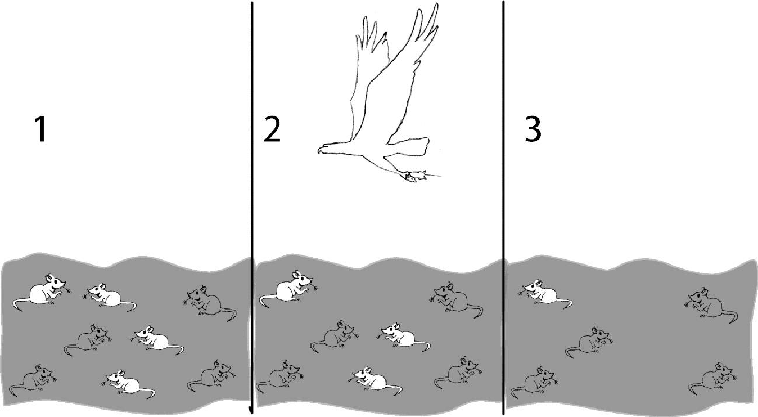

An **adaptation** is any characteristic that increases **fitness**, which is defined as the ability to survive and reproduce.

1. For the mice in figure 3, what physical characteristic increased their fitness?

Suppose a population had three female mice with the following characteristics.

|  |  |  |  |
| --- | --- | --- | --- |
| Characteristics of each female mouse | Color of Fur | | |
| White | Gray | Black |
| Running Speed | 5 cm/sec. | 6 cm/sec. | 8cm/sec. |
| # of offspring | 5 | 19 | 8 |
| Age at death | 3 months | 6 months | 3 months |

1. According to the definition of fitness given above, which of these mice would be the fittest? Explain why this mouse would be the fittest.
2. If a mouse’s fur color is generally similar to its mother’s fur color, which fur color would be the most common among the offspring from the table above?

___black ___gray __white

A characteristic that is influenced by genes and passed from parents to offspring is called a **heritable trait**. Fur color is a heritable trait for mice.

In general, individuals with a heritable trait that increases their fitness live longer and produce more offspring than individuals that do not have this trait. Because individuals with this trait have more offspring, there should be more individuals in the second generation that have this beneficial trait. If the trait is still beneficial to the second generation, individuals with this trait will pass it onto their offspring in the third generation. Therefore, over time, beneficial heritable traits tend to become more common in a population. This is a part of the process of natural selection.

5a. Suppose that one day while the mice were sleeping in their burrows, the gray sand of their habitat was replaced with white sand (perhaps the owner of the desert had a plan to attract more tourists). Think about what would happen to the population of mice on the white sand. After a year, which color fur do you think most mice would have? __black __gray __white

5b. Explain how the change in color of the sand could eventually result in a change in the most common fur color in this population of mice.

1. When mice live on gray sand, which color fur is a beneficial heritable trait?

When mice live on white sand, which color fur is a beneficial heritable trait?

1. Why would the answer you gave in 6 matter? How do all of the answers in this handout relate to the four definitions you saw at the beginning?

* Dora: “I think ‘fit’ means being bigger and stronger.”
* Lance: “I think ’fit’ means being more likely to reproduce.”
* Felix: “I think ‘fit’ means being able to run faster.”
* Keisha: “I think ‘fit’ means being more intelligent.”

That is, how is each definition ‘good’ and ‘bad’? How do they fit together but also say different things? As part of your answer, explain why an adaptive heritable trait tends to become more common in a population.