The Peppered Moth Story

Instructions: Read the story. Determine which color moths have greater fitness at the end of the story. Draw a cartoon illustration to show what happened to the peppered moths during the story.

From Light to Dark Moths
Moth collectors in England noted that most peppered moths collected in the early 1800’s were light gray peppered with bits of black. Many years later most of the moths collected were almost completely black.
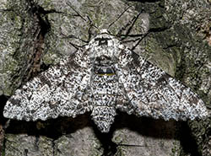
Most of the peppered moths collected in the early 1800s were the light form.

What could have caused the more common light colored moth to become rare? Scientists bred the moths and figured out that the light-colored form of the peppered moth has different genes from the dark form. The black color of the dark form was due to a mutation in the DNA of the light-colored form.
Once this mutation was present, the dark-colored moths would produce offspring with dark-colored wings. Light colored adults that didn't have the mutation produced light offspring. But genetics is only part of the story.

A Changing World
During the 1800’s, Europe and America experienced the Industrial Revolution. It was a time of change in manufacturing processes that led to the building of factories. This enabled humans to make many more things much faster.

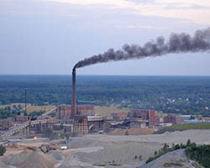
In the 1800s, manufacturing processes changed.

We went from a largely rural society to a city or urban one. One of the new fuel sources that was heavily used during this time period was coal. Small amounts of coal can produce large amounts of heat. It nearly replaced wood in many homes in Europe during this time. It was used for heating homes and cooking and it became the main energy source in factories.
Coal burning released large amounts of smoke and smog into the surrounding environment. This left a layer of black soot on the once lighter-colored trees. The pollution also killed the light speckled colored lichens that grew on the tree trunks. The tree bark was now exposed and dark without the lichens. How did this affect the peppered moth?

The Pepper in Peppered Moth
Like many moths in forests, the peppered moth tends to rest (or "perch") on tree trunks during the day. They do most of their flying at night. So it would probably be a good thing if the moths look similar to the trees that they perch on, right? Then they can be camouflaged from birds that want to eat them.
Before the Industrial Revolution, the light peppered moth was common, while the dark form was very rare. The light moths blended in with the light-colored trees. However, the Industrial Revolution changed the tree colors.

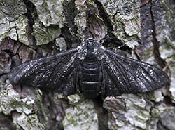
After the pollution from the Industrial Revolution started affecting trees, most of the collected peppered moths were of the dark form.

As the trees darkened with soot, the light-colored moths were easier to see. They were eaten by birds more and more, while the rare dark colored moths blended in better on the darker trees. This made the dark colored moths have a higher survival rate. They lived longer and passed their dark colored genes onto their offspring or young. Over time, the dark colored moths became the more common of the two color forms. Natural selection favored the dark individuals, so they were more successful after the trees changed.
Sound a little hard to believe? Well, more observations have come about since these conditions started to reverse, starting in the 1950s. Then, a Clean Air Act was introduced. Since that time, technology and cleaner burning fuels have started to decrease pollution in the areas where the peppered moth lives. The lichen has started to grow again and the black soot no longer settles on the barks of the trees. As expected, the light peppered moth population has recently been more common in the population. This is because it is better camouflaged.

Adapted from The Peppered Moth - A Seasoned Survivor, https://askabiologist.asu.edu/peppered-moth

