Name:________________________________ Lab Partner:______________________________
In this investigation, you will achieve the following objectives:
- Observe the gametophyte in the haploid phase of the moss lifecycle.
- Become familiar with the dissecting or stereoscope.
- Recognize and observe the sporophytes in a sample of moss, using the dissecting scope.
- Use safe and correct lab procedures.
- Understand and observe the stages of the alternation of generations in moss.
Background information:
All land plants undergo alternation of generations in the life cycle. Mosses are the most primitive of land plants, lacking vascular tissue. This is one reason they are usually found in very moist environments. Another reason they are found in moist environments is because they depend on water in order to reproduce.
When mosses reproduce, they exhibit an alternation of generations. In other words, they take turns having different types of bodies between each generation of the plant offspring.
The alternation of generations in moss is illustrated below.
The male and female gametophytes are the most conspicuous (or easily seen) forms of moss. Gametophytes are haploid, meaning they each contain only one set of chromosomes. Each one will produce either male or female gametes (eggs or sperm). The male and female plants look the same, and the only way to tell them apart is either with a microscope or by the presence of sporophytes.
Water must transport sperm from a male gametophyte to the egg of a female gametophyte, where the two gametes will fuse. Since fertilization of the gametes takes place within the female gametophyte, the sporophytes grow from, and depend on, the female gametophyte for food, water, and structural support.
The sporophytes are diploid plants that got their DNA from the union of male and female gametes. The sporophyte undergoes meiosis to make genetically different, haploid spores. Although the spores are like baby brothers and sisters, they will grow through mitosis, into gametophytes. The “brother and sister” gametophytes will reproduce together to continue to the cycle into the next generation.

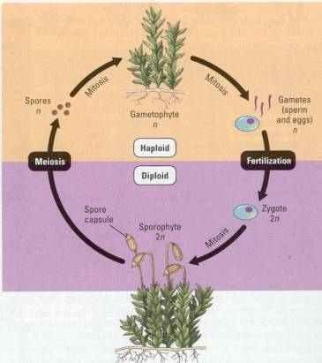

Pre-lab questions.
- What does alternation of generations mean?

- Based on your previous investigation, which stage is most common?

- What are gametes?

- How does fertilization in moss occur? Be specific and describe the gametes.

- What is a fertilized egg called?

- How does a fertilized egg become a sporophyte? Is it haploid or diploid?

- How can you tell whether a sporophyte is growing from a female or male gametophyte?

- What process do sporophytes undergo before they die? What do they make?

- After the sporophyte stage, is the next stage haploid or diploid? What do they grow to become?

- Why do mosses need sexual reproduction?

Lab Procedures:
At each station, observe each sample under either the dissecting or compound microscope. Draw a picture of each in the appropriate place, and answer the following questions for each station:
- What part of the moss are you viewing?
- Based on your answer, is the specimen in the haploid of diploid phase?

Station 1 | Station 2
Station 3 | Station 4
Station 5 | Station 6

