SCISSOR LIFT PARALLEL PROOF SOLUTION

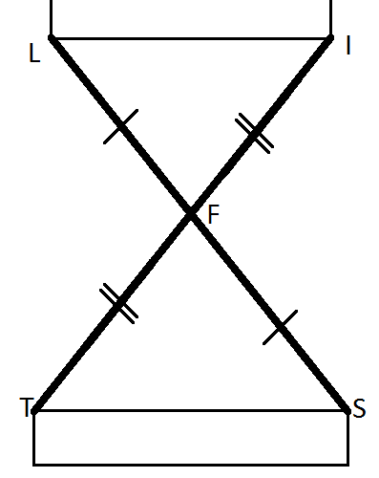Given F is the midpoint of LS and IT

Prove LI || TS

**General Reasoning**

Since F is the midpoint of both segments, we have two sets of congruent sides for the two triangles. The vertical angles create a pair of congruent angles. Since these angles are between the two sets of parallel sides, the two triangles are congruent by SAS. That means S is congruent to L. These are alternate interior angles. Since they are congruent, that means .

|  |  |
| --- | --- |
| STATEMENT | REASON |
| 1. F is the midpoint of LS and IT | 1. Given |
| 2. LF = FS and TF = FI | 2. Definition of midpoint |
| 3. LF  FS and TF  FI | 3. Definition of congruent segments |
| 4. LFI SFT | 4. Vertical angles are congruent |
| 5. LFI SFT | 5. Side angle side theorem for proving congruent triangles |
| 6. ILFTSF | 6. Corresponding parts of congruent triangles are congruent. |
| 7. | 7. If alternate interior angles are congruent, then the lines are parallel. |