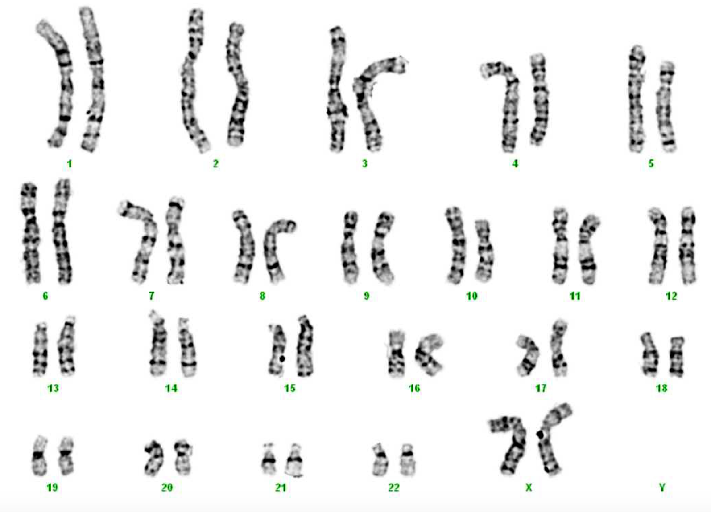
DOHERTY FETUS
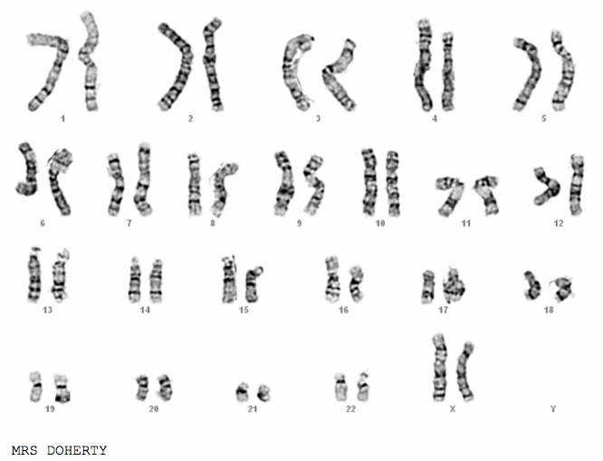
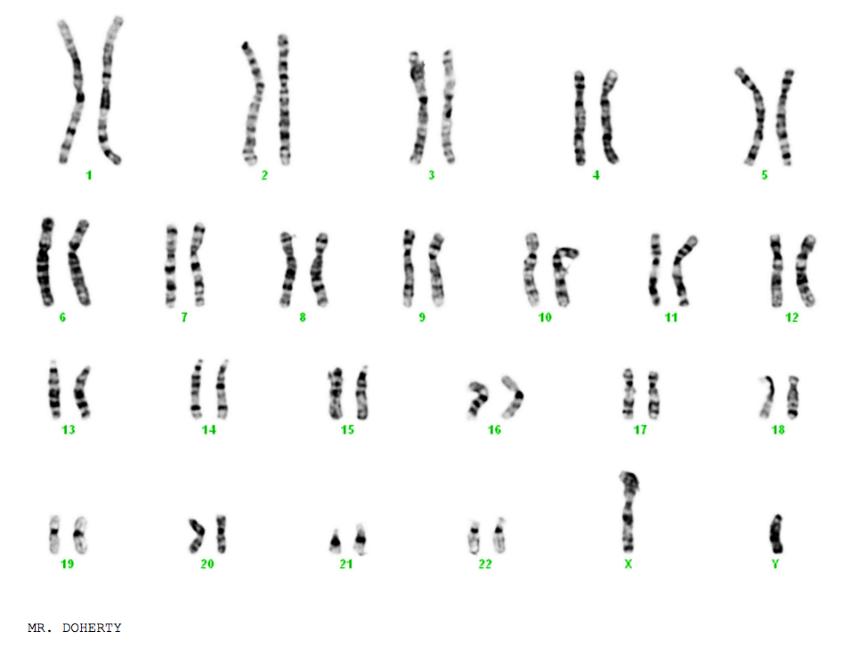
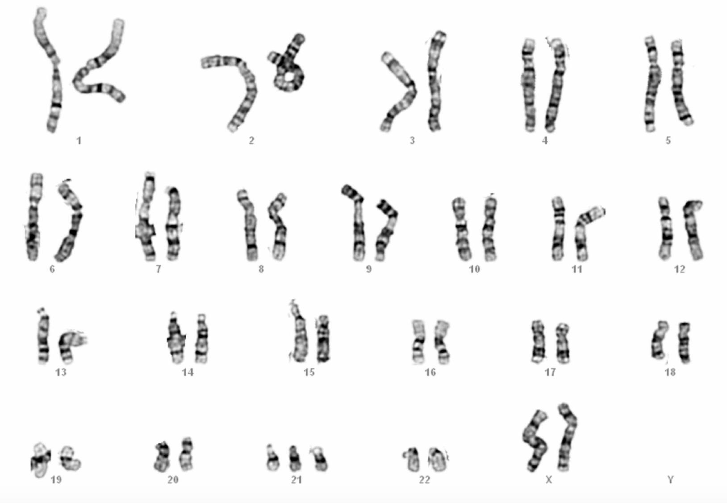
GREENE FETUS
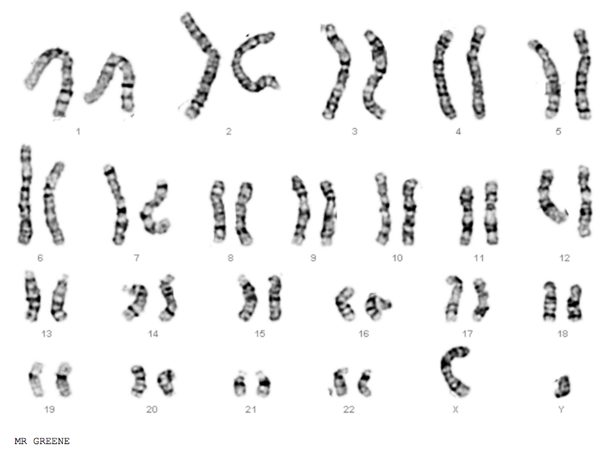
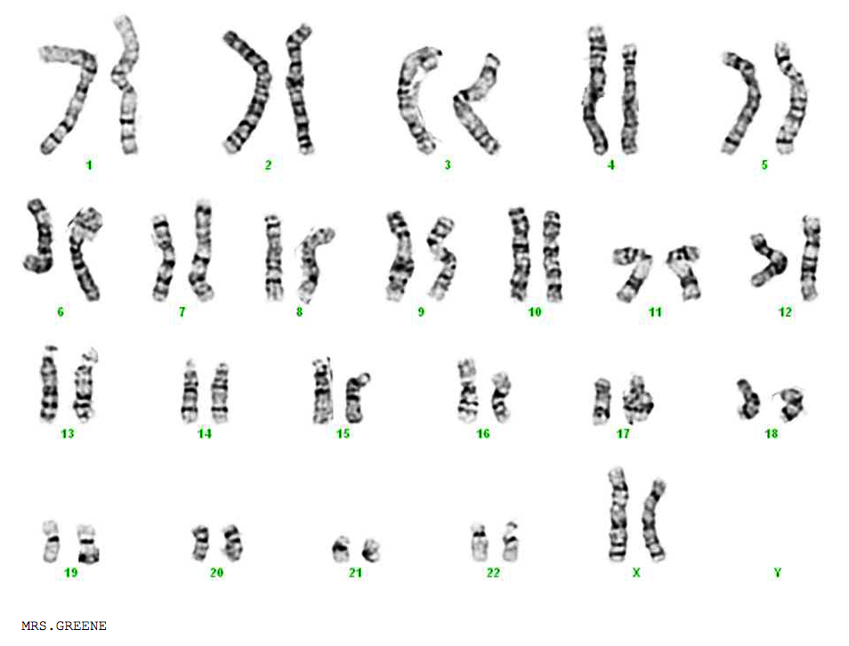
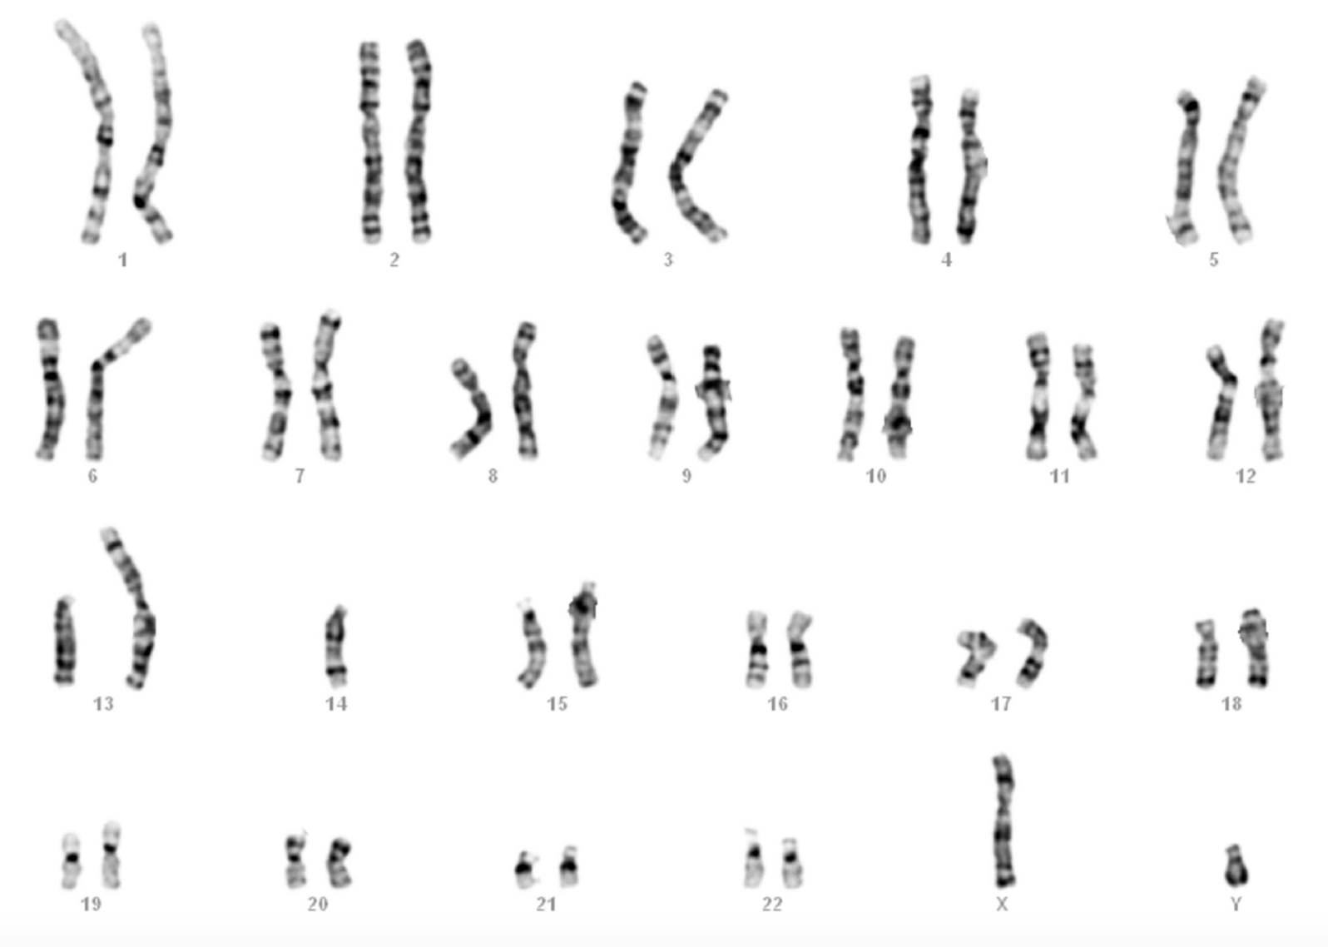
SINGH FETUS
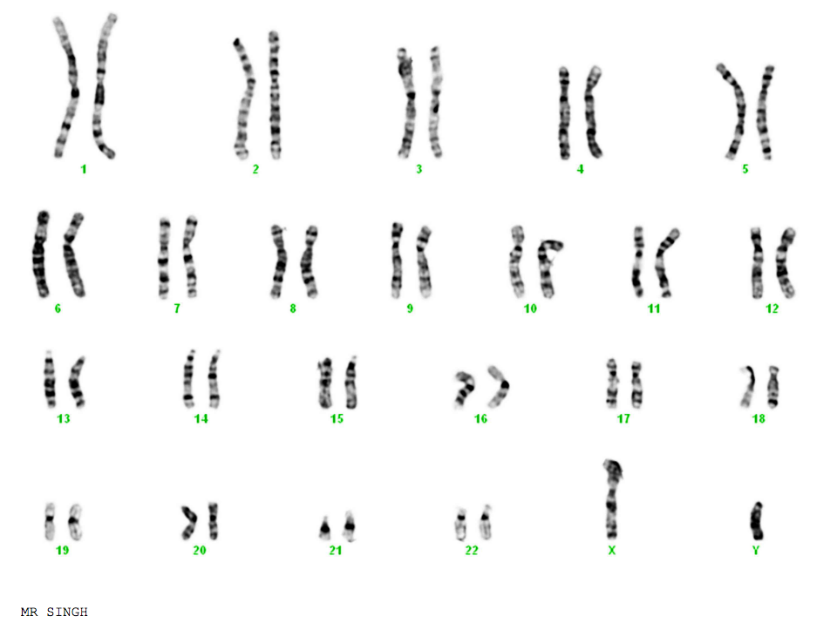
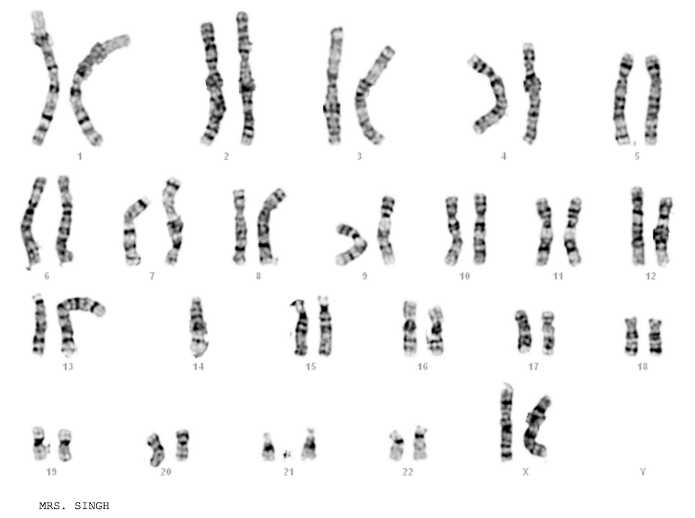
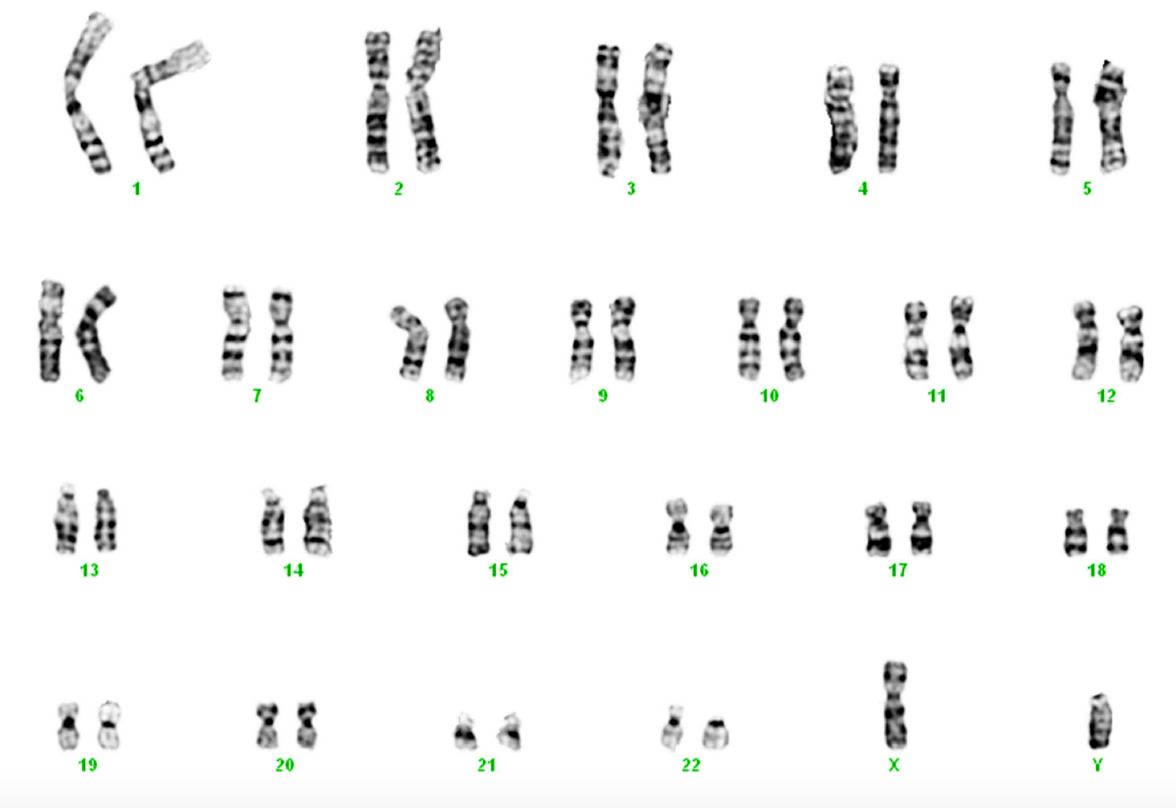
JACKSON FETUS
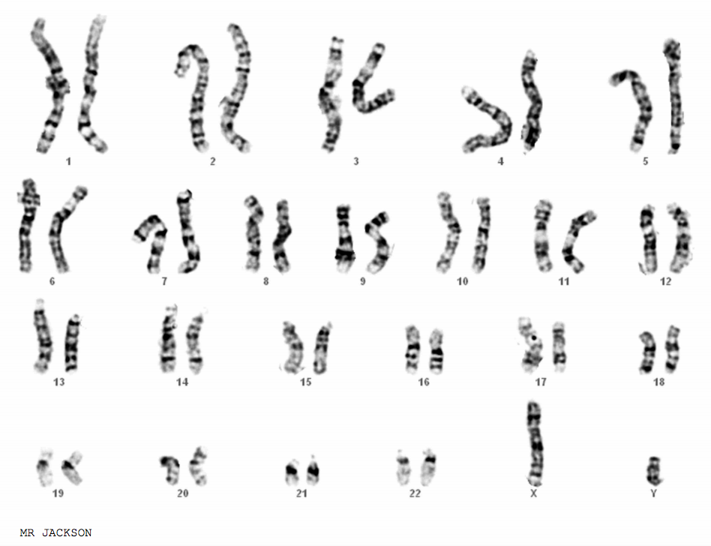
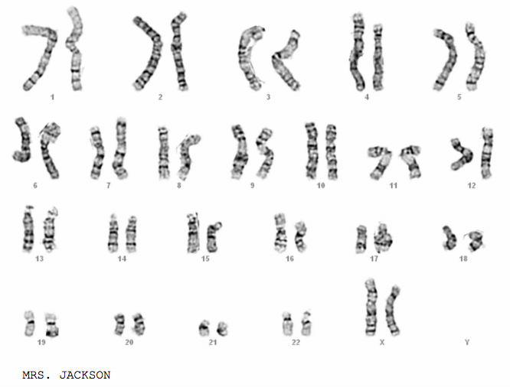
RAMIERZ FETUS
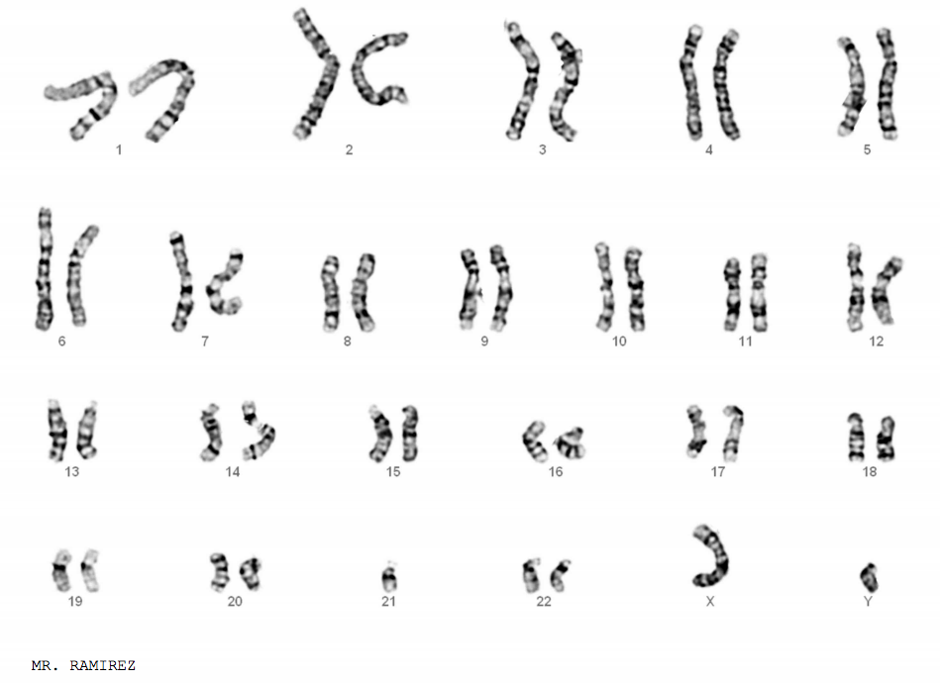
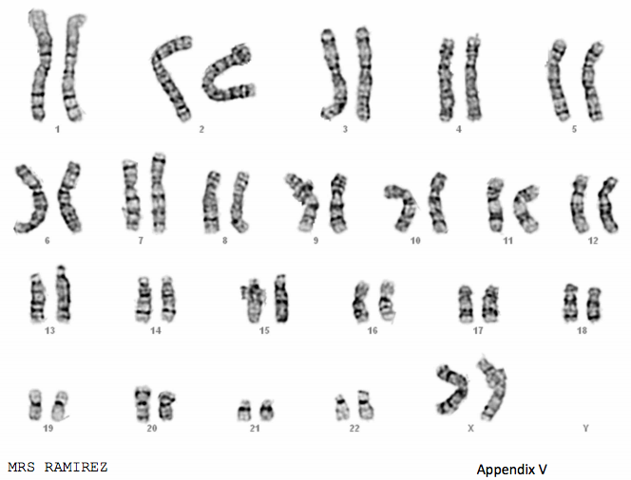
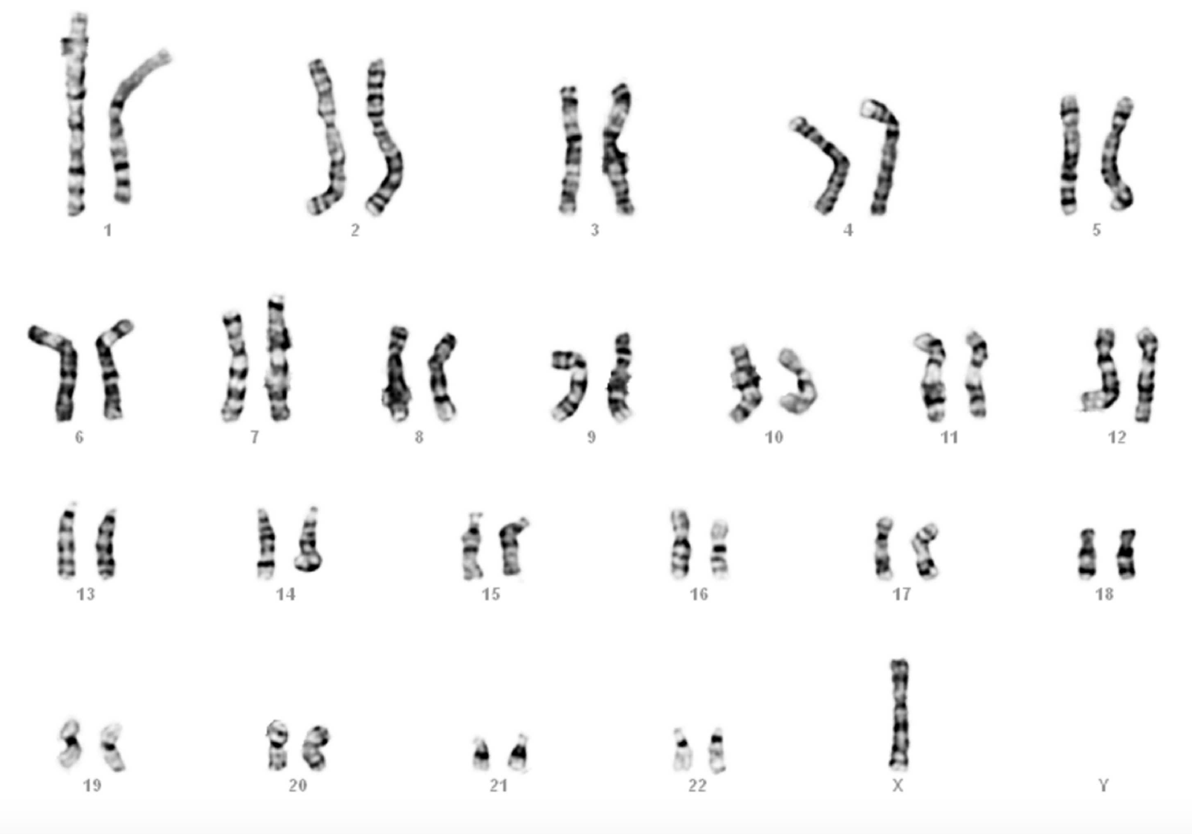
WOLF CHILD
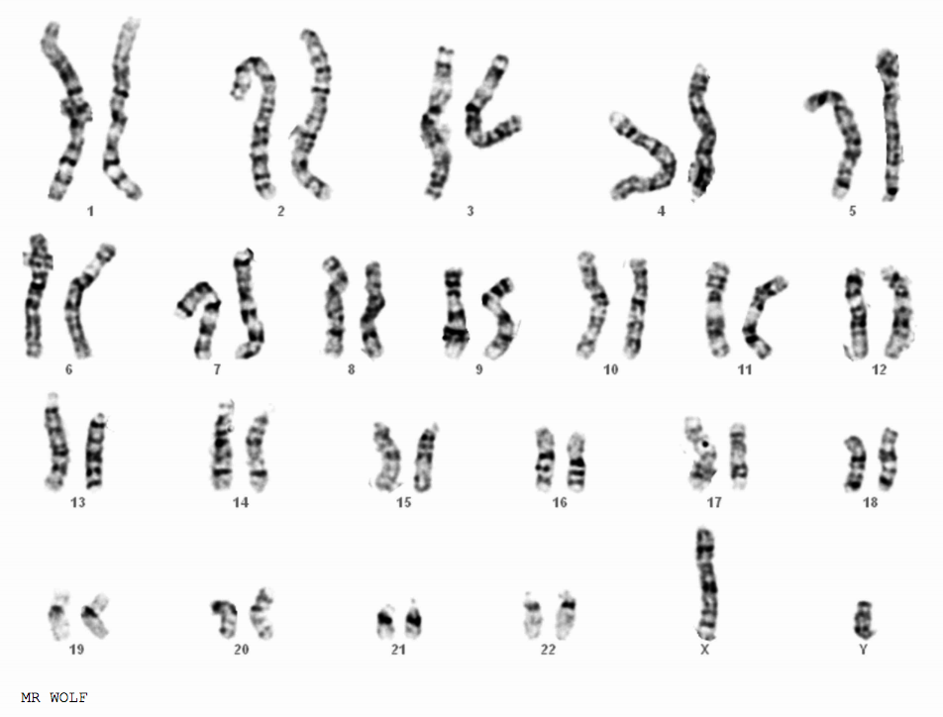
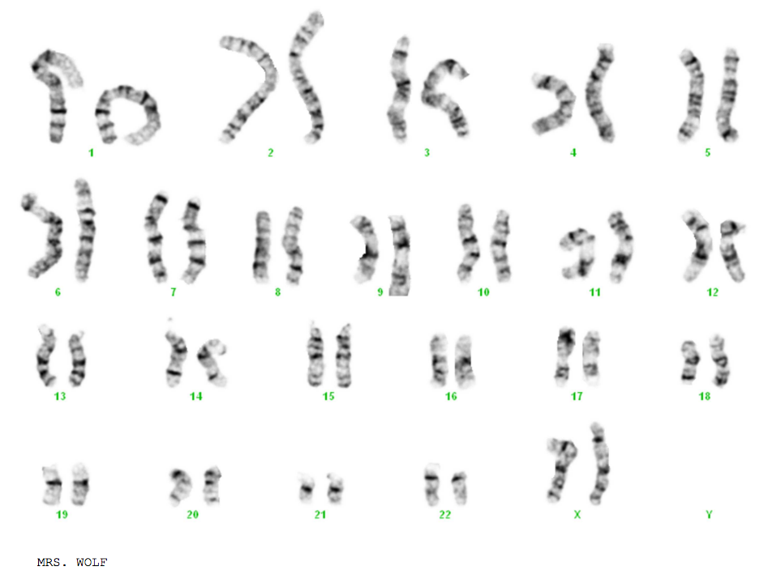
Answers

Doherty Fetus: Normal

Greene Fetus: Trisomy-21, so the baby has Down’s Syndrome

Singh Fetus: Robertsonian Translocation 14 onto 13; probably going to be a normal baby because the mom has the same translocation

Jackson Child: Normal

Ramierz Fetus: Robertsonian Translocation of an extra 21 onto 14; since it’s an extra 21, it’s still trisomy-21, so the baby has Down’s Syndrome. The twisted chromosome 2 is fine.

Wolf Child: Turner’s Syndrome; there is only one sex chromosome

