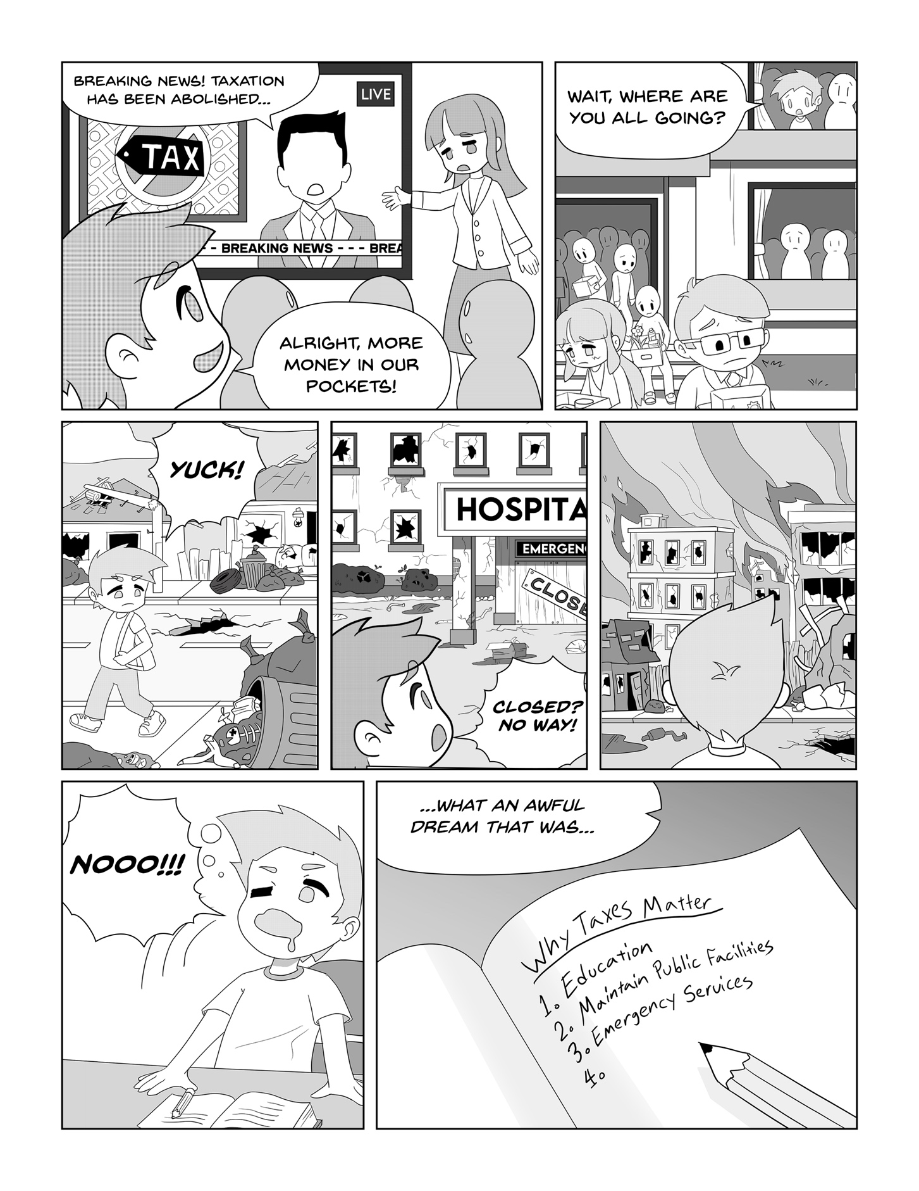
A DAY WITHOUT TAXES

