EXAMPLES OF CULTURE

What is each picture about and what element of culture might it represent?

1.  4. 

[This Photo](http://www.zuzeeko.com/2010_03_01_archive.html) by Unknown Author is licensed under [CC BY-NC-ND](https://creativecommons.org/licenses/by-nc-nd/3.0/)

[This Photo](http://www.styleonvega.com/grown-up-alternative-stylehow-to-dress-alternative-in-adult-age-grown-up-goth-30-thirty-years-old-punk-alternative-lady-girl/) by Unknown Author is licensed under [CC BY-NC-ND](https://creativecommons.org/licenses/by-nc-nd/3.0/)

1.  5. 

[This Photo](http://www.yesmagazine.org/issues/solidarity/how-i-changed-my-holiday-traditions-to-match-my-values-20171218) by Unknown Author is licensed under [CC BY-NC-ND](https://creativecommons.org/licenses/by-nc-nd/3.0/)

[This Photo](http://www.miss604.com/2012/08/italy-wins-2012-honda-celebration-of-light.html) by Unknown Author is licensed under [CC BY-SA-NC](https://creativecommons.org/licenses/by-nc-sa/3.0/)

1. 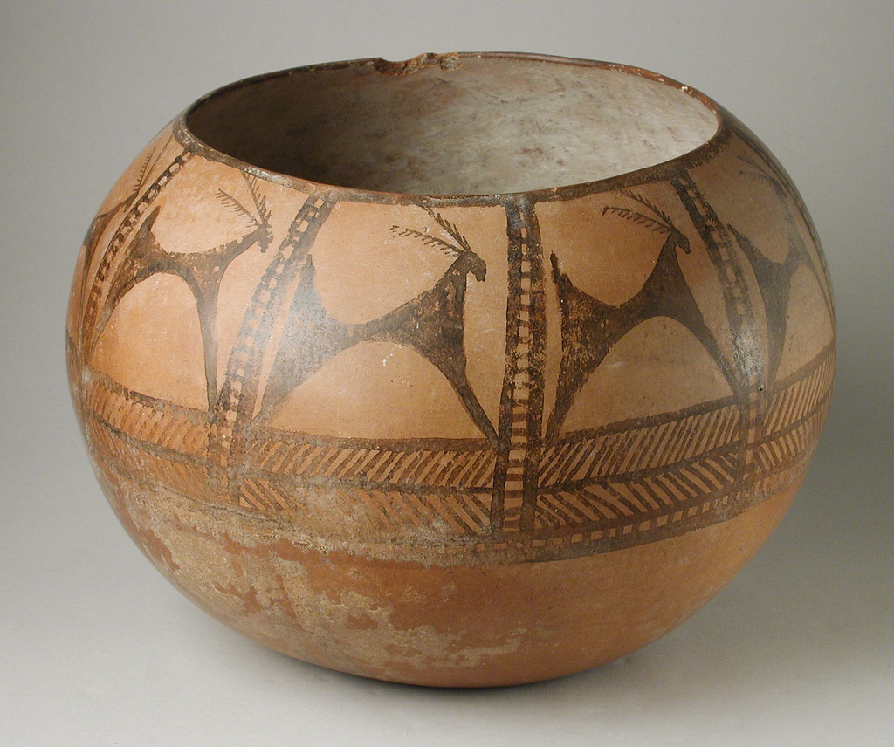 6. 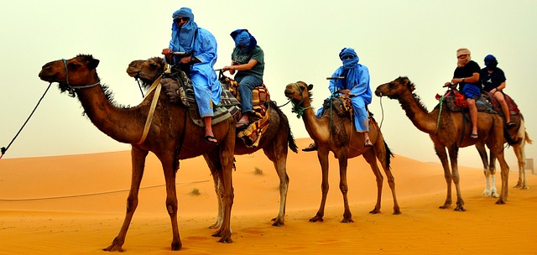

[This Photo](http://en.wikipedia.org/wiki/File:London_High_School_-_London_Ohio.jpg) by Unknown Author is licensed under [CC BY-SA](https://creativecommons.org/licenses/by-sa/3.0/)

[This Photo](https://en.wikipedia.org/wiki/Tlacolula_de_Matamoros) by Unknown Author is licensed under [CC BY-SA](https://creativecommons.org/licenses/by-sa/3.0/)