1. 
2. 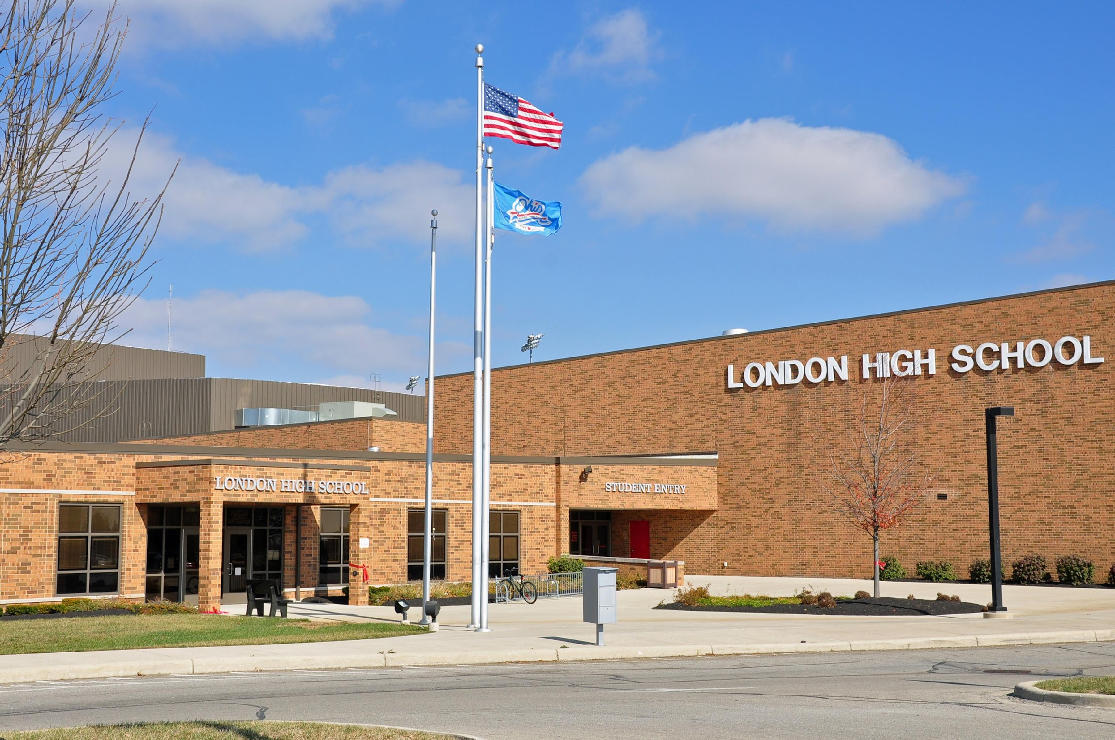
3. 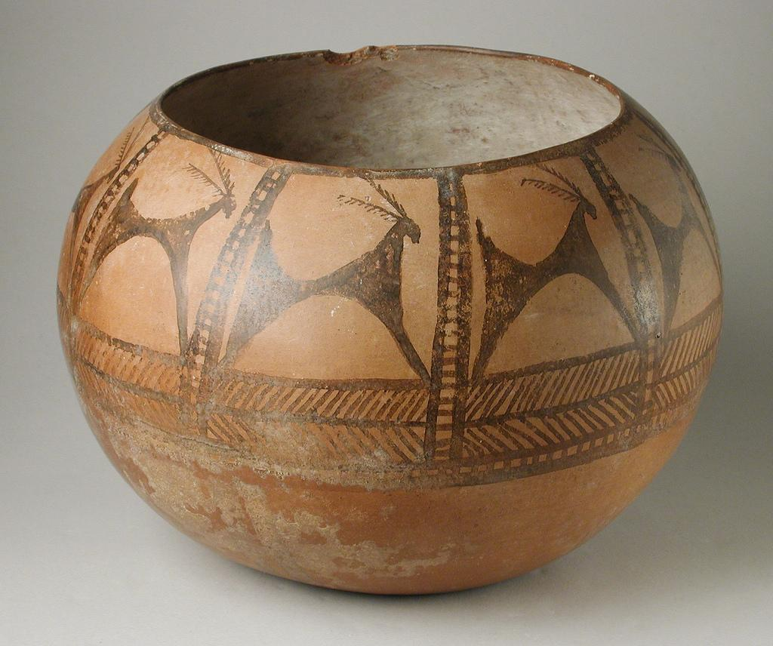
4. 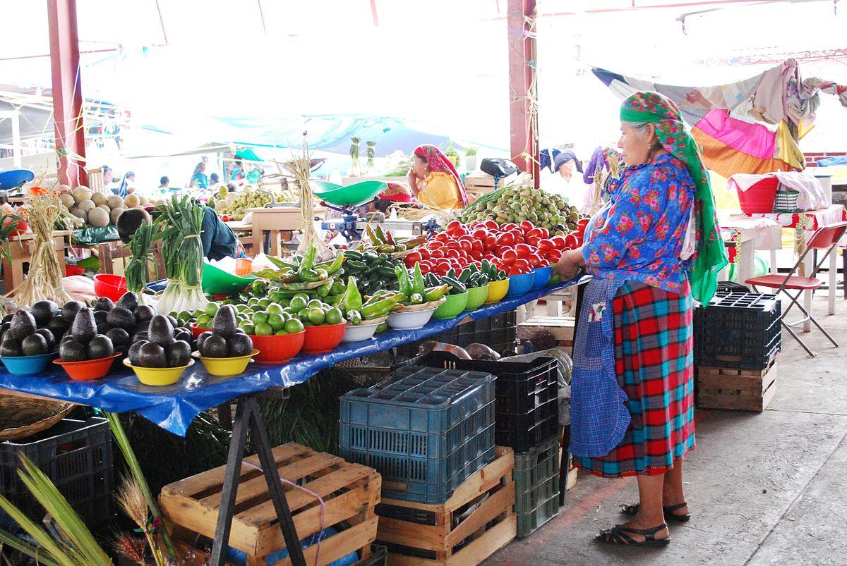
5. 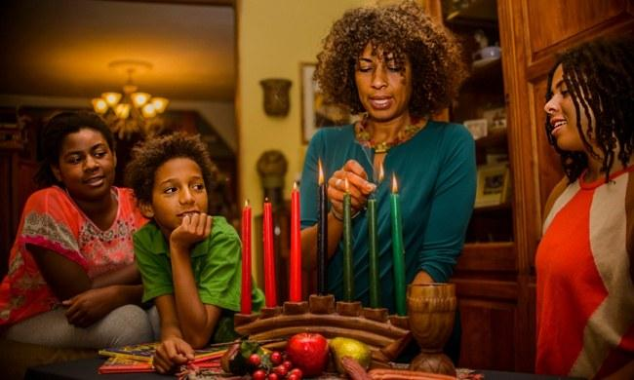
6. 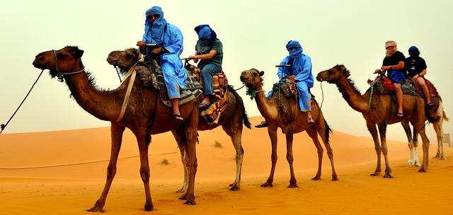

References:

1. Ali, H. (2023, October 25). Merits of prostration in prayer. Prayer In Islam. <https://prayerinislam.com/merits-prostration-prayer/>
2. Wikimedia Foundation. (2024, March 30). London High School (Ohio). Wikipedia. <https://en.wikipedia.org/wiki/London_High_School_(Ohio)>
3. Prehistoric painted pottery vessel. Prehistoric Painted Pottery Vessel | LACMA Collections. (n.d.).<https://collections.lacma.org/node/184796/>
4. Projects, C. to W. (2024, May 25). Wikimedia Commons. <https://commons.wikimedia.org/wiki/File:Tlacolula_Market_230122_62.jpg>
5. Warfield, Zenobia Jeffries. (2018, Dec 18). How I changed my holiday traditions to match my values. Yes! The Solidarity Economies Issues: Solutions We Love. <https://www.yesmagazine.org/issue/solidarity-economy/2017/12/18/how-i-changed-my-holiday-traditions-to-match-my-values>
6. CCO-Photographers. (2017, March 01). Landscape photo of camel riders. Wordpress. [https://pxhere.com/fi/photo/913554#google_vignette](https://pxhere.com/fi/photo/913554)