THINK-PAIR-SHARE
What would be the value of the triangles? | I Think | My Partner Thinks | Our Class Thinks

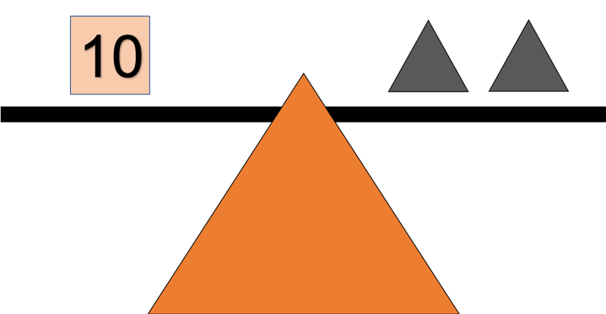
This Photo by Unknown Author is licensed under CC BY-NC-ND

