Alabama Tornado
On March 3, 2019, Alabama, Georgia, and Florida experienced a severe tornado outbreak. One of these tornadoes, an EF-4, began in Alabama and continued over the state line into Georgia. It caused at least 23 deaths over its path of almost 70 miles.
- Select a location along the Alabama tornado track between 32.44° N, 85.48° W and 32.57° N, 85.05° W, on March 3, 2019.
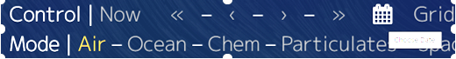
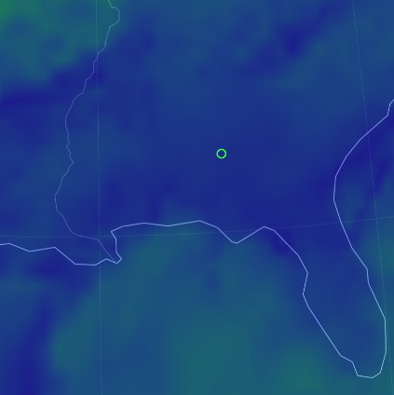
Florida

- Create a table in Desmos to record data at your point from 00:00 on March 3 through 00:00 on March 4. Record the following air mode variables at Earth’s surface (Height – Sfc):
  - MSLP – Mean Sea Level Pressure
  - Wind – Wind Speed
  - CAPE – Convective Available Potential Energy
- Make a claim about what time the tornado likely touched down. What evidence supports your claim?

Claim

Evidence

- Record at least one more variable from the Overlay list in Desmos. Don’t use WPD or MI. Does the new variable support your claim? Why or why not?

- Using the patterns that you see in your data, explain how these variables could be used to predict the development of future tornadoes. Are there any variables that are not good predictors of tornadic activity? Why not?

- What additional information would you want or need to make your claim stronger?

Alabama Tornado
Time (24 hr) | MSLP  (hPa) | Wind  (km/h) | CAPE  (J/kg) | Other:

00:00

03:00

06:00

09:00

12:00

15:00

18:00

21:00

00:00

