Using Desmos

Create a Graph
- Go to www.desmos.com/calculator.
- Click + (plus) at the top of the left panel.
- Select “Table” from the menu. The top row of the table is your variable header.
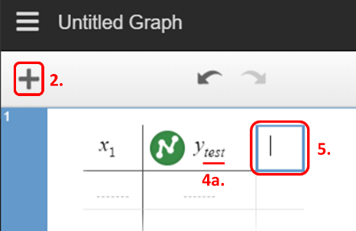
- Name your X and Y variables with a one-word (no spaces) subscript: X_{variable} or Y_{variable}. You must keep the X and Y or Desmos will not recognize the data.
  - To make a subscript, click to the right of the letter X or Y in your variable header.
  - Press shift and minus (-) at the same time, and then enter your variable name.
- To add a new Y variable,
  - With your cursor in the variable header, press Tab. Or, Click in the blank box to the right of the current variable header.
  - Enter Y to add a new variable. Don’t forget to name your variable using a subscript.
    - Click to the right of the Y in your variable header.
    - Press shift and minus (-) at the same time, and then type your variable name.

Edit Graph Appearance

Data Points and Lines
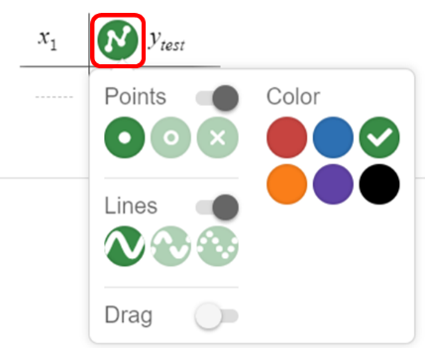
To make changes to the look of your data on the graph, click and hold within the circle next to your variable name. A menu appears with the following options:
- Points changes the shape of your data points.
- Color changes the variable color.
- Lines connects your data points and changes the line type (solid, dashed, or dotted).

Graph Scale
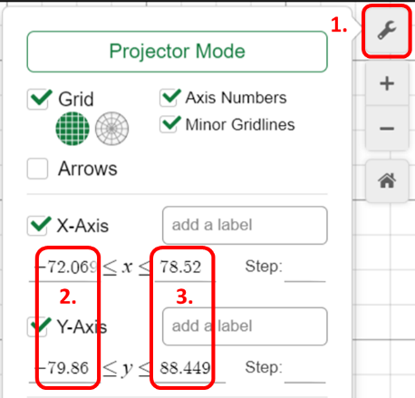
- Click the wrench icon in the upper-right corner of the graph area. The Options menu opens.
- For each axis, change the minimum value to -1 or 0.
- For each axis, change the maximum value to something greater than your largest data value.

