TEACHER KEY MAP ANALYSIS
- Using these layers on the map, 1) March GPS – Bison; 2) Bison Unit; and 3) 2009 Winter/Spring Burns, describe any apparent spatial relationship between the bison and burned patches during March. Why do you think the relationship or lack of relationship you described occurs during this month?

Students may determine that there is a relationship for March. If so, their answers should reflect that conclusion. After seeing the map for May, most students will change this prompt’s response to describe “no relationship” or a “weak relationship.” Examples of possible responses: There does not appear to be a spatial relationship between bison locations and the areas burned in the spring and winter. Lack of forage in the burned areas probably encourages bison to graze in the unburned areas. GPS points from bison within the burned areas could be from bison crossing those areas from one unburned area to another. Since fire is often “patchy,” GPS points from bison within the burned areas could result from the likelihood that some areas within the burn units still had forage available for bison after the burns.
The map used for A. should have looked like this: 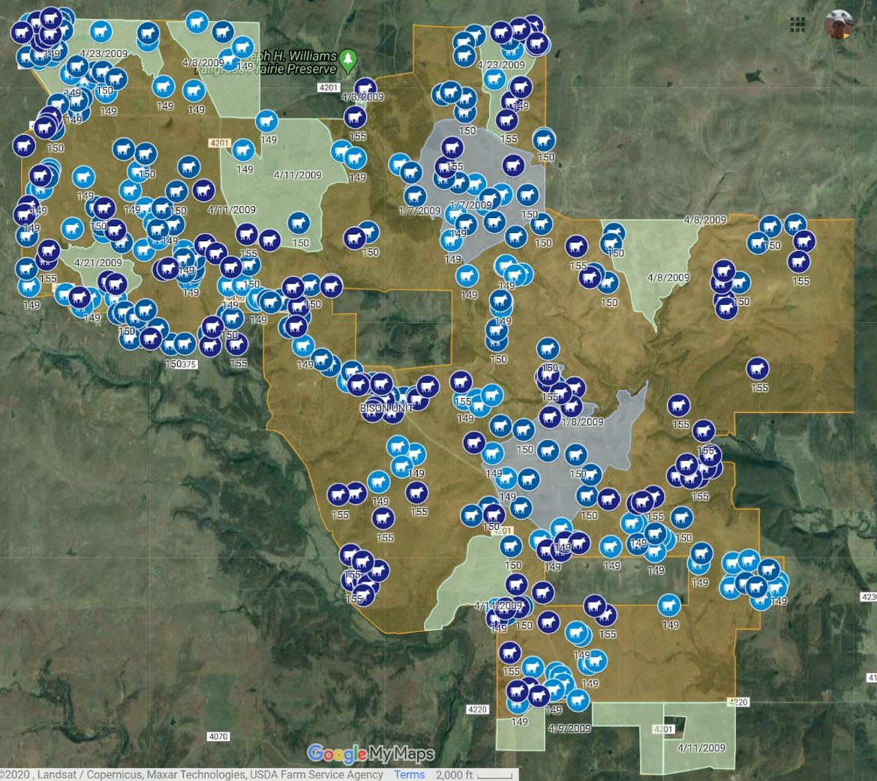

- Using these layers on the map, 1) March GPS – Bison; 2) Bison Unit; and 3) 2009 Winter/Spring Burns, describe any apparent spatial relationship between the bison and burned patches during April. Why do you think the relationship or lack of relationship you described occurs during this month?

Students may determine that there is a relationship for March. If so, their answers should reflect that conclusion. After seeing the map for May, most students will change this prompt’s response to describe “no relationship” or a “weak relationship.” Examples of possible responses: There does not appear to be a spatial relationship between bison locations and the areas burned in the spring and winter. Lack of forage in the burned areas probably encourages bison to graze in the unburned areas. GPS points from bison within the burned areas could be from bison crossing those areas from one unburned area to another. Since fire is often “patchy,” GPS points from bison within the burned areas could result from the likelihood that some areas within the burn units still had forage available for bison after the burns. Grasses and other plants are beginning to emerge from subsurface structures, so there is some forage available for bison which could attract them to the burned areas.
The map used for B. should have looked like this:
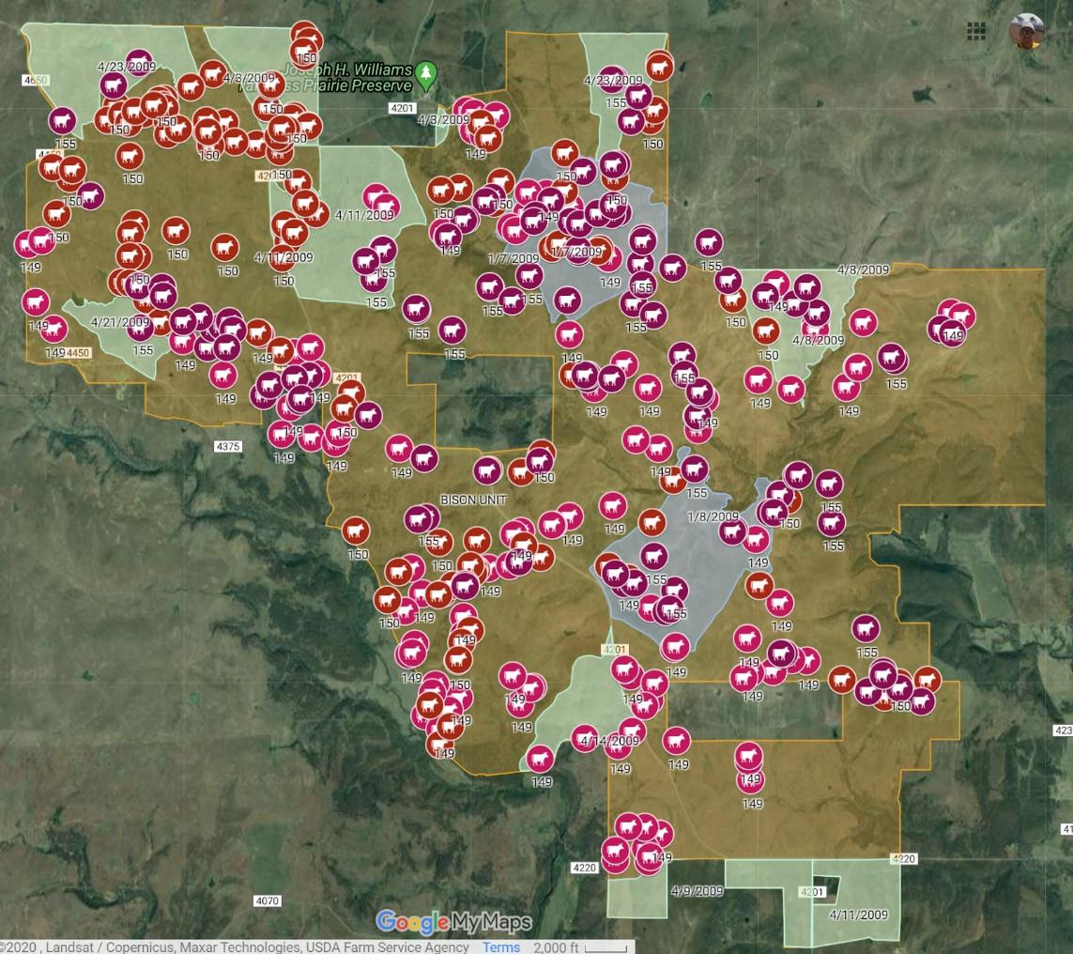

- Using these layers on the map, 1) March GPS – Bison; 2) Bison Unit; and 3) 2009 Winter/Spring Burns, describe any apparent spatial relationship between the bison and burned patches during May. Why do you think the relationship or lack of relationship you described occurs during this month?
Examples of possible responses: There appears to be a very strong correlation between areas that were burned in the winter and spring and the distribution of bison during the month of May. One factor that could influence bison grazing is the lush, new growth of grasses and other plants during this time of the year. In the burned areas, there is no old growth present to impede the grazing of bison on the new plant growth. This could make grazing easier and more efficient for the bison.
The map used for C. should have looked like this:
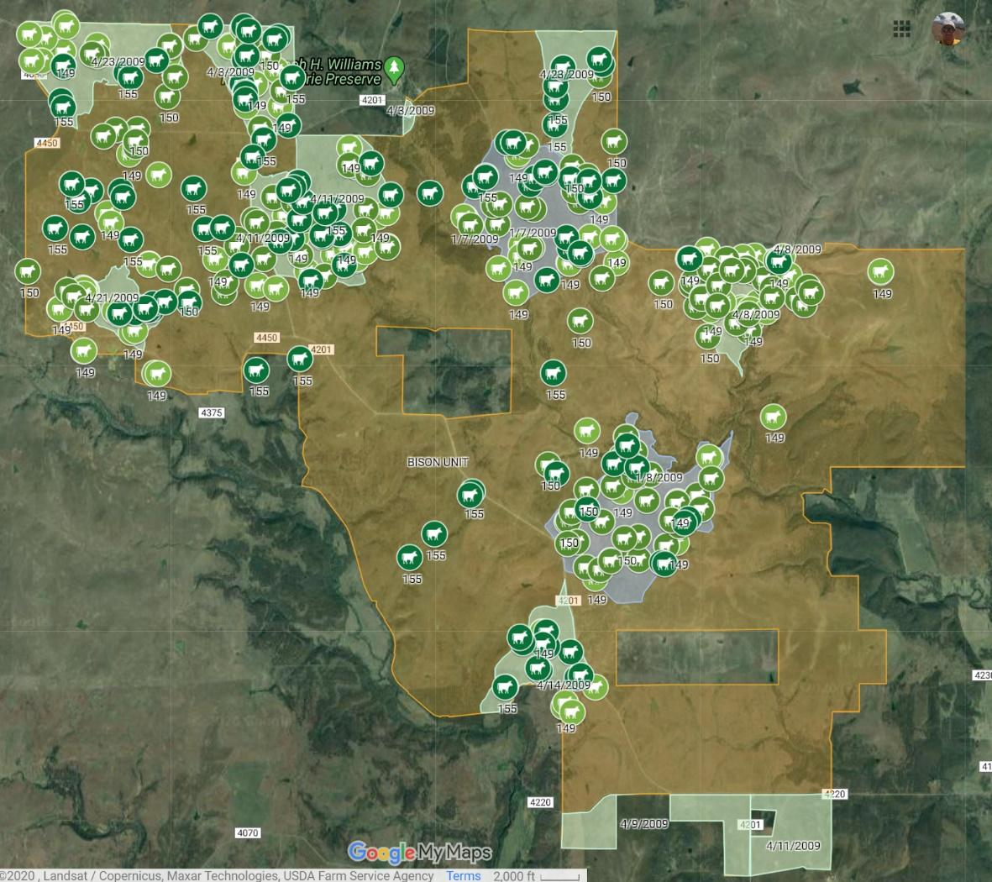

- What is a question for future research that results from your findings? Describe data that would be needed to answer your question.

There could be a wide variety of responses to this prompt. Common research questions with possible data requirements:

1) Are there differences in forage quality between burned and unburned areas? Data needed: Data comparing the “quality” of forage in burned and unburned areas at any given time. Protein content is a measure of forage quality that could be mentioned to students. Dormant vegetation or dead vegetation from the previous year will have a much lower protein content compared to new growth.

2) Does forage quality change from March to May in burned and unburned areas? Data needed: Data comparing forage quality from March through May for only burned areas and data comparing forage quality during that same time period for only unburned areas.

3) How do bison grazing efficiencies compare between burned and unburned areas? Data needed: The “spatial search pattern” of bison could be recorded to reflect how easily quality forage is encountered. Bison showing “sinuosity” in movements are typically having to spend more time searching for quality forage whereas those grazing “straighter” are having little difficulty and are, thus, grazing more efficiently.

4) Due to the “patchiness” of fire, how much forage remains in burn units immediately after prescribed burns? Data needed: Determine the mass of forage left standing in a burn unit after prescribed fires are conducted.
5) Were bison influenced by other factors such as the availability of water? Data needed: Determine and create a map layer of watering sites available to bison on the Tallgrass Prairie Preserve to determine if there is an apparent relationship.

