MAPPING BISON

**Student Guide**

Follow the steps below to create a Google Map for “Response of Bison to Fire.”

# Step 1: Access 2009 “Response of Bison to Fire” Google map.

Scan the QR code or type in: <http://k20.ou.edu/bisonmap> .

**Step 2: Copy Map.** Click on the Menu button 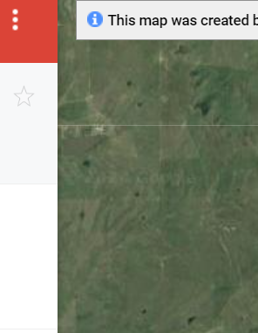 then select “Copy map.” Now this map should be in your Google drive. You can rename the file but just remember how to access it later.

**Step 3: Add/import data files.**

1. Click on the “add layer” option at the top left then scroll down to the “untitled layer” section and click “Import.”
2. Navigate to where you saved the data files and select the file for “March.”
3. Afterwards, keep the pre-selected items and hit the “continue” button.
4. Next, select “collar” and then hit “finish.” The bison data should appear on the map.

**Step 4: Let your artistic flare stand out!** Scroll down and select “uniform style” and select “collar.” This will identify the markers as one of the three bison. Under the “label” drop down menu, select “collar.” Now you can have artistic freedom and choose how to visually represent the markings on your map by changing the color and shape.

1. Click on the paint bucket or “edit” button next to each numbered bison.
2. Select an icon you’d like to use. If you go to “more icons” and then “animals,” you can find the “cow” which looks similar to a bison.
3. Repeat these steps for the remaining bison numbers.

**Step 5: Repeat Steps 3 and 4 for “April” and “May” files.**

**Step 6: Other visual changes options.** 1) Use the paint bucket or edit menu for the burn patches to change colors. 2) Select “base map” to change how the map typography looks.

**To Access Your Map**

From Google maps go to “Your Places” then “Maps” and select the file you retitled.

**Map Analysis**

**Directions.** By manipulating the layers of the map appropriately, respond to the prompts below.

1. Using these layers on the map, **1) March GPS – Bison; 2) Bison Unit;** and **3) 2009 Winter/Spring Burns**, describe any apparent spatial relationship between the bison and burned patches during March. Why do you think the relationship or lack of relationship you described occurs during this month?
2. Using these layers on the map, **1) March GPS – Bison; 2) Bison Unit;** and **3) 2009 Winter/Spring Burns**, describe any apparent spatial relationship between the bison and burned patches during April. Why do you think the relationship or lack of relationship you described occurs during this month?
3. Using these layers on the map, **1) March GPS – Bison; 2) Bison Unit;** and **3) 2009 Winter/Spring Burns**, describe any apparent spatial relationship between the bison and burned patches during May. Why do you think the relationship or lack of relationship you described occurs during this month?
4. What is a question for future research that results from your findings? Describe data that would be needed to answer your question.