Not Like the Others:

Graph #1
Discuss with your group why you think this graph is not like the others.
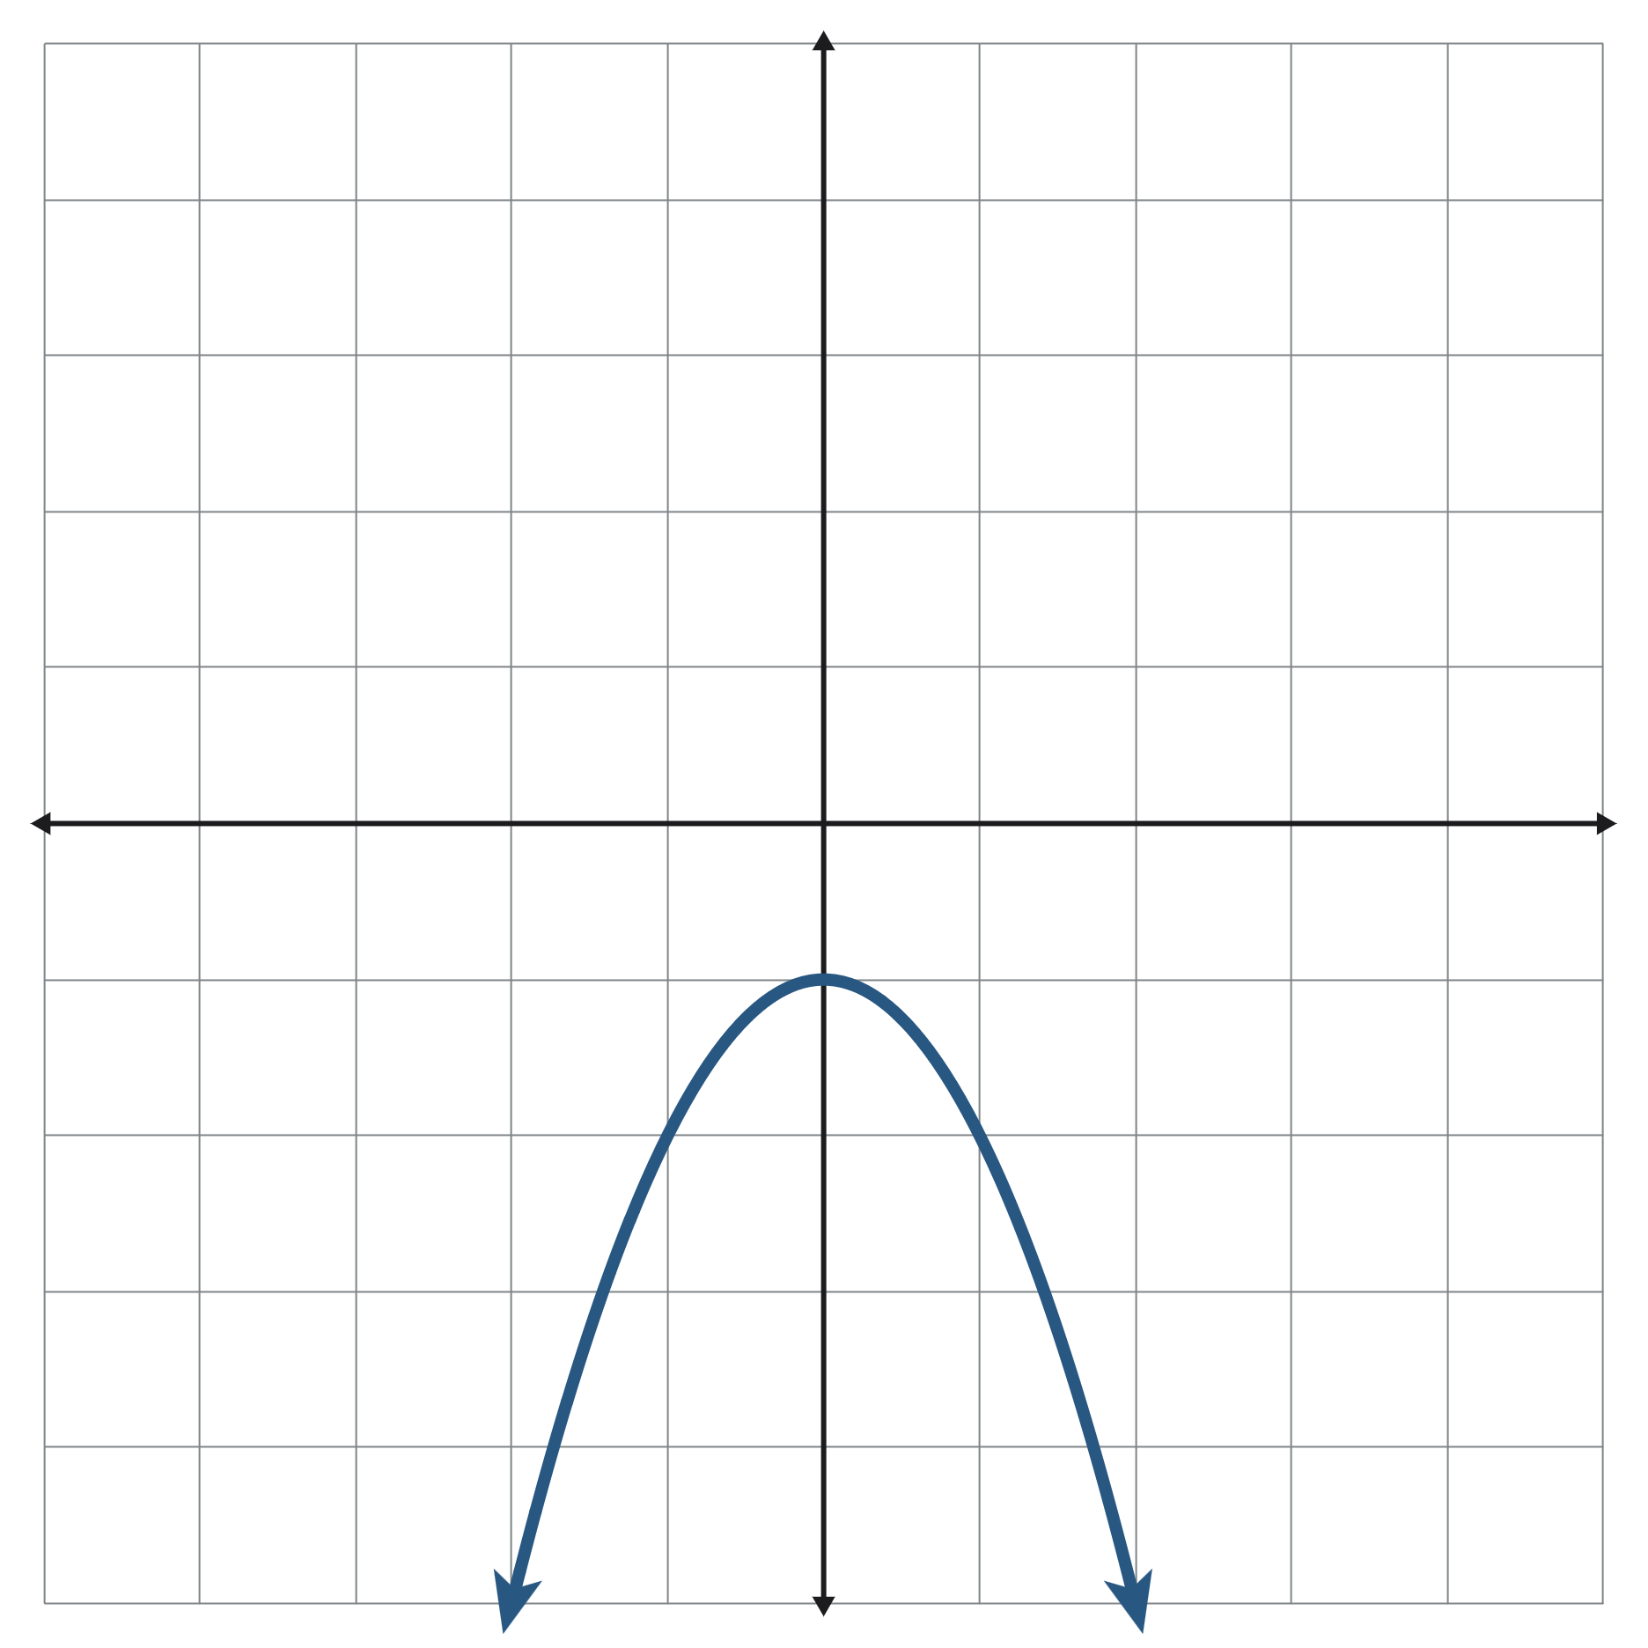

Not Like the Others:

Graph #2
Discuss with your group why you think this graph is not like the others.
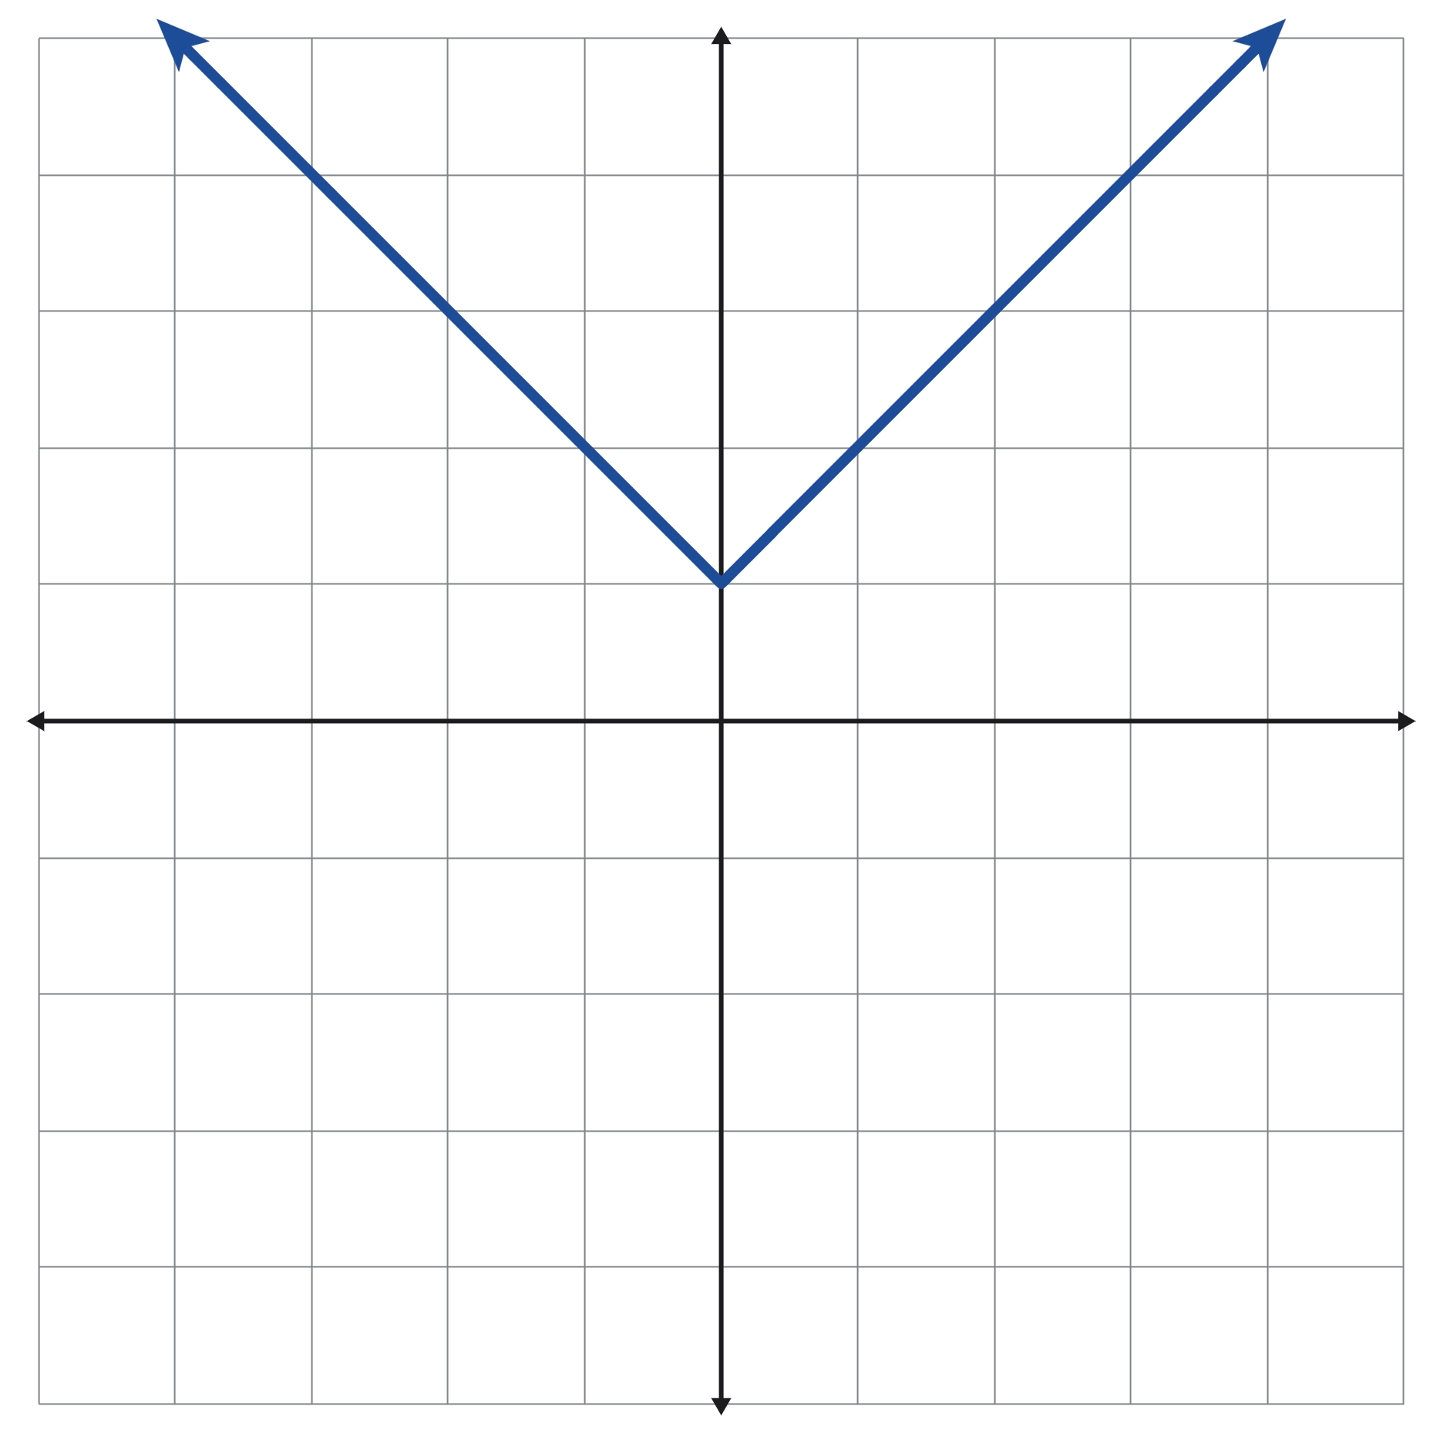

Not Like the Others:

Graph #3
Discuss with your group why you think this graph is not like the others.
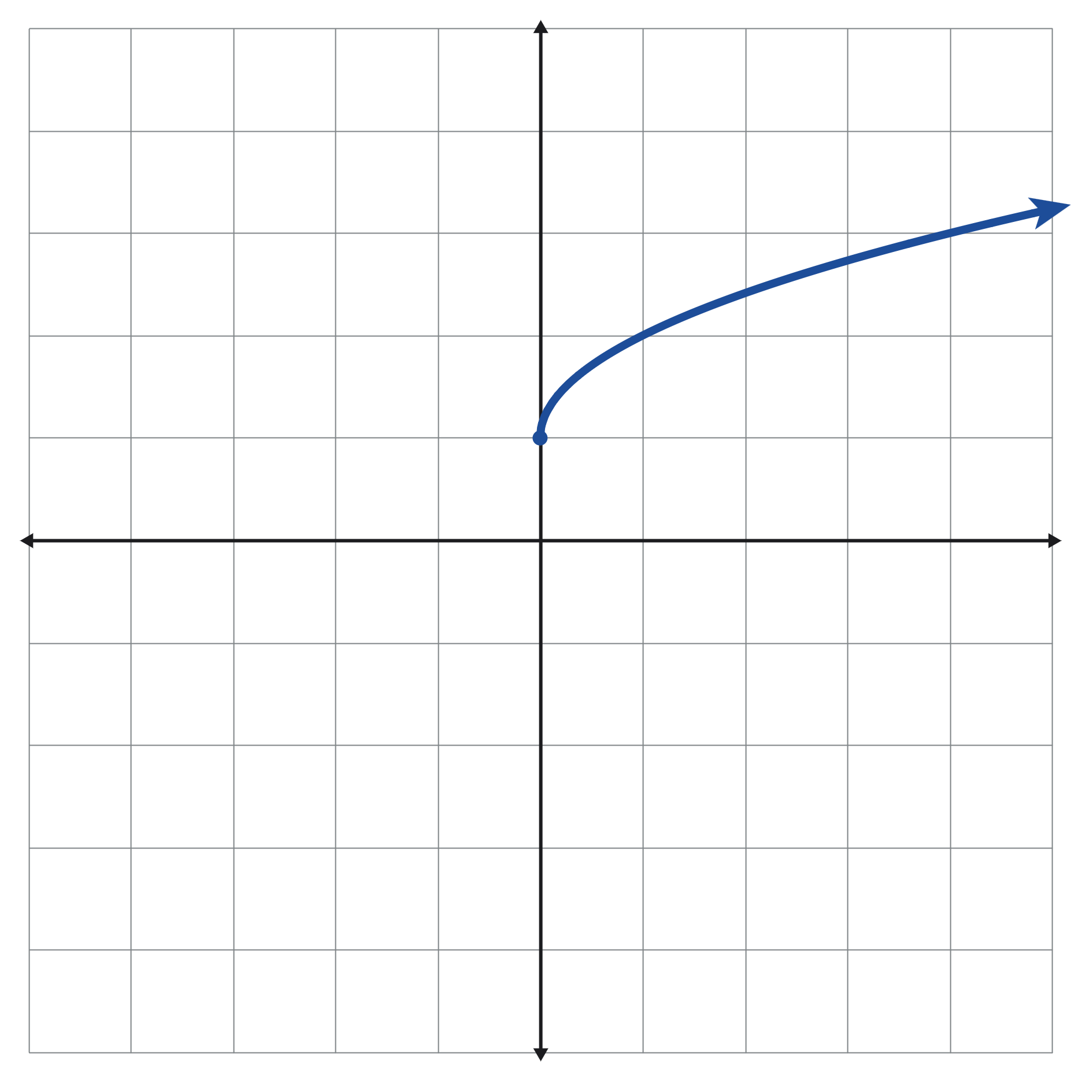

Not Like the Others:

Graph #4
Discuss with your group why you think this graph is not like the others.
