Tonya’s Travels

TONYA’S DISTANCE FROM HOME ON SATURDAY AS A FUNCTION OF TIME SINCE 8AM
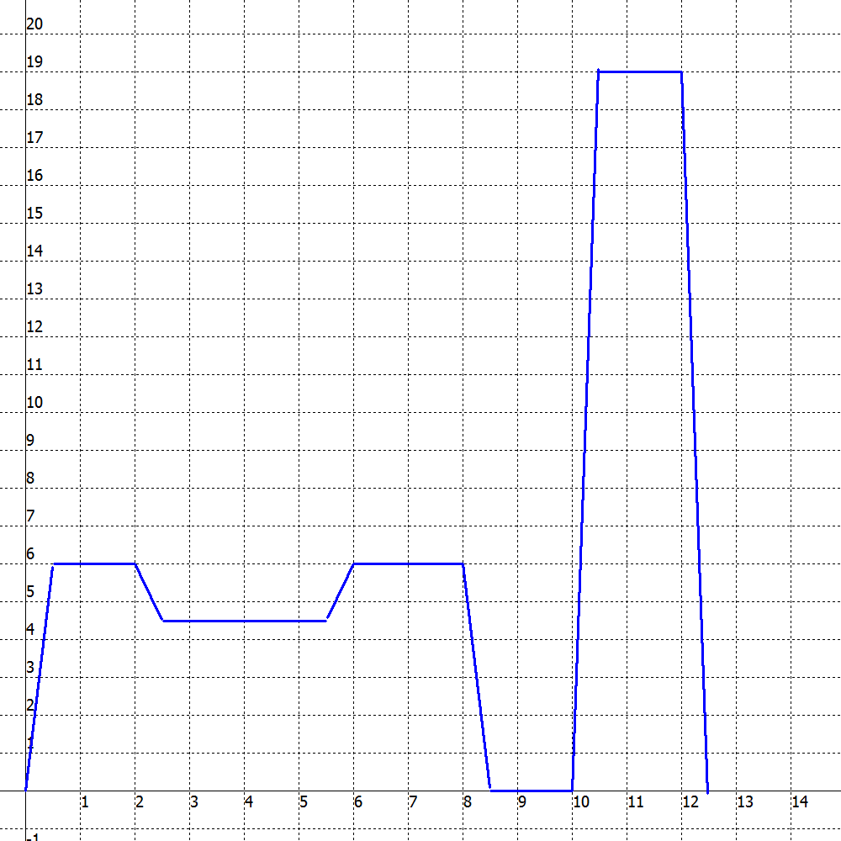
- During which time intervals was Tonya not moving?
- During which time intervals was Tonya moving away from her home? How can you tell?
- How far did she move and how fast was she moving during each of the time intervals you listed in question 2?
- During which time intervals was Tonya moving toward her home? How can you tell?
- How far did she move and how fast was she moving during each of the time intervals you listed in question 4?

