INDICATIVE MOOD  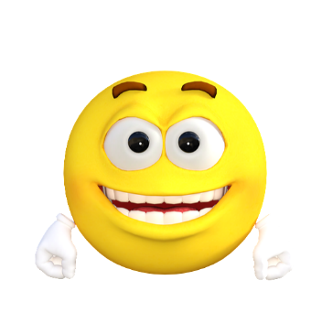 | IMPERATIVE MOOD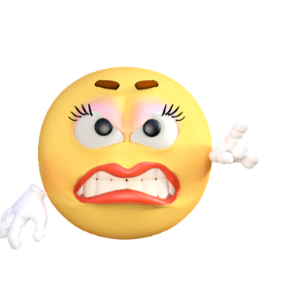 | INTERROGATIVE MOOD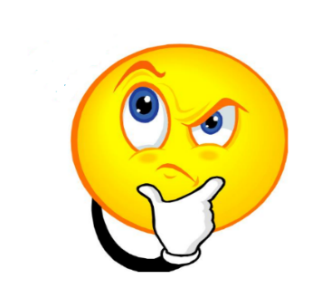
Matching Sentences | Matching Sentences | Matching Sentences

Emoji/sentence matching
Match the sentences below to their sentence mood.

You better do as I say! | Please get me some water. | Today is so cool! | It’s a great day for a movie.
Where are you going? | Get back in line! | I’m satisfied with that grade. | Come back here.
When will I study for that test? | You are a good friend. | Please listen. | I will be back soon.
What were you thinking about just now?

