WHAT IS A SALT MARSH?

Salt marshes are coastal wetlands that are flooded and drained by salt water brought in by the tides.
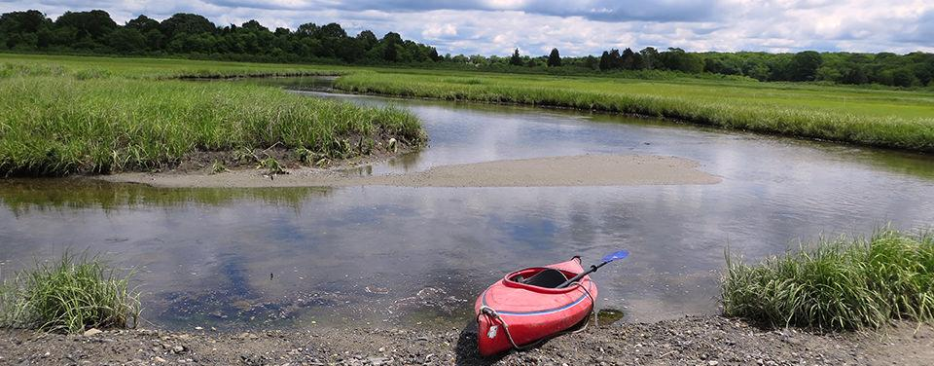
IMAGE: Salt marsh within Narragansett Bay National Estuarine Research Reserve. Salt marshes are coastal wetlands which are flooded and drained by tides.
Salt marshes are coastal wetlands that are flooded and drained by salt water brought in by the tides. They are marshy because the soil may be composed of deep mud and peat. Peat is made of decomposing plant matter that is often several feet thick. Peat is waterlogged, root-filled, and very spongy. Because salt marshes are frequently submerged by the tides and contain a lot of decomposing plant material, oxygen levels in the peat can be extremely low—a condition called hypoxia. Hypoxia is caused by the growth of bacteria which produce the sulfurous rotten-egg smell that is often associated with marshes and mud flats.
STOP AND JOT

Salt marshes occur worldwide, particularly in middle to high latitudes. Thriving along protected shorelines, they are a common habitat in estuaries. In the U.S., salt marshes can be found on every coast. Approximately half of the nation's salt marshes are located along the Gulf Coast.

These intertidal habitats are essential for healthy fisheries, coastlines, and communities—and they are an integral part of our economy and culture. They also provide essential food, refuge, or nursery habitat for more than 75 percent of fisheries species, including shrimp, blue crab, and many finfish.
STOP AND JOT

Salt marshes also protect shorelines from erosion by buffering wave action and trapping sediments. They reduce flooding by slowing and absorbing rainwater and protect water quality by filtering runoff, and by metabolizing excess nutrients.
STOP AND JOT

US Department of Commerce, N. O. and A. A. (2013, June 1). What is a salt marsh?. NOAA’s National Ocean Service. https://oceanservice.noaa.gov/facts/saltmarsh.html

SALT MARSHES
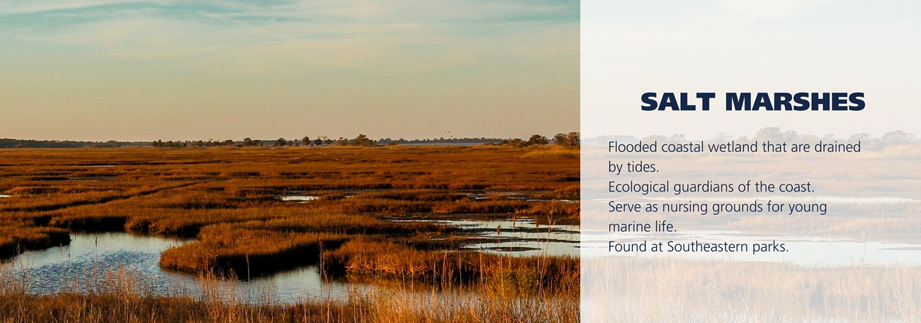

Salt marshes are coastal wetlands that are flooded and drained by tides. They grow in marshy soils composed of deep mud and peat. Peat is made of decomposing plant matter in layers several feet thick. Since salt marshes are often submerged by the tides and contain a lot of decomposing material, oxygen levels in the peat can be extremely low. These conditions give salt marshes their reputation for sometimes exuding a rotten-egg odor.
STOP AND JOT

Although not always pleasing to our human sense of smell, salt marshes are the “ecological guardians of the coast” that maintain healthy fisheries, coastlines and communities. They provide shelter, food and nursery grounds for more than 75% of coastal fisheries species including shrimp, crab and many finfish. Salt marshes also protect shorelines from erosion by creating a buffer against wave action and by trapping soils. In flood prone areas, salt marshes reduce the flow of flood waters and absorb rainwater. By filtering runoff and excess nutrients, salt marshes also help to maintain water quality in coastal bays, sounds and estuaries. Salt marshes and other coastal wetlands also serve as “carbon sinks,” holding carbon that would otherwise be released into the atmosphere and contribute to climate change.
STOP AND JOT

The U.S. has experienced tremendous losses of freshwater and coastal wetlands since the early 20th century, primarily from construction, development and habitat loss. The U.S. Fish and Wildlife Service estimated that between 2004 and 2009 alone, wetlands in coastal watersheds declined by 360,720 acres or over 80,000 acres per year. The National Park Service puts a high priority on wetland protection and restoration. Coastal parks have made great strides in restoring damaged wetlands and reclaiming their remarkable values for our coasts.
STOP AND JOT

U.S. Department of the Interior. (n.d.). Salt marshes. National Parks Service. https://www.nps.gov/subjects/oceans/salt-marshes.htm

SALT MARSH KEYSTONE INITIATIVE

BETWEEN LAND AND SEA
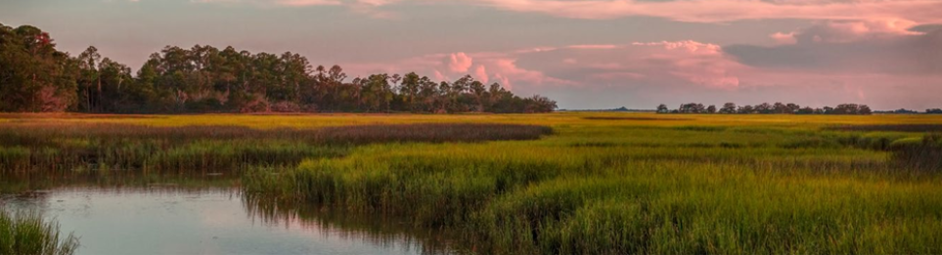
The mosaic of grassland, mud flats, and channels where the ocean meets the land is called a tidal wetland or salt marsh. These areas—which extend along the Atlantic coast, from the rocky shores of Maine to the expansive tidal wetlands of Florida—flood and drain twice daily with the tides. A globally rare ecosystem, salt marsh is home to unique, native species that can live nowhere else; many birds, fish, and other wildlife rely on salt marshes, including most commercial and recreational species that support a multi-billion-dollar industry. These marshes buffer coastal communities—and billions of dollars in infrastructure—from flooding due to major storms, which are intensifying due to climate change. Additionally, salt marshes store carbon at a rate 50 times greater than terrestrial forests, making them critical to lessening the effects of climate change.
STOP AND JOT

These important ecosystems are disappearing due to development and climate change, and over the last decade, the United States has led the world in rates of salt marsh loss.
To help bring back this ecosystem, as part of the Department of the Interior’s Restoration and Resilience Framework funded by President Biden’s Investing in America agenda, we launched the Salt Marsh Keystone Initiative. The initiative will work with partners to advance nature-based solutions that increase resilience, protect important natural carbon storage opportunities, conserve fish and wildlife habitats, and promote local economies.
STOP AND JOT

Despite the significant losses in salt marsh habitat, there are bright spots: restored marshes are better equipped to adapt to sea-level rise and scientists have developed and honed successful techniques to restore these complex ecosystems from centuries of human impact. Restoring degraded marshes and protecting marsh-migration pathways in adjacent uplands are the two essential strategies to protecting our coastlines for humans and wildlife.
The U.S. Fish and Wildlife Service and its partners have already effectively restored parts of the coastline, which has enabled vegetation to return and flourish, and increased community resiliency to flooding. Partners along the Atlantic Coast are collaborating to further restore and enhance salt marshes to protect the people, fish, and wildlife that depend on them, and to protect migration pathways for marsh as sea levels continue to rise.
STOP AND JOT

U.S. Department of the Interior. (n.d.). Salt Marsh Keystone Initiative Between Land and Sea.

