What Numbers Work

Inequality: 3x + 5 > 20
Works | Doesn’t Work

Show the numbers that work on the number line.
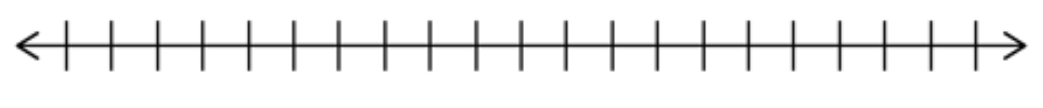
Why do certain numbers not work?

Inequality: 4x – 5 < 39
Works | Doesn’t Work

Show the numbers that work on the number line.
Why do certain numbers not work?

Inequality: 2x + 7 ≥ 21
Works | Doesn’t Work

Show the numbers that work on the number line.
Why do certain numbers not work?

Inequality: 12 ≤ 4x – 8
Works | Doesn’t Work

Show the numbers that work on the number line.
Why do certain numbers not work?

My Rules for Graphing Inequalities:

Additional Rules for Graphing Inequalities:

