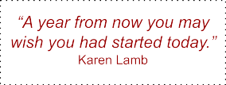
MY MATH GOALS:
“I AIN’T AFRAID OF NO MATH”
After completing this handout, post it somewhere you’ll see it every day. This will serve as a daily reminder to stay on track toward completing your goals for the year.

Reflection
Biggest Success: List one highlight of last school year you are most proud of? Celebrate it!

Biggest Failure: Failures are wonderful opportunities for growth. Acknowledge them and learn. What would you do differently now? Did you learn any lessons?

This Year’s Goals
A SMART goal is:
- Specific—Who/what/where/why/which?
- Measurable—How will I know when it is accomplished?
- Achievable—How realistic is the goal?
- Relevant—Does this seem worthwhile?
- Time bound—When will I reach this goal by?

Goal #1 | Goal #2 | Goal #3
Deadline: | Deadline: | Deadline:
Reward: | Reward: | Reward:
Completed: | Completed: | Completed:

