Note Catcher

Choose three careers and take notes on the salary expectations, possible school options, necessary skills, certification requirements, and availability for each.

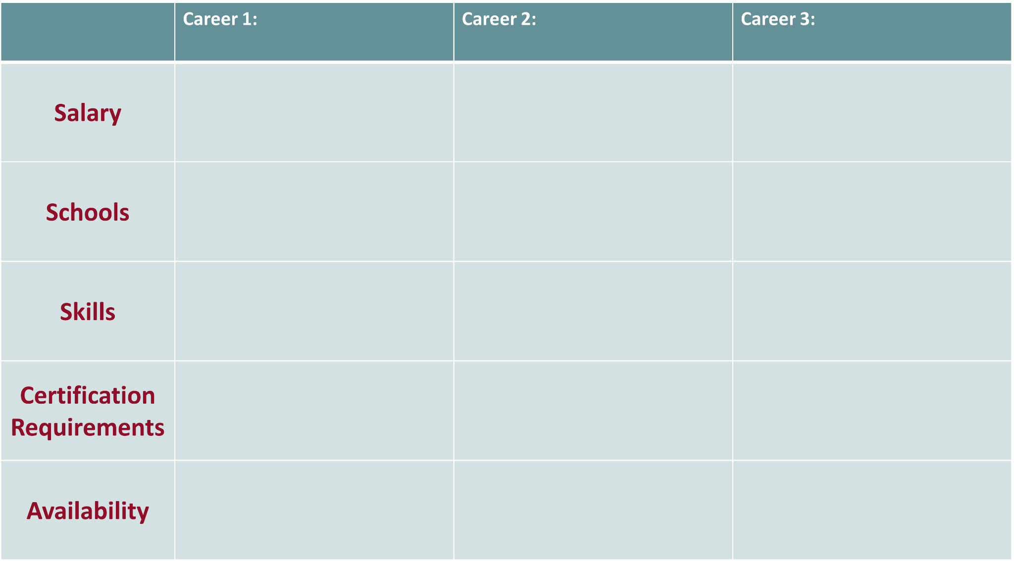

**Reflection**

*Based on my research and discussion with a significant person in my life, my next steps towards a successful career are...*