BEYOND FIRE AND FURY: A CULTURAL HISTORY OF DRAGONS
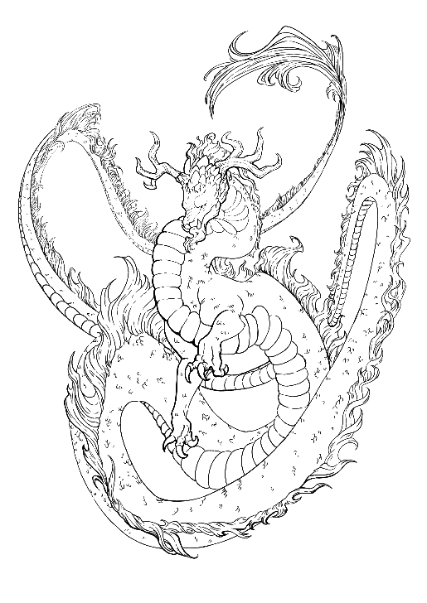
The Eastern Dragon
In countries across Asia, most notably China, the symbol of the dragon reigns above all other animal symbolism. It is seen in China’s earliest tales and legends. Even before writing, as early as 4500 B.C.E., dragon carvings were created, carved in precious stones like jade and etched in rock and wood.
The Chinese dragon, called loong in China, has many animal characteristics. Images in early art and literature often show the dragon with the horns of a stag, the forehead of a camel, the eyes of a demon, the neck of a snake, the belly of a sea monster, the scales of a carp, the claws of an eagle, the pads of a tiger, and the ears of an ox. There are four reliable theories for how the loong came to be: first, it was a deified snake whose anatomy is a collage of otherworldly animals (based upon how, as ancient Chinese tribes merged, so did the animal symbols that represent them); second, it was a callback to the Chinese alligator found and revered in parts of China; third, it was a reference to thunder and a harbinger of rain; and lastly, it was a by-product of nature worship.
Most of these theories point to the dragon’s supposed influence on water. Because they were believed to be gods of that element, they became the farmer’s symbol for a bountiful harvest. Some experts have said that across regions, ancient Chinese groups continued to enrich the dragon image with features of animals most familiar to them—for example, those living near the Liaohe River in northeast China integrated the hog into the dragon image, while people in central China added the cow, and up north where Shanxi is now, earlier residents mixed the dragon’s features with those of the snake.
Dragons are so important to Chinese culture that in their zodiac, which cycles every twelve years with a different animal, people born in a dragon year are believed to be lucky. Dragons may only seem to be mythological creatures, but they are so significant to China that they are included in important festivals, like the Chinese New Year. During the fifteen-day New Year festival, sometime from January to February, the most notable tradition is the elaborate dragon dance. It involves a team of dancers carrying a large red, dragon puppet.
Although dragons are depicted in many colors (for example white representing purity, yellow dragons symbolizing power, and black dragons suggesting vengeance), the red dragon represents good fortune and prosperity, most important to the New Year. Prosperity is deeply important to Chinese culture because it is seen as a foundation for social harmony, a means to achieve a better life for all, and a symbol of national strength. The social value of good fortune also has historical roots, revealing a desire to overcome hardship and poverty, which China had known for much of its history.
There are also literary descendants of the dragon in the written literature of China. One of the oldest is the classic novel Journey to the West, published in the 16th century by Wu Cheng’en. This early novel tells the story of Tang Zhanzang, a Buddhist monk who travels to India to bring sacred scriptures back to China. During the long journey, he meets four shape-shifting dragon kings and one of the dragon’s sons who transforms into the White Dragon Horse that Tang rides for the rest of his journey.
Dragons continue to populate contemporary literature. A recent work by Cynthia Zhang, a Chinese American, brings her Chinese heritage to her fantasy novel, After the Dragons (2021). It explores the concept of dragons in contemporary Chinese society, delving into themes of cultural identity and the legacy of mythical creatures. The story describes the plight of aquatic dragons in Beijing threatened by climate change.
Historically, the Chinese dragon has served as an important symbol in history and culture. The dragon’s influence is seen not only in China, but across other Asian countries like South Korea, Vietnam, and Japan. Celebrated in art, festivals, and literature, the dragon interacts with humans in a variety of ways, revealing their magical powers in gifts or challenges to the humans they encounter.
The Western Dragon
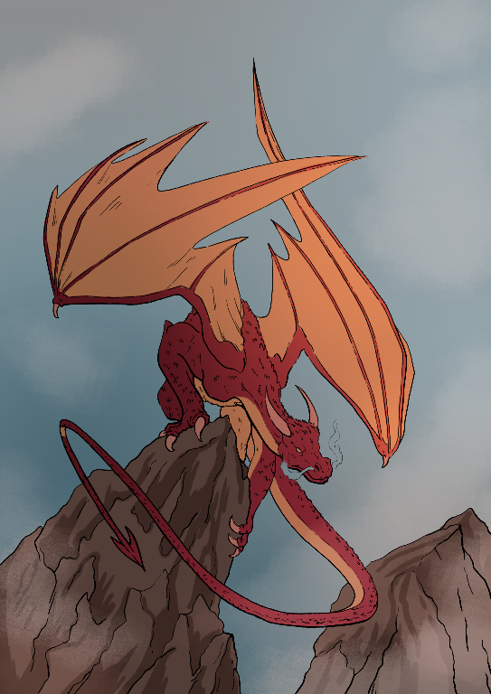
One of the most common types of dragons known in the Western world is the evil dragon. It is large, fire-breathing, scaly, horned, lizard-like with leathery, bat-like wings, four legs, and a long muscular tail. This type of dragon developed in part from Christian theology with its duality of good versus evil. The dragon symbolized sin and satan. In fact, the word dragon comes from the Greek word for serpent, drakōn. Scholars believe that at least some of the characteristics of the dragon may also tie into early Christian descriptions of the seven deadly sins—pride, greed, wrath, envy, lust, gluttony, and sloth. The Western dragon hordes and guards gold, terrorizes good people, and threatens godly heroes.
The earliest known story about dragons in the Christian tradition is the oral story of St. George and the dragon. Many of the features of the dragon, fire-breathing and scaly for example, appear in it. In the original early Christian saint’s tale, St. George saves a princess from the dark, evil dragon who is terrorizing an entire town with extortion. Each day the dragon requires golden trinkets, livestock, and eventually human beings or they will receive its fiery wrath. As in many Christian saint’s tales, good triumphs over evil as Saint George promises to kill the beast—if all the townspeople will convert to Christianity. Once he has accomplished his holy mission, St. George kills the dragon with his sword.
Although the St. George and the dragon tale is recorded as early as the 11th century, it reached Medieval Europe through the Crusades in the 12th. Crusading knights believed that Saint George fought alongside them against the infidel, sinners defeated by the moral goodness of the Crusaders. By the 13th century, the character of the dragon was well-established in both literature and art. The image of St. George slaying the dragon was seen throughout Europe in paintings, etchings, woodblocks, and stone. These images symbolized the triumph of good over evil, the victory of virtue over vice.
By the late Middle Ages and Renaissance, dragons continued to be depicted as the enemies of good in oral and written legend. In the Arthurian legends, for example, the “Great Dragon” attempts to defeat idyllic Camelot, threatening it with its fiery wrath. Merlin joins King Arthur to defeat the dragon. Once more evil is overcome.
In the Renaissance, tales of dragons grew more sophisticated, as in an epic poem called The Faerie Queen (1596) by Edmund Spenser. In Spenser’s imagination, the dragon has grown to the size of a hill and is twice as fearsome. As in the much earlier St. George and the Dragon story, the dragon threatens more than an individual, this time a castle. The dragon has vast wings, sulfurous smoke coming from its nostrils, huge talons, and a deadly, barbed tail. The dragon, the very image of vice, is defeated by a virtuous hero, the Red Cross Knight, but only after a grueling battle. For a Renaissance writer like Spenser, the battle is more an allegory than a plot device. During this time, people focused more on human thoughts and feelings. From this perspective, the dragon represented an inner struggle that a person had to conquer to grow and reach their full potential.
More contemporary encounters with dragons occur in fantasy literature. Most famous is J.R.R. Tolkien’s Smaug from The Hobbit (1937). He is a winged, red dragon who steals and hoards the dwarves' jeweled treasure, driving them away from their Lonely Mountain home. The small and unassuming hero, Bilbo Baggins, helps defeat Smaug by knowing where the weakest point in the dragon’s scales is. Tolkien briefly mentions six dragons in the three books of The Lord of the Rings (1954). In his many other writings about Middle Earth, Tolkien introduces the dragon Glaurung. He has traditionally Western dragon characteristics. He is four-legged and breathes fire, though flightless.
Evil dragons are recorded in every country in Europe, including Great Britain, Italy, Spain, Russia, Ukraine, and Poland. Icons of sin, darkness, or paganism in the Western and Christian traditions, the dragon can tempt as well as defeat the unguarded, or unprepared. The Western dragon is a formidable, external foe, only defeated by a strong human hero.
The Companion Dragon
The kind of dragon who lets a hero ride and guide them can be described as a companion dragon. As a companion, the traditional, evil dragon has been tamed in current stories, changed from a beast to be slain to a beast that bonds with its human hero. Since the 1960s, the stable image of the fire-breathing dragon has been adapted to reveal the connection between people and other animals, even dragons. This contemporary perspective is guided by a reassessment of humans and their relationship with nature. Among these changes in the mid-twentieth century were animal rights activism and cultural upheaval. Uncertain of their place in the universe, having an all-powerful dragon as a pet alleviated a sense of powerlessness.
Made popular in America in the 1960s in books like Anne McCaffrey’s novel Dragonflight (1968), these dragons are large, bat-winged, and fire-spitting, but rather than being an enemy, they become friends. In this way, the archetype of the evil dragon, despite being thousands of years old, has been reversed in modern fantasy narratives. More than anything, this change came with new ideas about good and evil, a shift in power, and a fresh way of seeing the relationship between people and nature. Writers started exploring different viewpoints and recognizing the importance of other living things.
This new companion dragon can be tamed by a hero who taps into a telepathic relationship with the terrifying creature. The idea of a hero fighting from a dragon’s back—popularized by McCaffrey—has become prevalent in modern fiction in books, manga, anime, films, and video games. In many of these stories, dragons let the rider fly above their enemies, both to see their battle strategies or to punish them. The dragon rider in these stories has a built-in fire-powered weapon.
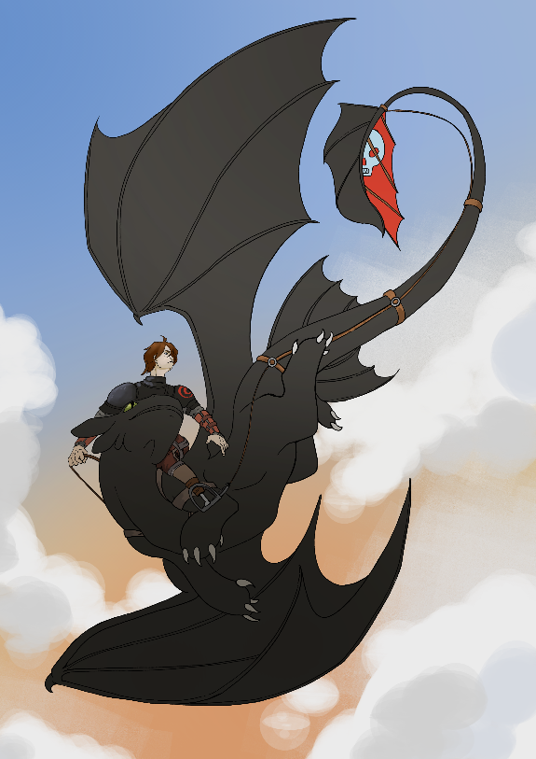
Dragon-riding can also show who has the right to lead or reign. This is true for Hiccup, the unlikely hero of the animated film How to Train Your Dragon (2010), as well as for Daenerys Targaryen in the popular television series Game of Thrones (2011-2019). When Hiccup, upon the back of Toothless, shows the Vikings what dragon and human cooperation can do, his worthiness as a ruler and future chief of his tribe is revealed. Similarly, when Daenerys arrives on the back of her black dragon Drogon in Westeros, the land of her ancestors, many submit to her as the true heir to her dynasty.
The bonds between dragon and dragon rider can only be described as magical. The human and the beast can communicate and share emotions telepathically. Together they form a whole. Because of the dangerous, wild nature of the dragon, this bond can be hazardous, especially for the dragon. In many stories, once the bond is broken, the companion dragon dies.
As a companion, the traditional, evil dragon has been tamed in current stories, changed from a beast to slay to a beast that bonds with its human hero. Since the 1960s, the stable image of the fire-breathing dragon has been adapted to reveal the connection between people and other animals, even dragons. Dragons are no longer the terrifying monsters at the edge of the world. Dragon stickers, dragon costumes, and dragon cartoons reveal a shifted perspective.
The Egyptian Dragon
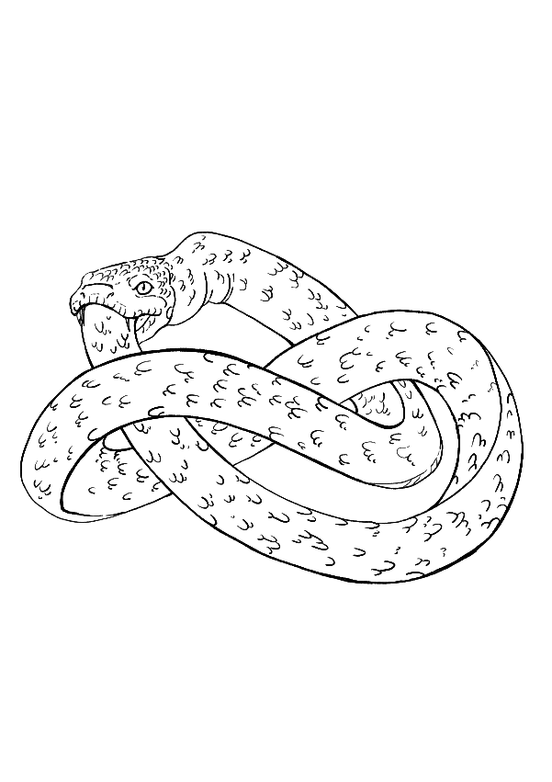
Egyptian dragons come in many visual forms and are a part of many mythological tales from Egypt. In this tradition, dragons often have serpent-like characteristics. One famed creature is the ouroboros, an ancient symbol of a serpent eating its own tail. In an ancient burial text called the Enigmatic Book of the Netherworld (14th century B.C.E.), two ouroboros surround the figure of Ra, the Sun god. Ra was considered the creator of all life, and as he created the seasons, plants, animals, and even humans, he was the central god of ancient Egyptian culture. From what Egyptologists can tell, the ouroboros protected and guided Ra on his many journeys. So, too, could it guide humans in their journey to the afterlife.
Beyond its association with the powerful Ra, the ouroboros is believed to be connected to a central belief of ancient Egypt: the eternal cycle of life, death, and rebirth. A visual representation of the ouroboros was found in the tomb of King Tutankhamun in the 13th century B.C.E. It is a positive symbol of the afterlife, a force for good.
The resilient form of the ouroboros moved from ancient Egypt to Greece, where it got its Greek name ouro (tail) and boros (eating), and later to Rome. In both Greek and Roman cultures, the image became associated with magic. It appeared on talismans, objects attributed with powers to heal or protect their owner or wearer. From Rome to other parts of Europe, the tail-eating serpent began to appear with more dragon-like features.
By the 15th century, the ouroboros from ancient Egypt had become a pre-scientific symbol for magic and even healing. In a manuscript on alchemy—a kind of early form of chemistry—called Aurora Consurgens (circa 1400), the ouroboros had the distinctive head of a dragon, flames, and all. Alchemists, who searched for the elixir of life and the cure for illness, regarded the circular figure as an allegory for the unity of time, the concept of endless return, and the emblem of eternity.
In modern fantasy literature, books like E.R. Eddison’s The Worm Ouroboros (1922) and Michael Ende’s The Never-Ending Story (1979) use the circular dragon concept in their narratives. In Eddison’s high fantasy novel, where a war between demons and witches is the central conflict, the King of Witchland, Gorice, wears an ouroboros as a talisman against the dark demons. In Ende’s fantasy, Auryn is a magic medallion in the shape of the ouroboros that protects its wearers from harm.
Dragons from Egypt have influenced art, literature, and life. Today, the ouroboros is a popular tattoo. As for the ancient Egyptians, it could symbolize unity, protection or guidance, the eternal nature of renewal, and the interconnectedness of all things. Resilient and compelling, it continues to appeal at an unconscious level to the contemporary world.

Resources
Art in Tuscany. (n.d.). Traveling in Tuscany. http://www.travelingintuscany.com/art/art/goldenlegend.htm

Bekhrad, J. (2017, December 4). The ancient symbol that spanned millennia. BBC. https://www.bbc.com/culture/article/20171204-the-ancient-symbol-that-spanned-millennia
Britannica, T. Editors of Encyclopaedia (2024, October 11). dragon. Encyclopedia Britannica. https://www.britannica.com/topic/dragon-mythological-creature

Britannica, T. Editors of Encyclopaedia (2024, October 25). Ouroboros. Encyclopedia Britannica. https://www.britannica.com/topic/Ouroboros
Cartwright, M. (2017, September 19). The dragon in ancient China. World History Encyclopedia. https://www.worldhistory.org/article/1125/the-dragon-in-ancient-china/
Chinese dragons: their types, history, and symbolism (2024, 14 October). Chinese Language Institute. https://studycli.org/chinese-culture/chinese-dragons/#The_Origins_of_Chinese_Dragon_Legends

Kramer, Samuel Noah. (1944, revised 1961). The myths of Kur. Sumerian Mythology. https://sacred-texts.com/ane/sum/sum08.htm

McLean, A. (n.d.). Alchemical symbolism. The Alchemy Website. https://www.alchemywebsite.com/Alchemical_Symbolism_Triple_headed_snakes.html
McNeil, D. (2003, April 29). Dragons, a brief history long in miles. The New York Times. https://www.nytimes.com/2003/04/29/science/dragons-a-brief-history-long-in-miles

Sheridan, Brendan. (2016). Dragon-riding: Live and let fly. Fafnir: Nordic Journal of Science Fiction and Fantasy Research, 3(3), 19–30. https://researchcommons.waikato.ac.nz/server/api/core/bitstreams/c43deb88-7840-4909-9069-1b9a7841b30f/content
St. Margaret the Virgin. (n.d.). Catholic Online. https://www.catholic.org/saints/saint.php?saint_id=19

