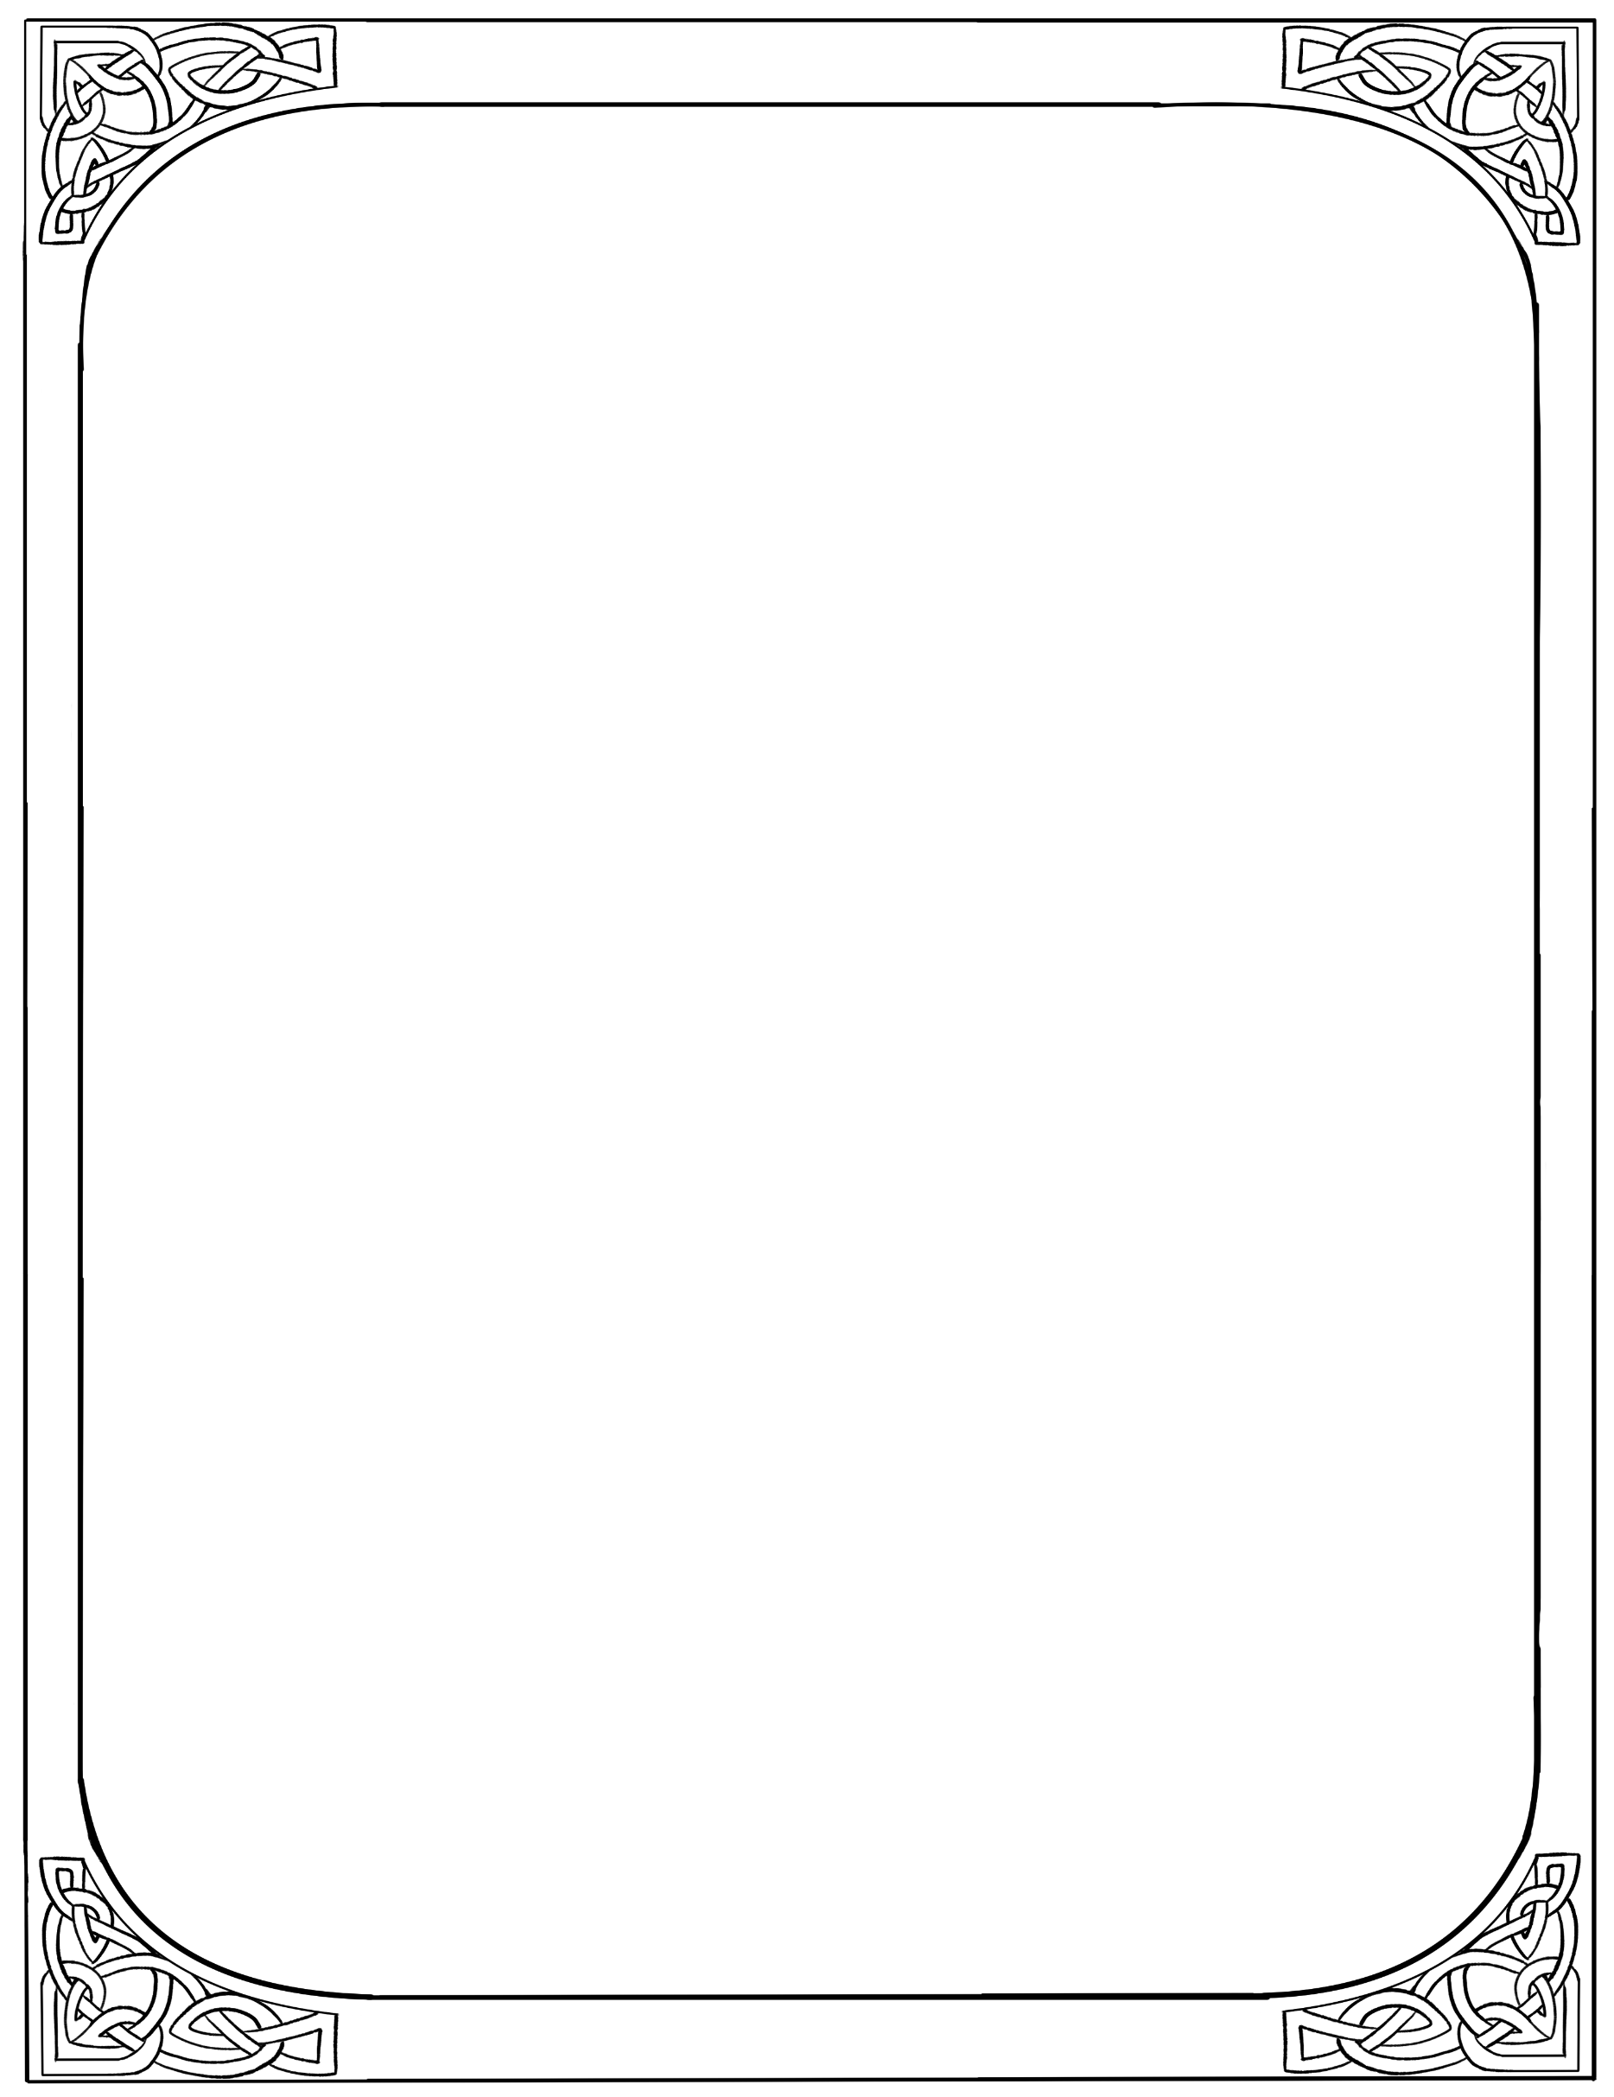
ONE-PAGER

What does your dragon look like?
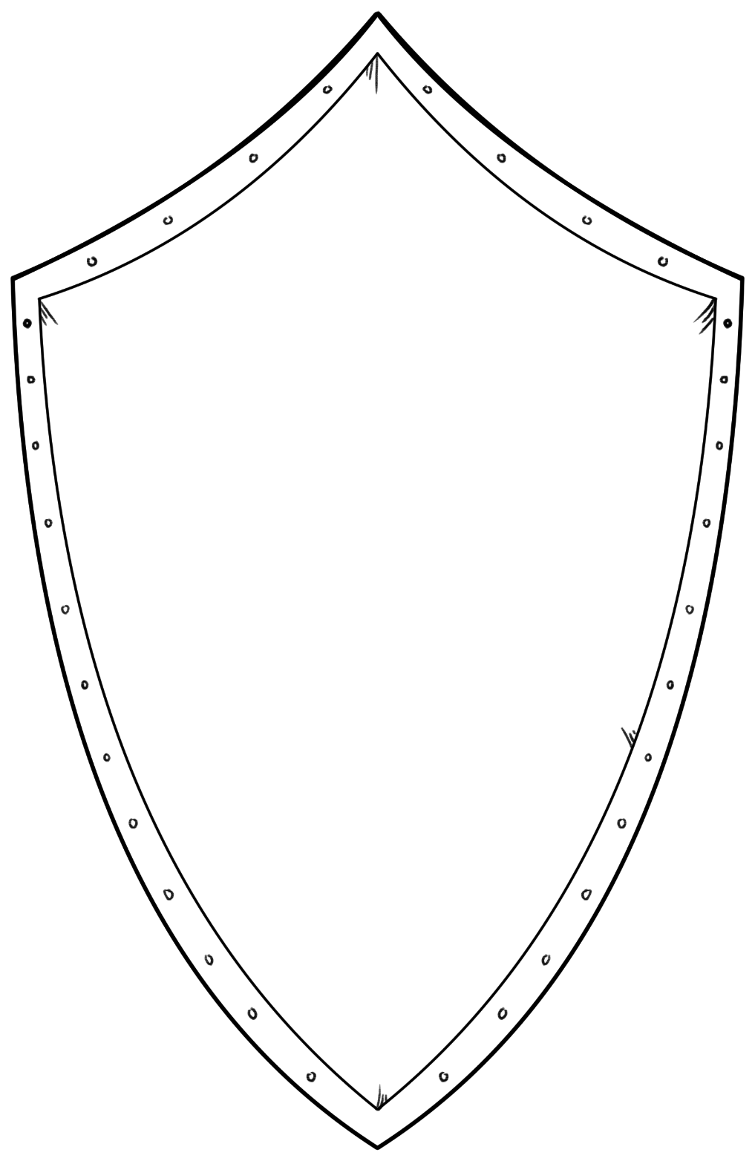
What is the cultural significance of your dragon?
Draw your dragon!

How does your dragon interact with people?

What’s your dragon’s personality like?

