Matching Cards
4:30 PM | 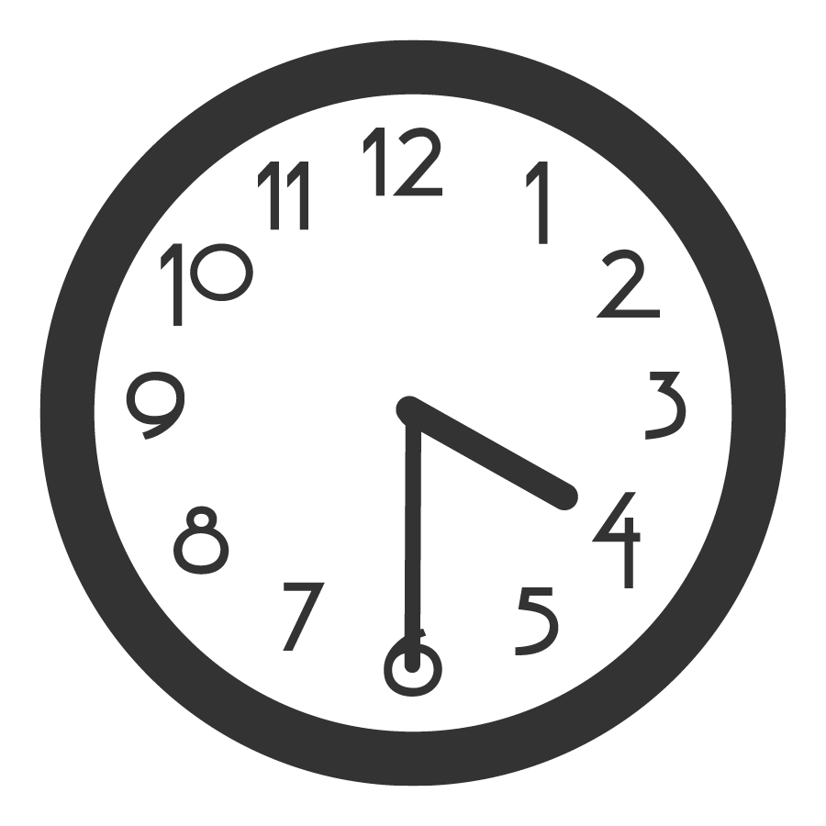 | Four thirty in the afternoon
1:15 PM | 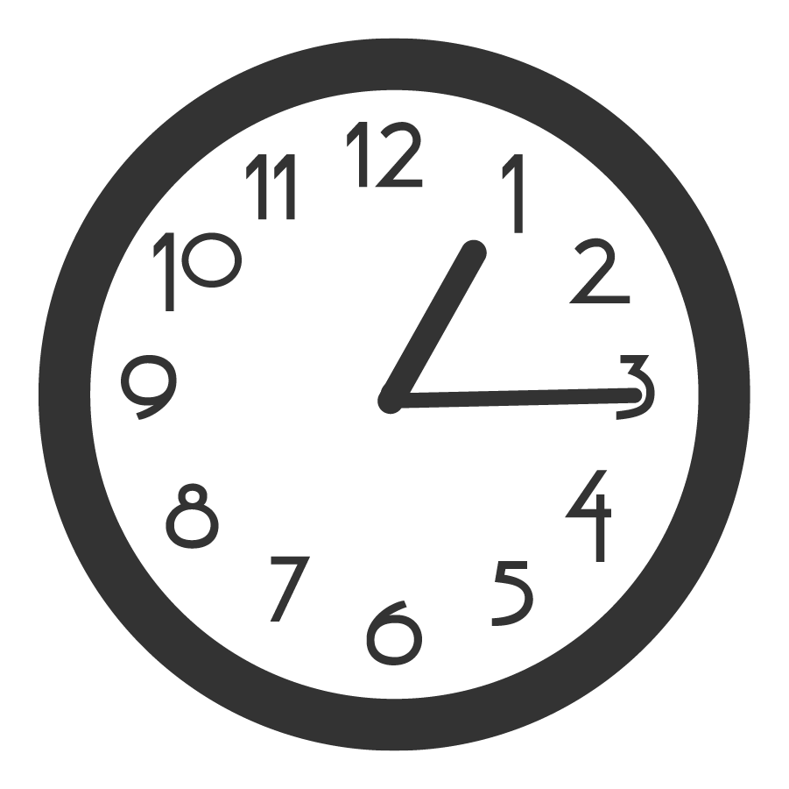 | One fifteen in the afternoon
1:45 AM | 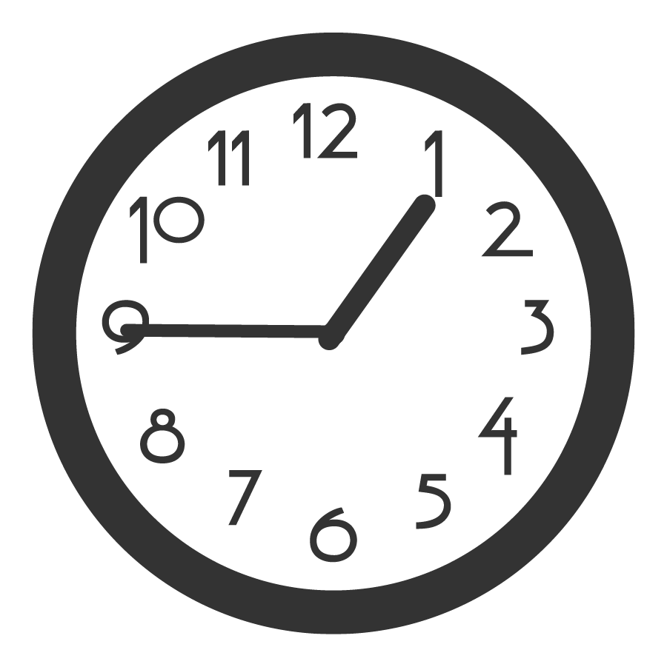 | One forty-five in the morning
7:00 AM | 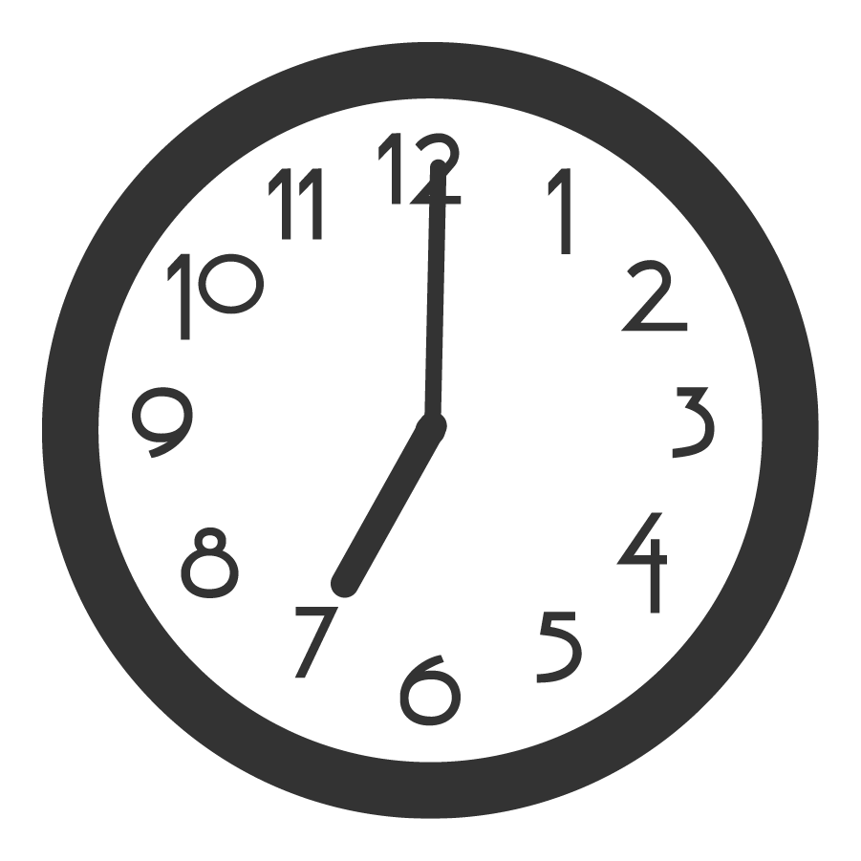 | Seven o’clock in the morning
7:00 PM |  | Seven o’clock in the evening
10:30 AM | 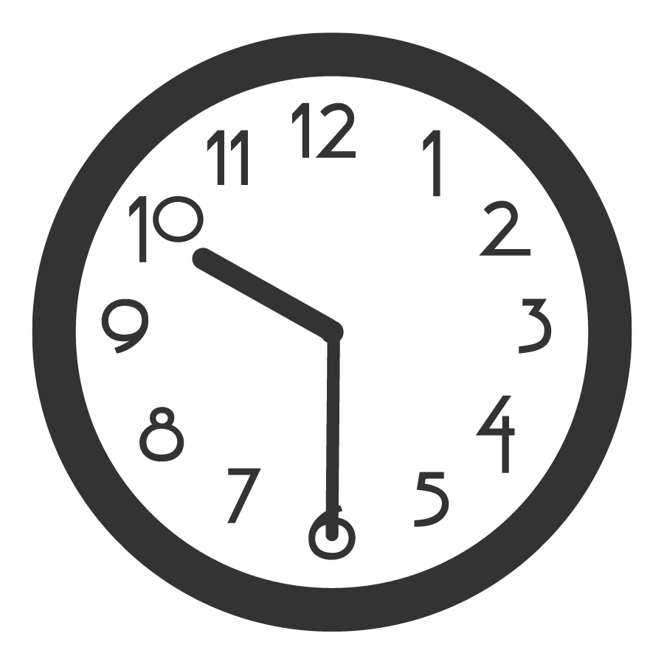 | Half past ten in the morning
8:45 PM | 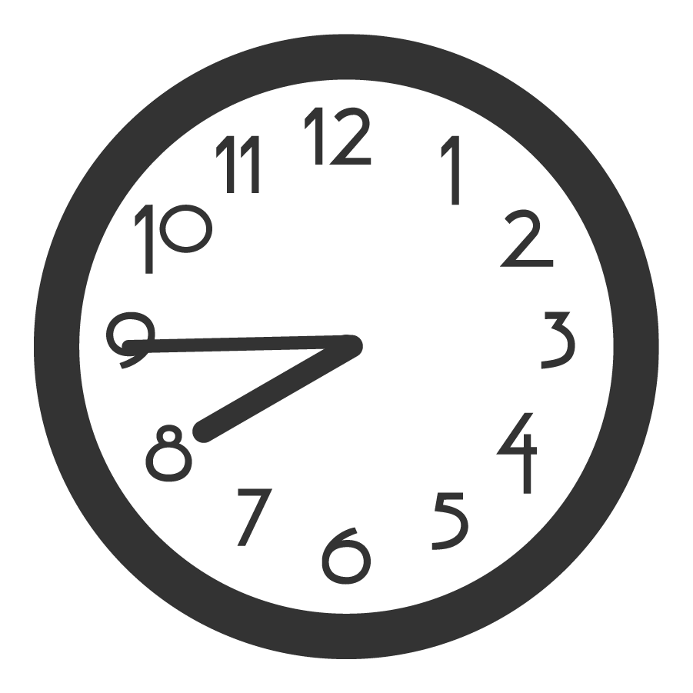 | Quarter ‘til eight in the evening
12:00 PM | 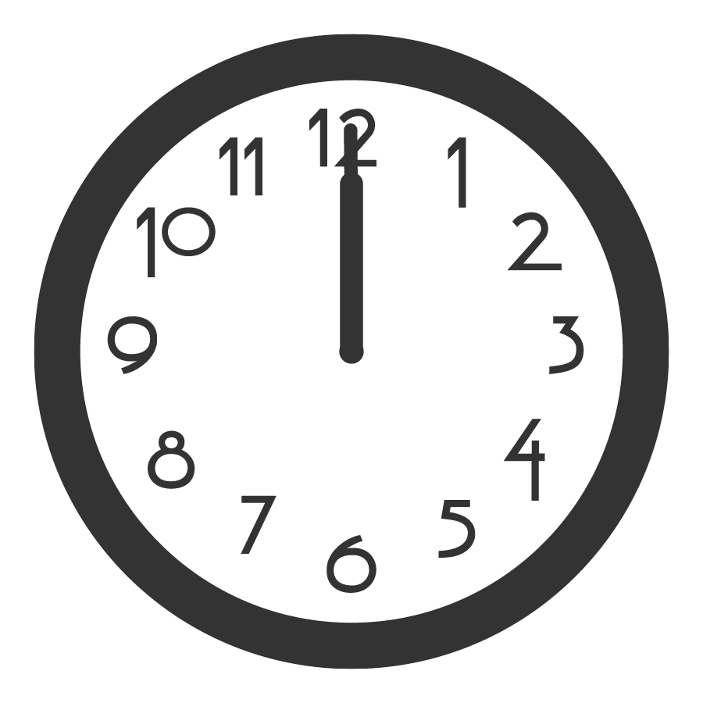 | Noon
12:00 AM |  | Midnight
2:15 PM | 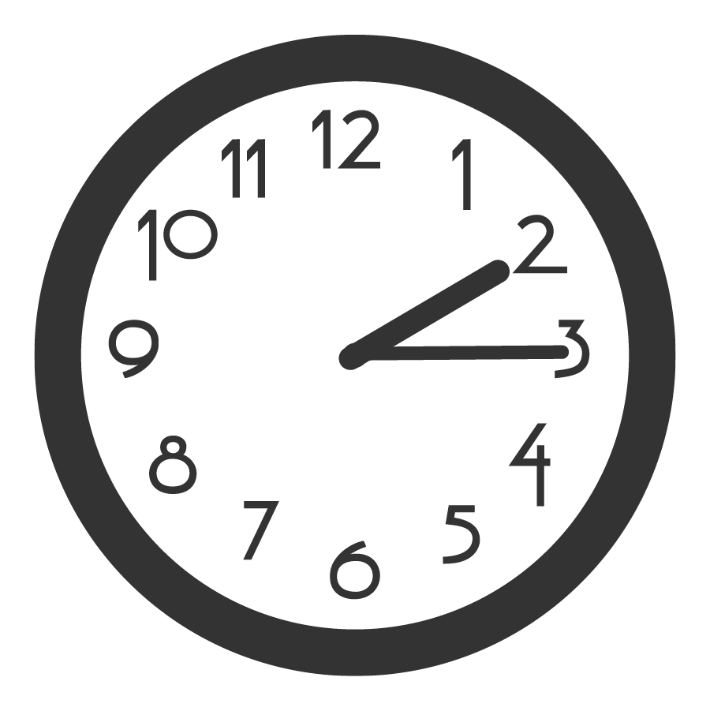 | Quarter after two in the afternoon

