Schedule template
__________________’s Schedule
Digital | Analog | Activity
: AM/PM | 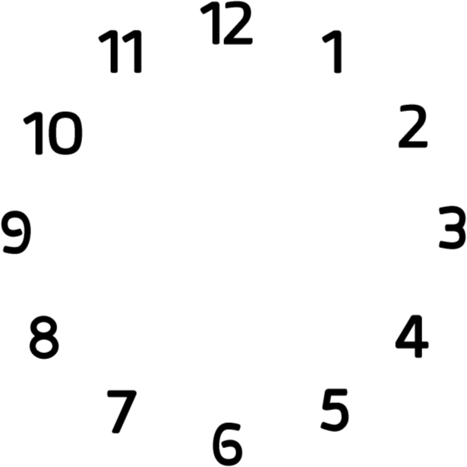

: AM/PM

: AM/PM

: AM/PM

: AM/PM

