Ecosystems Card Sort
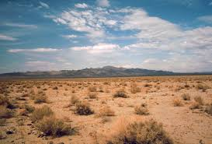 | 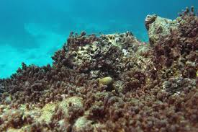
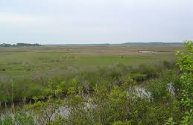 | 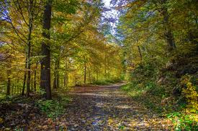
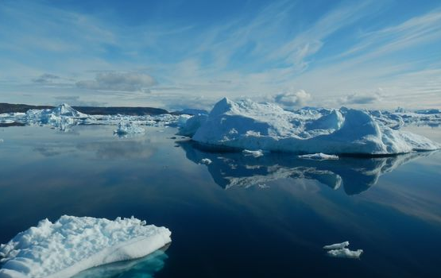 | 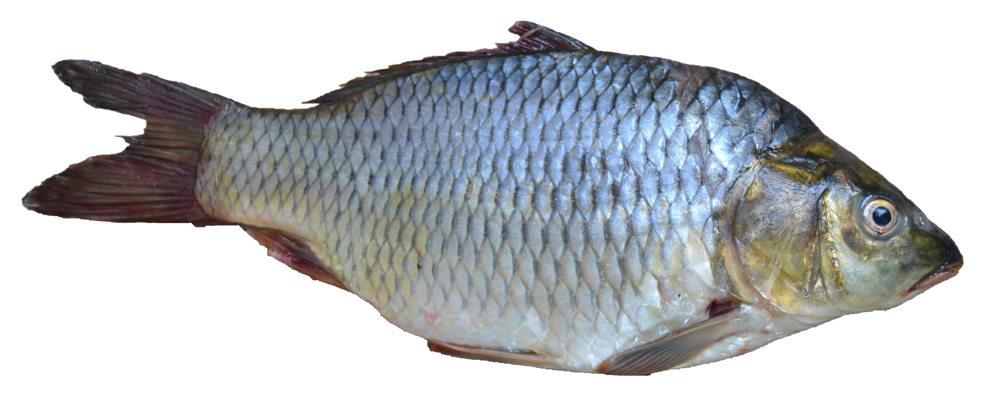
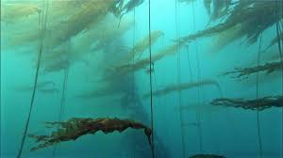 | 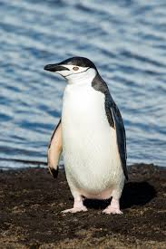
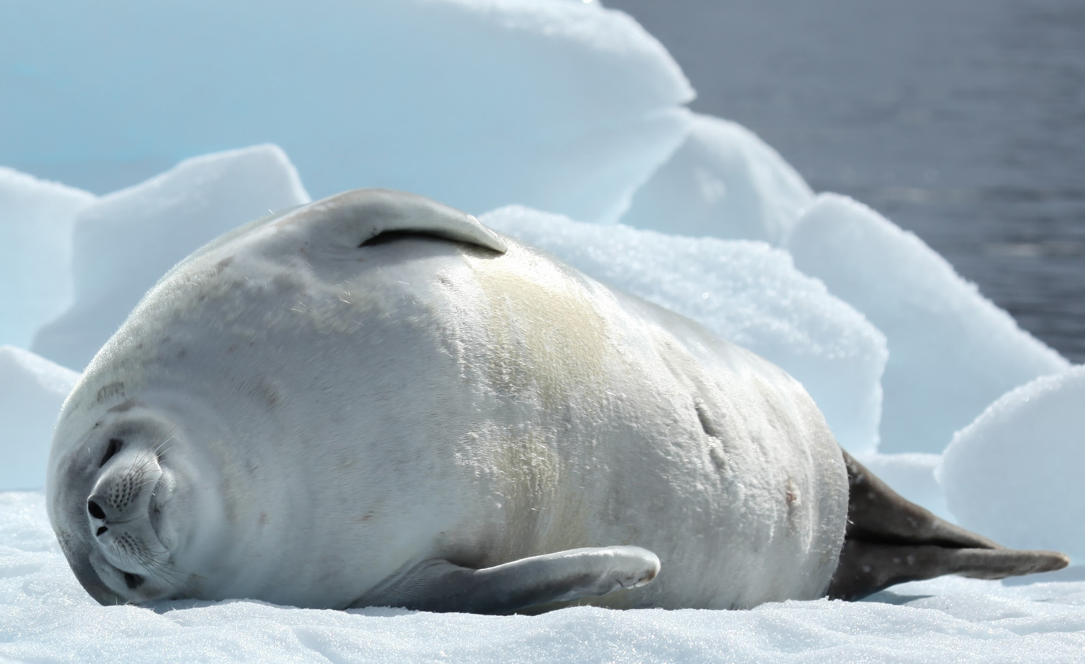 | 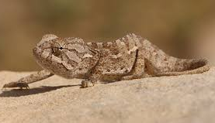
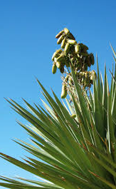 | 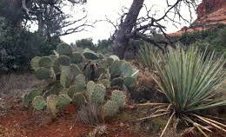
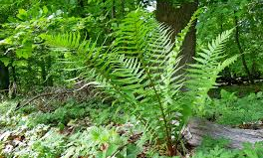 | 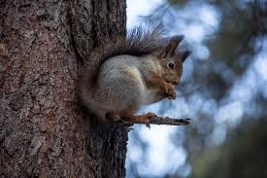
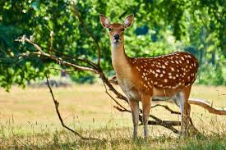 | 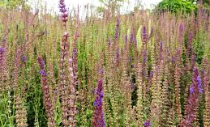
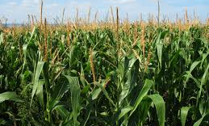 | 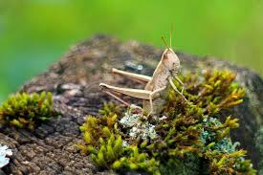
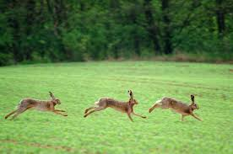 | 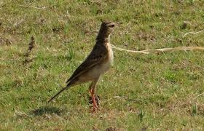

Image Sources
Halun, J. (2014, April 27). Running hares [Image file]. Retrieved from https://en.wikipedia.org/wiki/European_hare
NakNakNak (n.d.). Roe deer [Image file]. Retrieved from https://pixabay.com/photos/animal-roe-deer-forest-wild-mammal-3606918/
NASA Jet Propulsion Laboratory-Caltech (2015). Greenland’s southwestern coastline [Image file]. Retrieved from https://www.jpl.nasa.gov/edu/teach/activity/whats-causing-sea-level-rise-land-ice-vs-sea-ice/
National Park Service (n.d.). Kelp forests [Image file]. Retrieved from https://www.nps.gov/glba/learn/nature/kelp-forest.htm
National Park Service (n.d.). Yucca plant [Image file]. Retrieved from https://www.nps.gov/articles/uplands-monitoring-sonoran-desert.htm
Niko_Shogol (n.d.). Squirrel [Image file]. Retrieved from https://pixabay.com/photos/squirrel-forest-animals-nature-2125020/
Picryl (2016). Field grasshopper [Image file]. Retrieved from https://picryl.com/media/caelifera-grasshopper-field-grasshopper-animals-f7ff4b
Picryl (2016). Field pipit [Image file]. Retrieved from https://picryl.com/media/pipit-paddy-field-pipit-karnataka-animals-090e8e
Pxhere (2017, March 16). Corn field [Image file]. Retrieved from https://pxhere.com/en/photo/1159860
Pxhere (2017, Feb. 11). Field of lavender [Image file]. Retrieved from https://pxhere.com/en/photo/681184
Pxhere (2017, Jan. 12). Forest [Image file]. Retrieved from https://pxhere.com/en/photo/340781
Pixnio (2017, Aug. 19). Underwater coral reef [Image file]. Retrieved from https://pixnio.com/nature-landscapes/underwater/underwater-coral-reef-fish-sea-ocean-ecosystem
Pxhere (2017, March 6). Vascular plant [Image file]. Retrieved from https://pxhere.com/en/photo/1012492
Quinn, L. (2011, Jan. 24). Crabeater seal in Pléneau Bay, Antarctica [Image file]. Retrieved from https://en.wikipedia.org/wiki/Crabeater_seal#/media/File:Crabeater_Seal_in_Pl%C3%A9neau_Bay,_Antarctica_(6059168728).jpg
Roger469 (1982, Aug. 16). Death valley, desert, incoming near Shoshones [Image file]. Retrieved from https://en.wikipedia.org/wiki/File:Death_Valley,19820816,Desert,incoming_near_Shoshones.jpg
Sharp, C. J. (2018, May 11). Mediterranean chameleon [Image file]. Retrieved from https://commons.wikimedia.org/wiki/File:Mediterranean_chameleon_(Chamaeleo_chamaeleon_recticrista).jpg
Shughez (2018, Nov. 5). Arid desert plants [Image file]. Retrieved from https://pxhere.com/en/photo/1456153
Shiva, A. (2016, Jan. 18). Chinstrap penguin [Image file]. Retrieved from https://en.wikipedia.org/wiki/Penguin#/media/File:South_Shetland-2016-Deception_Island%E2%80%93Chinstrap_penguin_(Pygoscelis_antarctica)_04.jpg
U.S. Fish and Wildlife Service (n.d.). Coastal wetland [Image file]. Retrieved from https://www.fws.gov/chesapeakebay/
Viswaprabha (2011, Sept. 23). Fish - Puntius sarana from Kerala (India) [Image file]. Retrieved from https://commons.wikimedia.org/wiki/File:Fish_-_Puntius_sarana_from_Kerala_(India).png

