Cost of production Line Graph

**Scenario**

Imagine you are a small business owner who produces and sells hair products. You want to take a closer look at your fixed and variable costs and calculate the total cost of production to assess profitability and ensure you are pricing your product correctly.

Below is a line graph showing the relationship between your fixed cost and output, variable costs and output, and total costs and output. Use the graph to answer the questions by writing what you see and what it means. Record your number to the answer in the blank provided.

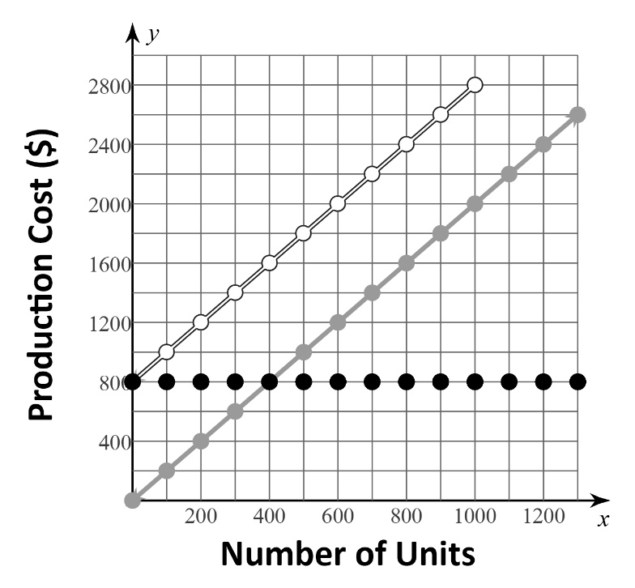

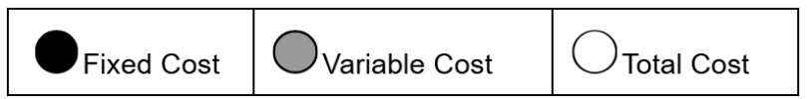

|  |  |
| --- | --- |
| 1. What is the fixed cost to produce 1200 units?**_____** | |
| What I see… | What it means… |

|  |  |
| --- | --- |
| 1. What is the fixed cost to produce 500 units?**_____** | |
| What I see… | What it means… |

|  |  |
| --- | --- |
| 1. What is the variable cost to produce 900 units? **_____** | |
| What I see… | What it means… |

|  |  |
| --- | --- |
| 1. What is the total cost to produce 900 units?**_____** | |
| What I see… | What it means… |

|  |  |
| --- | --- |
| 1. How much more is the variable cost to produce 800 units than the variable cost to produce 200 units?                                                                                              **____** | |
| What I see… | What it means… |

|  |  |
| --- | --- |
| 1. What is the total cost to produce 1300 units? Use the graph of fixed costs and variable costs.                                                                                                       **_____** | |
| What I see… | What it means… |

**What is your number sequence to the scavenger hunt?** ______________________