Cost of Production Line Graph
Scenario
Imagine you are a small business owner that produces and sells hair products. You want to take a closer look at your fixed and variable costs and calculate the total cost of production to assess profitability and ensure you are pricing your product correctly.
Below is a line graph showing the relationship between your fixed cost and output, variable costs and output, and total costs and output. Use the graph to answer the questions by writing what you see and what it means. Record your number to the answer in the blank provided.
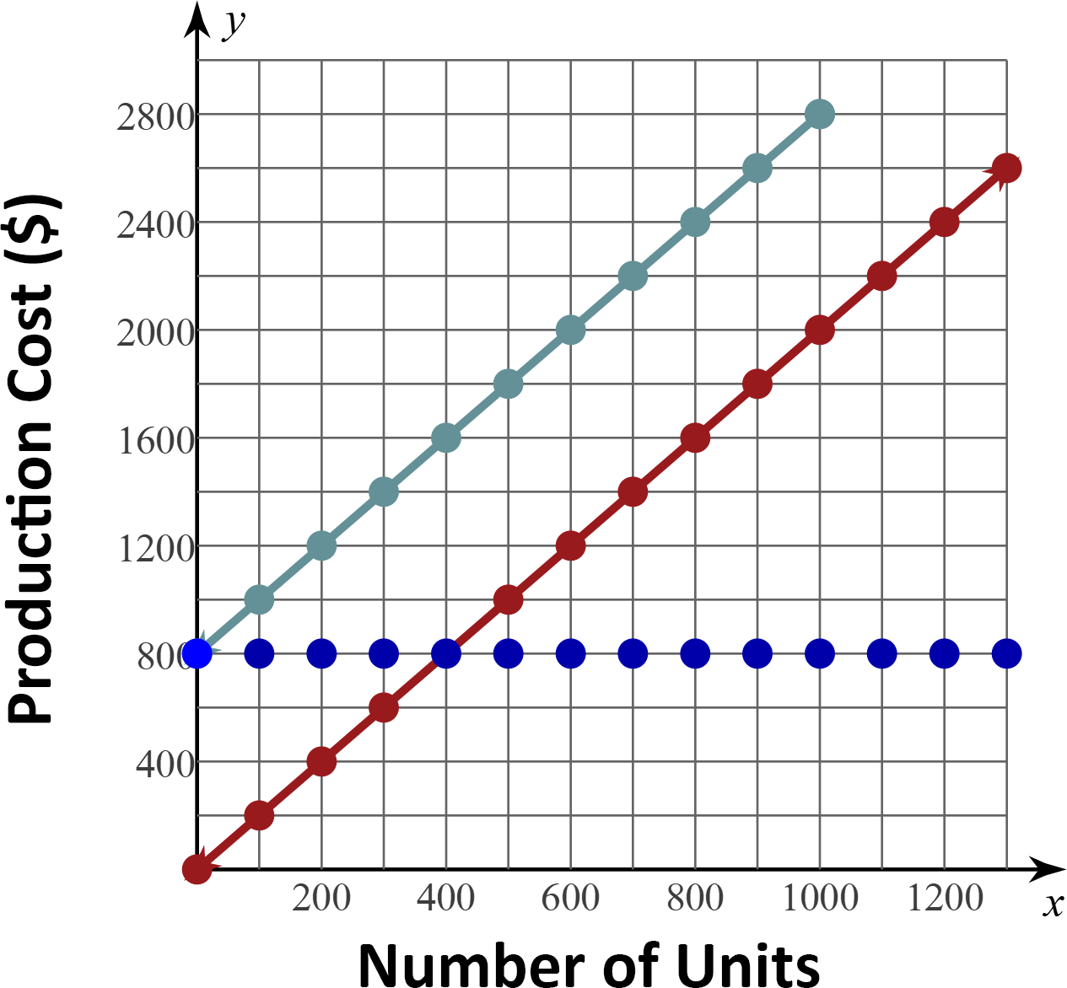

Fixed Cost | Variable Cost | Total Cost

- What is the fixed cost to produce 1200 units? _____
What I see… | What it means…

- What is the fixed cost to produce 500 units? _____
What I see… | What it means…

- What is the variable cost to produce 900 units? _____
What I see… | What it means…

- What is the total cost to produce 900 units? _____
What I see… | What it means…

- How much more is the variable cost to produce 800 units than the variable cost to produce 200 units? ____
What I see… | What it means…

- What is the total cost to produce 1300 units? Use the graph of fixed costs and variable costs. _____
What I see… | What it means…
What is your number sequence to the scavenger hunt? ______________________

