creating bar graphs
Follow the directions below to complete your bar graphs.
- Make a horizontal double bar graph below to show the fixed and variable production costs. Give your graph a title.
______________________
Production Costs, 6/22 - 11/22
Costs | June | July | August | September | October | November
Fixed | $3,000 | $3,000 | $3,000 | $3,000 | $3,000 | $3,000
Variable | $10,000 | $8,000 | $15,000 | $25,000 | $10,000 | $20,000
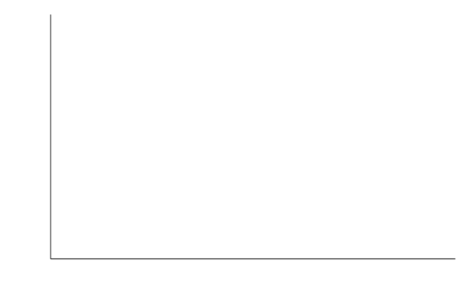

- Make a vertical double bar graph below to show the fixed and variable production costs. Give your graph a title.
___________________
Production Costs, 01/23 - 06/23
Costs | January | February | March | April | May | June
Fixed | $4,000 | $4,000 | $4,000 | $4,000 | $4,000 | $4,000
Variable | $7,000 | $10,000 | $8,000 | $14,000 | $12,000 | $20,000

