Guided notes

Use the table below to record your notes as we discuss.

|  | **Notes** |
| --- | --- |
| **Cost of Production** | Cost of production is the expense of manufacturing a product. Production costs can be fixed or varied. |
| **Fixed Cost** | Fixed cost refers to expenses with prices that do not change regardless of production costs. |
| **Examples of Fixed Cost** | Sample student responses:   * Rent * Subscription for a program used in your business * Insurance * Salaries (if applicable) * License or permit |
| **Variable Cost** | Variable cost refers to expenses with prices that change due to production costs. |
| **Examples of Variable Cost** | Sample student responses:   * Material for production * Labor * Shipping and packaging * Utilities |

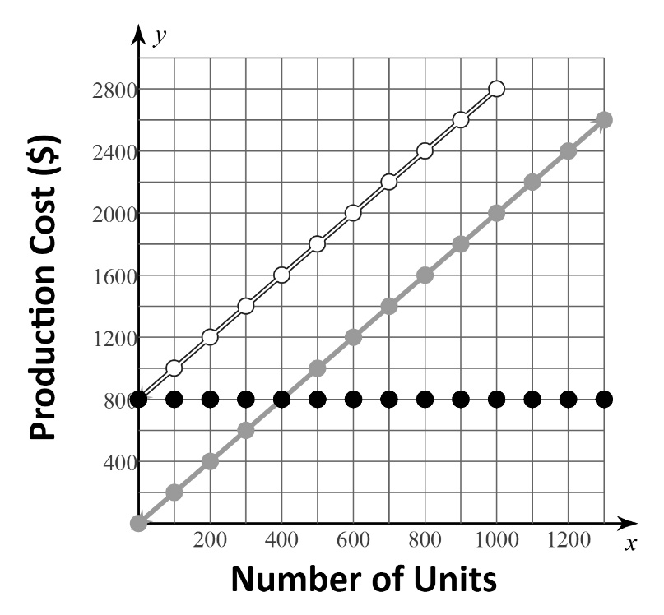



Use your notes from the table on page one and the information on the graph to answer the following questions:

1. What do you notice about the graph of the fixed cost? *Horizontal line, the cost of production is $800 no matter what number of units is produced*
2. What is the fixed cost if nothing is produced? *$800*
3. What is the fixed cost if 1000 units are produced? *$800*
4. What is the total cost of producing nothing? *$800*
5. What is the total cost of producing 1000 units? *$2800*
6. What is the relationship between the graph of total costs and the graphs of fixed and variable costs? *Total cost is the sum of the fixed costs and variable costs*