Guided notes
Use the table below to record your notes as we discuss.
 | Notes
Cost of Production | Cost of production is the expense of manufacturing a product. Production costs can be fixed or varied.
Fixed Cost | Fixed cost refers to expenses with prices that do not change regardless of production costs.
Examples of Fixed Cost | Sample student responses:  - Rent  - Subscription for a program used in your business  - Insurance  - Salaries (if applicable)  - License or permit
Variable Cost | Variable cost refers to expenses with prices that change due to production costs.
Examples of Variable Cost | Sample student responses:  - Material for production  - Labor  - Shipping and packaging  - Utilities

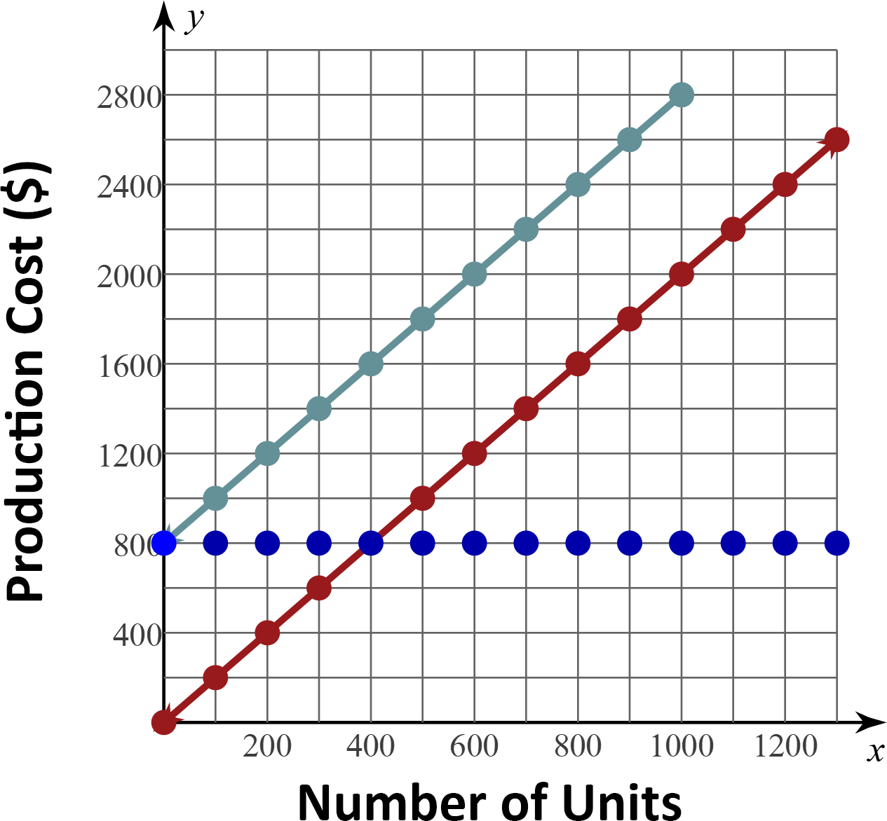

Fixed Cost | Variable Cost | Total Cost

Use your notes from the table on page one and the information on the graph to answer the following questions:
- What do you notice about the graph of the fixed cost? Horizontal line, the cost of production is $800 no matter what number of units is produced

- What is the fixed cost if nothing is produced? $800

- What is the fixed cost if 1000 units are produced? $800

- What is the total cost of producing nothing? $800

- What is the total cost of producing 1000 units? $2800

- What is the relationship between the graph of total costs and the graphs of fixed and variable costs? Total cost is the sum of the fixed costs and variable costs

