Guided notes
Use the table below to record your notes as we discuss.
Notes
Cost of Production
Fixed Cost
Examples of Fixed Cost
Variable Cost
Examples of Variable Cost

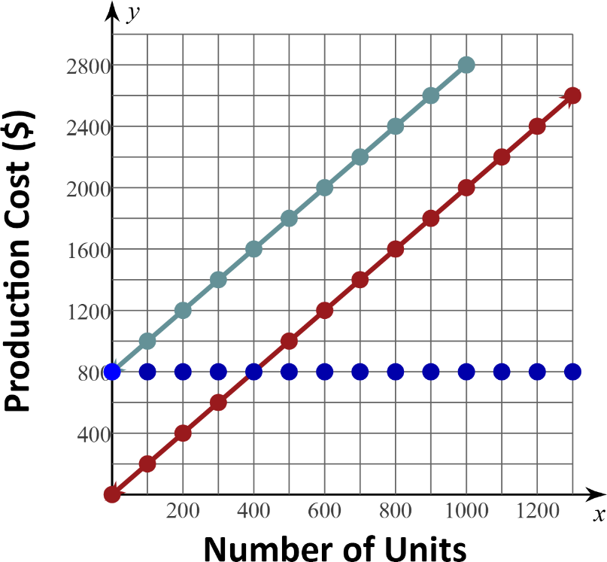

Fixed Cost | Variable Cost | Total Cost

Use your notes from the table on page one and the information on the graph to answer the following questions:
- What do you notice about the graph of the fixed cost?

- What is the fixed cost if nothing is produced?

- What is the fixed cost if 1000 units are produced?

- What is the total cost of producing nothing?

- What is the total cost of producing 1000 units?

- What is the relationship between the graph of total costs and the graphs of fixed and variable costs?

