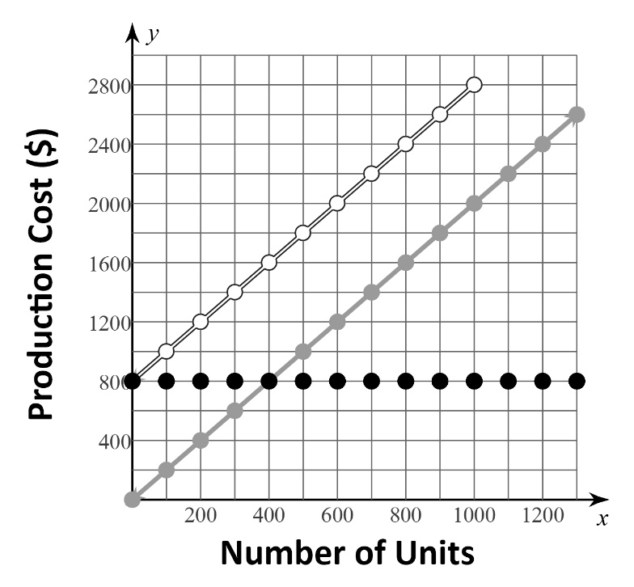**STATION 1**

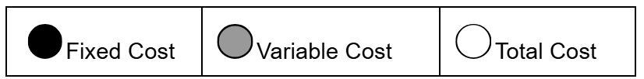

**Question:** What is the fixed cost to produce 1200 units?

If the answer is **800**, go to **Station 3.**

If the answer is **2400**, go to **Station** **2.**

If the answer is **3200**, go to **Station** **5.**

If the answer is **1600**, go to **Station** **4.**

**STATION 2**



**Question:** What is the fixed cost to produce 500 units?

If the answer is **1000**, go to **Station** **3.**

If the answer is **800**, go to **Station** **5.**

If the answer is **1800**, go to **Station** **1.**

If the answer is **200**, go to **Station** **6.**

**STATION 3**



**Question:** What is the variable cost to produce 900 units?

If the answer is **800**, go to **Station** **6.**

If the answer is **1000**, go to **Station** **4.**

If the answer is **2600**, go to **Station** **1.**

If the answer is **1800**, go to **Station** **2.**

**STATION 4**



**Question:** What is the total cost to produce 900 units?

If the answer is **1800**, go to **Station** **1.**

If the answer is **800**, go to **Station** **3.**

If the answer is **2600**, go to **Station** **6.**

If the answer is **1000**, go to **Station** **5.**

**STATION 5**



**Question:** How much more is the variable cost to produce 800 units than the variable cost to produce 200 units?

If the answer is **1200**, go to **Station** **4.**

If the answer is **1600**, go to **Station** **1.**

If the answer is **400**, go to **Station** **2.**

If the answer is **2000**, go to **Station** **6.**

**STATION 6**



**Question:** What is the total cost to produce 1300 units? Use the graph of fixed costs and variable costs.

If the answer is **800**, go to **Station** **2.**

If the answer is **1800**, go to **Station** **3.**

If the answer is **3400**, go to **Station** **1.**

If the answer is **2600**, go to **Station** **5.**