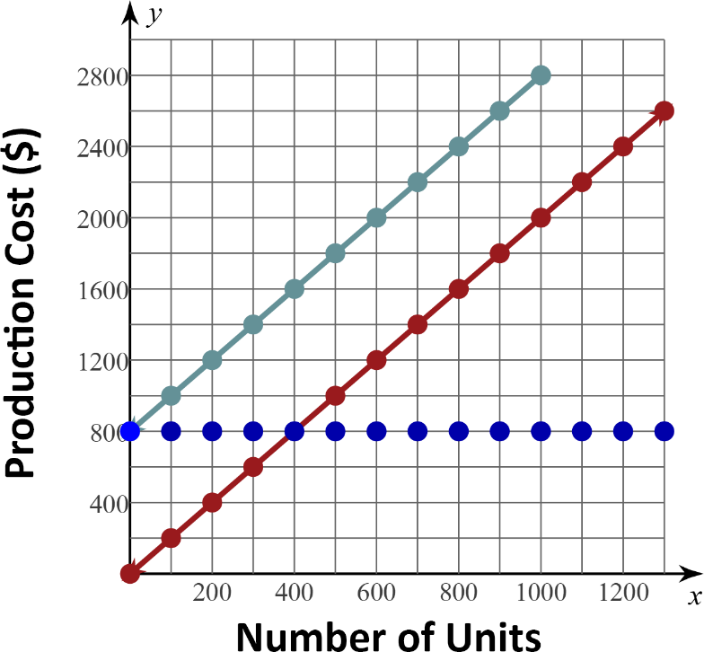
STATION 1

Fixed Cost | Variable Cost | Total Cost

Question: What is the fixed cost to produce 1200 units?
If the answer is 800, go to Station 3.
If the answer is 2400, go to Station 2.
If the answer is 3200, go to Station 5.
If the answer is 1600, go to Station 4.
STATION 2

Fixed Cost | Variable Cost | Total Cost

Question: What is the fixed cost to produce 500 units?

If the answer is 1000, go to Station 3.
If the answer is 800, go to Station 5.
If the answer is 1800, go to Station 1.
If the answer is 200, go to Station 6.
STATION 3

Fixed Cost | Variable Cost | Total Cost

Question: What is the variable cost to produce 900 units?
If the answer is 800, go to Station 6.
If the answer is 1000, go to Station 4.
If the answer is 2600, go to Station 1.
If the answer is 1800, go to Station 2.

STATION 4

Fixed Cost | Variable Cost | Total Cost

Question: What is the total cost to produce 900 units?
If the answer is 1800, go to Station 1.
If the answer is 800, go to Station 3.
If the answer is 2600, go to Station 6.
If the answer is 1000, go to Station 5.
STATION 5

Fixed Cost | Variable Cost | Total Cost

Question: How much more is the variable cost to produce 800 units than the variable cost to produce 200 units?
If the answer is 1200, go to Station 4.
If the answer is 1600, go to Station 1.
If the answer is 400, go to Station 2.
If the answer is 2000, go to Station 6.
STATION 6

Fixed Cost | Variable Cost | Total Cost

Question: What is the total cost to produce 1300 units? Use the graph of fixed costs and variable costs.
If the answer is 800, go to Station 2.
If the answer is 1800, go to Station 3.
If the answer is 3400, go to Station 1.
If the answer is 2600, go to Station 5.

