COOKING WITH CLARITY CHOICE BOARD

Directions: Choose three boxes in any row or diagonal to complete a Tic-Tac-Toe.
Take out the emojis in this dialog and put in brackets. For example, 🙄 [roll my eyes].  Teen 1: Can you believe the size of the project Mr. Ortiz just assigned?📜🤯  Teen 2: Yeah, he’s ordered up a big one this time! 🫡  Teen 1: Doesn’t he know we have a baseball tournament, and we are the big hitters? 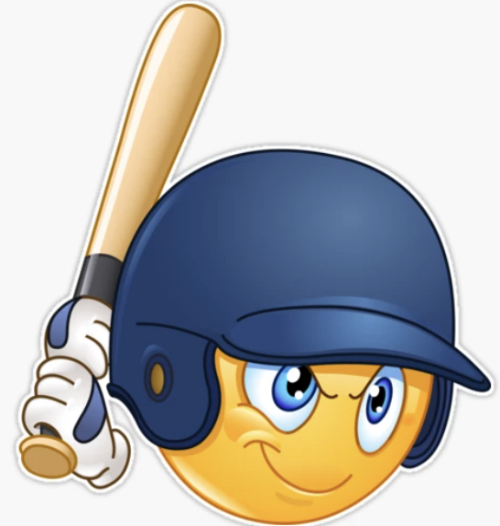  Teen 2: I’m pretty sure learning Spanish trumps baseball. 🤷 | You are preparing a large batch of a special dessert. For each batch, the following equation gives the total number of cups of ingredients needed:  T(x) = 3(4x + 5) – 2 [3 (x – 2) +6]  where x represents the number of batches you're making.  You know the total number of cups of ingredients available is 48. Determine how many batches you can make. Show your work! | Create an original musical score of at least four bars using at least two different kinds of brackets.
Using this scene as a model  https://www.youtube.com/watch?v=y6EDlD_fWn0  write out the stage directions and create a [homage] video. | Watch a school appropriate movie trailer (PG13) and transcribe the dialogue and action using appropriate parentheses, brackets, and ellipses. | Balance this chemical equation:  __AlBr₃ + __ K₂SO₄ →  __ KBr + __ Al₂(SO4)₃
Make a list of all the food you ate yesterday. In your nutritional analysis, use parentheses to clarify the total number of calories you consumed. | Using the tech tool, Suno, create an original song with lyrics that have brackets, parentheses, and ellipses. | Imagine you step out of your time machine to witness a one-minute exchange between two famous historical people. Using brackets, parentheses, and ellipses, record details of their conversation for a historical journal.

