EXAMPLES OF BRACKETS, PARENTHESES, AND ELLIPSES
…in Academic Writing

"The study found that 'the participants [aged 25-35] showed significant improvement.'" (Brackets rule A)

"The author stated, 'the results were conclusive [sic]' which indicates a possible mistake in the original text." (Brackets rule C)

“[T]his study has been widely cited, notwithstanding its dubious methodology.” (Brackets rule C)

She said she would consider “a very short extension of the deadline, but only under the most extraordinary circumstances [emphasis added].” (Brackets rule A)

"The soufflé [which had collapsed] was still delicious," the judge said. (Brackets rule B)

Please bring flour (all-purpose or cake) for the baking class. (Parentheses rule A)

Isabel Cobb (1858-1947) was the first woman physician in Indian Territory who cared primarily for women and children and did not always charge for her services. (Parentheses rule A)

The Culinary Institute of America (CIA) offers prestigious programs for aspiring chefs and culinary professionals. (Parentheses rule D)

The Oklahoma Department of Transportation (ODOT) is responsible for maintaining the state’s highways and bridges. (Parentheses rule D)

He finally answered (after taking several minutes to think) that he did not understand the question. (Parentheses rule B)

Hamlet’s dilemma is “To be, or not to be” (Shakespeare 3.1.59). (Parentheses rule B)

…in Closed Captioning/Plays

—Will you meet me at the west side entrance to the theater tonight at midnight? [whispering]
—Certainly. [soft music playing] (Brackets rule D)

—Where is she? [clock ticking](Brackets rule D)

—Let’s get out of here. [In black and white, a man in a dark sedan pulls up] [rock music playing]
—Get in! [Tires screeching](Brackets rule D)

—I can’t believe we’re getting here so late. Where are our seats? It’s already the third inning.
—What are you complaining about? [angrily] They’re tied zero to zero. [crowd cheering].
—Not anymore. It’s a grand slam. We missed it looking for our seats. [organ music playing] (Brackets rules A and D)

♪ It's the circle of life, [Rafiki lifts Simba into the air for all the animals to see. In answer, the animals rear onto their hind legs. Elephants raise their trunks and trumpet.] and it moves us all, [Monkeys cheer, jumping and stamping the ground. Zebras bray and stamp, raising dust.] through despair and hope, through faith and love, [Simba watches the scene below him, seemingly confused and unaffected.] till we find our place [A single beam of light shines through the clouds, illuminating Simba.] on the path unwinding [The animals bow to Simba.] in the circle, the circle of life. ♪ (Brackets rule A and D)

ROMEO [taking Juliet’s hand]
If I profane with my unworthiest hand
This holy shrine, the gentle sin is this:
My lips, two blushing pilgrims, ready stand
To smooth that rough touch with a tender kiss.
JULIET
Good pilgrim, you do wrong your hand too much,
Which mannerly devotion shows in this;
For saints have hands that pilgrims’ hands do touch,
And palm to palm is holy palmers’ kiss.
ROMEO
Have not saints lips, and holy palmers too?
JULIET
Ay, pilgrim, lips that they must use in prayer.
ROMEO
O then, dear saint, let lips do what hands do.
They pray: grant thou, lest faith turn to despair.
JULIET
Saints do not move, though grant for prayers’ sake.
ROMEO
Then move not while my prayer’s effect I take.
[He kisses her.]
Thus from my lips, by thine, my sin is purged. (Brackets rule D)

STAGE MANAGER
This play is called "Our Town." It was written by Thornton Wilder…The name of the town is Grover's Corners, New Hampshire—just across the Massachusetts line: latitude 42 degrees 40 minutes; longitude 70 degrees 37 minutes. The First Act shows a day in our town. The day is May 7, 1901. The time is just before dawn.
[A rooster crows.] The sky is beginning to show some streaks of light over in the East there [points stage left] behind our mount'in. The morning star always gets wonderful bright the minute before it has to go,—doesn't it? [He stares at it for a moment then goes upstage].
Well, I'd better show you how our town lies. Up here [pointing at audience] is Main Street. Way back there [pointing backstage] is the railway station; tracks go that way. Polish Town's across the tracks, and some Canuck families. Toward the left, over there is the Congregational Church [points stage right]. Across the street's the Presbyterian. Methodist and Unitarian are over there [turns mid-stage] . Baptist is down in the holla' by the river. Catholic Church is over beyond the tracks [faces audience, center stage]. Here's the Town Hall and Post Office combined; jail's in the basement.(Brackets rule D)

SOUS CHEF [chopping onions, tears streaming]
I'm not crying, you're crying (and you need to quit it)! (Brackets rule D; parentheses rule B)

[ambient coffee shop noise] (barista) "Order for Sarah!" [espresso machine whirring] Brackets rule B; parentheses rule A; brackets rule D)

CONTESTANT [tasting sauce, then grimacing]
(translated from Japanese) Mmm...delicious. (Brackets rule D; parentheses rule A)

HOST
This soufflé is absolutely…[loud crash] Oops! [whispers] That's not supposed to happen unless you forgot to take in account elevation. (Brackets rule D)
…In Math
([(5+3)×(4−1)]+[8÷(2+2)])×[6−(3×2)] (Parentheses rule E; Brackets rule F)

Hodge (1953) first described the steps involved in the Maillard reaction. (Parentheses rule D)

A typical oven temperature for baking cookies is 350°F (175°C). (Parentheses rule A)

$[(18 \div 3) \times (4 + 2)] - [5 \times (3 + 1)]$ (Parentheses rule E; Brackets rule F)

[(3 + 2) × (6 – 4) + 2] × 4 (Parentheses rule E; Brackets rule F)

f(x) = 3x + 5 (Parentheses rule E)
“Students, locate the Y-Coordinate (-4) and mark the point (2, -4) on a coordinate plane.” (Parentheses rule E)

To double a recipe: 2 × (1/4 cup flour) = 1/2 cup flour (Parentheses rule E)

Baking temperature conversion: °C = (°F - 32) × (5/9) (Parentheses rule E)

The volume of a cylindrical cake pan can be calculated using the formula V = πr²h, where V is volume, r is the radius (half the diameter), and h is the height. (Parentheses rule A)

…In Science
2-[(4-[(2-Aminoethyl)amino]butyl)amino]ethan-1-ol (Parentheses rule E; Brackets rule F)
This name demonstrates the use of nested parentheses and square brackets to indicate different structural elements:
- Innermost parentheses: (2-Aminoethyl)
- Inner square brackets: [4-[(2-Aminoethyl)amino]butyl]
- Outer square brackets: [(4-[(2-Aminoethyl)amino]butyl)amino]
The nesting order alternates between parentheses and square brackets to clearly delineate different parts of the molecule's structure.
(NH4)2[Ni(C2O4)2(OH2)2] - Ammonium diaqua(bisoxalato)nickel(III) (Parentheses rule E; Brackets rule F)

Total Calories = [(Protein grams × 4) + (Carbohydrate grams × 4) + (Fat grams × 9)] (Parentheses rule E; Brackets rule F)

Adjusted Serving Size = [Original recipe yield ÷ (Desired servings × [Original serving size])] (Parentheses rule E; Brackets rule F)

Baking Time Conversion = [Original baking time × (New pan area ÷ Original pan area)] (Parentheses rule E; Brackets rule F)

Vitamin C (Ascorbic Acid): [(R)-3,4-Dihydroxy-5-((S)-1,2-dihydroxyethyl)furan-2(5H)-one] (Parentheses rule E; Brackets rule F)

Citric Acid: [2-Hydroxypropane-1,2,3-tricarboxylic acid] (Parentheses rule E; Brackets rule F)

Caffeine: [1,3,7-Trimethyl-1H-purine-2,6(3H,7H)-dione] (Parentheses rule E; Brackets rule F)
Total time in the cooking show = (Prep time) + (Cooking time) (Parentheses rule E; Brackets rule F)

Baking soda (NaHCO₃) reacts with acidic ingredients to produce carbon dioxide (CO₂), which causes baked goods to rise. (Parentheses rule A)

The Maillard reaction (responsible for browning in cooking) involves the interaction of amino acids (NH₂) with reducing sugars. (Parentheses rule A)

…In Music

Original Lyric: "I love to bake, it's like a science (and a little bit of magic)." (Parentheses rule A)

Song title: Cooking Up Love (In the Kitchen)
“Song 2” (“Woo Hoo”), Blur
“Tubthumping” (“I Get Knocked Down”), Chumbawamba
“For What It’s Worth” (“Stop, Hey What’s That Sound”), Buffalo Springfield
“Piano Sonata No. 14 in C-sharp minor, Op. 27, No. 2” (“Moonlight Sonata”), Ludwig van Beethoven (all Parentheses rule A)

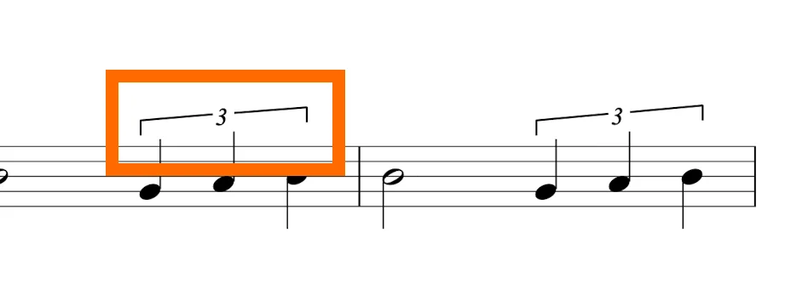
(Brackets rule E)
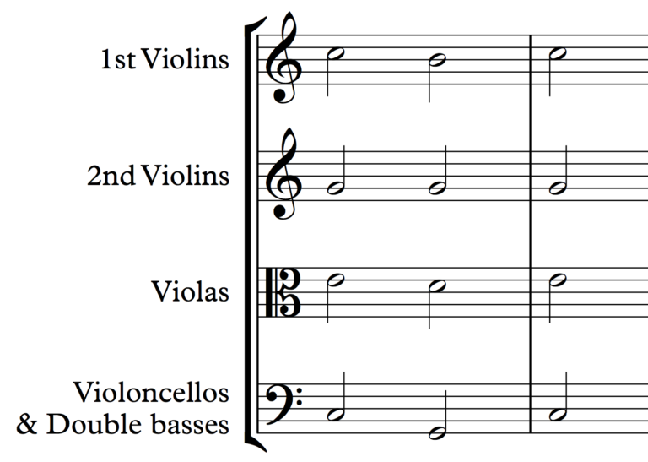
(Brackets rule E)

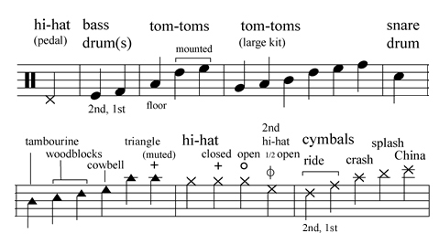

(Brackets rule E)

The critical edition of "Culinary Counterpoint" includes alternative notes (in parentheses) found in different historical sources. (Parentheses rule A)
Examples of Ellipses

"The soufflé was about to go into the oven and... Oh no! The egg whites weren't whipped properly." (Ellipses rule C)

"I followed the recipe exactly, but somehow the cake still looked like... well, let's just say it was more of a culinary crime scene." (Ellipses rule D)

"The judges took their first bite and... complete silence filled the kitchen." (Ellipses rule C)

"I was explaining to my friend how to make the perfect chocolate chip cookies when suddenly... did that spatula just move by itself?" (Ellipses rule B or C)

"Mom told a long story about making a dessert…in the end, she’d accidentally grabbed the salt instead of sugar." (Ellipses rule A)

"The cake was in the oven, timer counting down, and... something definitely smelled like it was burning." (Ellipses rule B or C)

"You see, the secret to a perfect meringue is... well, let's just say it involves some serious arm workout."(Ellipses rule B)

"It was the best of times, it was the worst of times, it was the age of wisdom, it was the age of foolishness [...] it was the season of Light, it was the season of Darkness, it was the spring of hope, it was the winter of despair." (Ellipses rule A)

