EXAMPLES OF BRACKETS, PARENTHESES, AND ELLIPSES

…in Academic Writing

"The study found that 'the participants [aged 25-35] showed significant improvement.'"

"The author stated, 'the results were conclusive [sic]' which indicates a possible mistake in the original text."

“[T]his study has been widely cited, notwithstanding its dubious methodology.”

She said she would consider “a very short extension of the deadline, but only under the most extraordinary circumstances [emphasis added].”

"The soufflé [which had collapsed] was still delicious," the judge said.

Please bring flour (all-purpose or cake) for the baking class.

Isabel Cobb (1858-1947) was the first woman physician in Indian Territory who primarily cared for women and children and did not always charge for her services.

The Culinary Institute of America (CIA) offers prestigious programs for aspiring chefs and culinary professionals.

The Oklahoma Department of Transportation (ODOT) is responsible for maintaining the state’s highways and bridges.

He finally answered (after taking several minutes to think) that he did not understand the question.

Hamlet’s dilemma is “To be, or not to be” (Shakespeare 3.1.59).

…in Closed Captioning/Plays

—Will you meet me at the west side entrance to the theater tonight at midnight? [whispering]
—Certainly. [soft music playing]

—Where is she? [clock ticking]

—Let’s get out of here. [In black and white, a man in a dark sedan pulls up] [rock music playing]
—Get in! [Tires screeching]

—I can’t believe we’re getting here so late. Where are our seats? It’s already the third inning.
—What are you complaining about? [angrily] They’re tied zero to zero. [crowd cheering].
—Not anymore. It’s a grand slam. We missed it looking for our seats. [organ music playing]

♪ It's the circle of life, [Rafiki lifts Simba into the air for all the animals to see. In answer, the animals rear onto their hind legs. Elephants raise their trunks and trumpet.] and it moves us all, [Monkeys cheer, jumping and stamping the ground. Zebras bray and stamp, raising dust.] through despair and hope, through faith and love, [Simba watches the scene below him, seemingly confused and unaffected.] till we find our place [A single beam of light shines through the clouds, illuminating Simba.] on the path unwinding [The animals bow to Simba.] in the circle, the circle of life. ♪

ROMEO [taking Juliet’s hand]
If I profane with my unworthiest hand
This holy shrine, the gentle sin is this:
My lips, two blushing pilgrims, ready stand
To smooth that rough touch with a tender kiss.
JULIET
Good pilgrim, you do wrong your hand too much,
Which mannerly devotion shows in this;
For saints have hands that pilgrims’ hands do touch,
And palm to palm is holy palmers’ kiss.
ROMEO
Have not saints lips, and holy palmers too?
JULIET
Ay, pilgrim, lips that they must use in prayer.
ROMEO
O then, dear saint, let lips do what hands do.
They pray: grant thou, lest faith turn to despair.
JULIET
Saints do not move, though grant for prayers’ sake.
ROMEO
Then move not while my prayer’s effect I take.
[He kisses her.]
Thus from my lips, by thine, my sin is purged.

STAGE MANAGER
This play is called "Our Town." It was written by Thornton Wilder…The name of the town is Grover's Corners, New Hampshire—just across the Massachusetts line: latitude 42 degrees 40 minutes; longitude 70 degrees 37 minutes. The First Act shows a day in our town. The day is May 7, 1901. The time is just before dawn.
[A rooster crows.] The sky is beginning to show some streaks of light over in the East there [points stage left] behind our mount'in. The morning star always gets wonderful bright the minute before it has to go,—doesn't it? [He stares at it for a moment then goes upstage].
Well, I'd better show you how our town lies. Up here [pointing at audience] is Main Street. Way back there [pointing backstage] is the railway station; tracks go that way. Polish Town's across the tracks, and some Canuck families. Toward the left, over there is the Congregational Church [points stage right]. Across the street's the Presbyterian. Methodist and Unitarian are over there [turns mid-stage] . Baptist is down in the holla' by the river. Catholic Church is over beyond the tracks [faces audience, center stage]. Here's the Town Hall and Post Office combined; jail's in the basement.

SOUS CHEF [chopping onions, tears streaming]
I'm not crying, you're crying (and you need to quit it)!

[ambient coffee shop noise] (barista) "Order for Sarah!" [espresso machine whirring]

CONTESTANT [tasting sauce, then grimacing]
(translated from Japanese) Mmm...delicious.

HOST
This soufflé is absolutely…[loud crash] Oops! [whispers] That's not supposed to happen unless you forgot to take in account elevation.

…In Math

([(5+3)×(4−1)]+[8÷(2+2)])×[6−(3×2)]

A typical oven temperature for baking cookies is 350°F (175°C).

$[(18 \div 3) \times (4 + 2)] - [5 \times (3 + 1)]$

[(3 + 2) × (6 – 4) + 2] × 4

f(x) = 3x + 5

“Students, locate the Y-Coordinate (-4) and mark the point (2, -4) on a coordinate plane.”

To double a recipe: 2 × (1/4 cup flour) = 1/2 cup flour

Baking temperature conversion: °C = (°F - 32) × (5/9)

The volume of a cylindrical cake pan can be calculated using the formula V = πr²h, where V is volume, r is the radius (half the diameter), and h is the height.

…In Science

2-[(4-[(2-Aminoethyl)amino]butyl)amino]ethan-1-ol

(NH4)2[Ni(C2O4)2(OH2)2] - Ammonium diaqua(bisoxalato)nickel(III)

Total Calories = [(Protein grams × 4) + (Carbohydrate grams × 4) + (Fat grams × 9)]

Adjusted Serving Size = [Original recipe yield ÷ (Desired servings × [Original serving size])]

Baking Time Conversion = [Original baking time × (New pan area ÷ Original pan area)]

Vitamin C (Ascorbic Acid): [(R)-3,4-Dihydroxy-5-((S)-1,2-dihydroxyethyl)furan-2(5H)-one]

Citric Acid: [2-Hydroxypropane-1,2,3-tricarboxylic acid]

Caffeine: [1,3,7-Trimethyl-1H-purine-2,6(3H,7H)-dione]

Total time in the cooking show = (Prep time) + (Cooking time)

Baking soda (NaHCO₃) reacts with acidic ingredients to produce carbon dioxide (CO₂), which causes baked goods to rise.

The Maillard reaction (responsible for browning in cooking) involves the interaction of amino acids (NH₂) with reducing sugars.

…In Music

Original Lyric: "I love to bake, it's like a science (and a little bit of magic)."

Song titles:
- “Song 2” (“Woo Hoo”), Blur
- “Tubthumping” (“I Get Knocked Down”), Chumbawamba
- “For What It’s Worth” (“Stop, Hey What’s That Sound”), Buffalo Springfield
- “Piano Sonata No. 14 in C-sharp minor, Op. 27, No. 2” (“Moonlight Sonata”), Ludwig van Beethoven
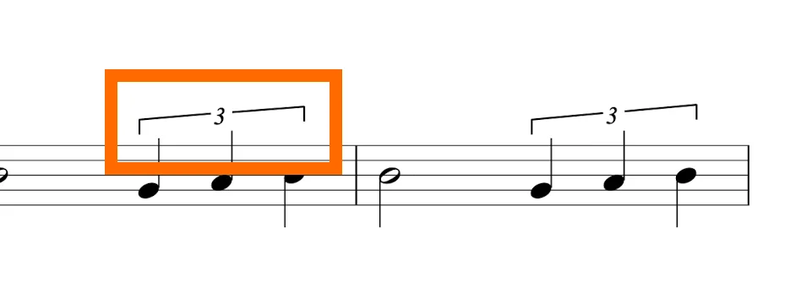
Music Theory. (2023, July). Reddit [Post]. https://www.reddit.com/r/musictheory/comments/1ebrwar/what_does_this_bracket_and_3_mean_in_violin_music/

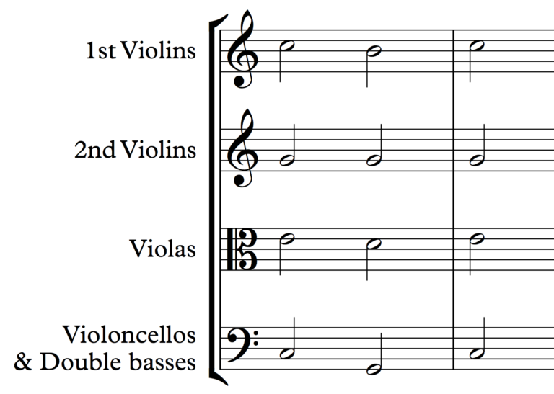
School of Composition. (2025). Beginner’s Guide to 4-Part Harmony. https://www.schoolofcomposition.com/beginners-guide-to-4-part-harmony/

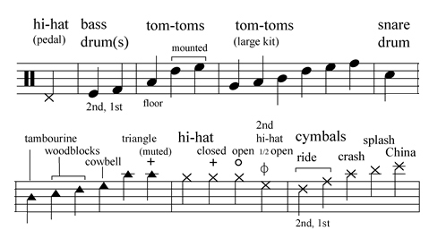
https://bpb-us-w2.wpmucdn.com/blogs.iu.edu/dist/8/489/files/2020/05/PercNotation2-a1.png

Examples of Ellipses

"The soufflé was about to go into the oven and...Oh no! The egg whites weren't whipped properly."

"I followed the recipe exactly, but somehow the cake still looked like...well, let's just say it was more of a culinary crime scene."

"The judges took their first bite and...complete silence filled the kitchen."

"I was explaining to my friend how to make the perfect chocolate chip cookies when suddenly... did that spatula just move by itself?"

"Mom told a long story about making a dessert…in the end, she’d accidentally grabbed the salt instead of sugar."

"The cake was in the oven, timer counting down, and...something definitely smelled like it was burning."

"You see, the secret to a perfect meringue is...well, let's just say it involves some serious arm workout."

“Four score and seven years ago our fathers brought forth on this continent a new nation, conceived in liberty, and dedicated to the proposition that all men are created equal….We have come to dedicate a portion of that field as a final resting place for those who here gave their lives that that nation might live. It is altogether fitting and proper that we should do this.”

