Conic Sections Sample Response
1. 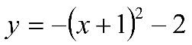  Vertex is ( -1 , -2 ); It opens Down.  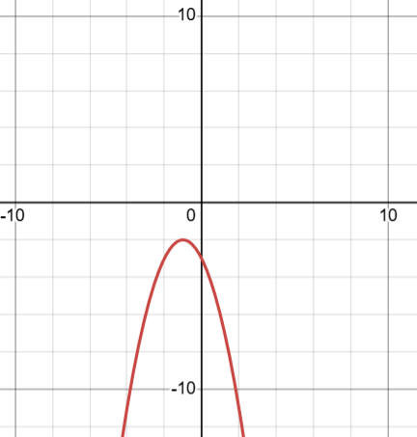 | 2. 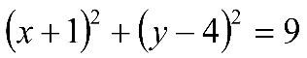  center is ( -1, 4 ); radius is 3  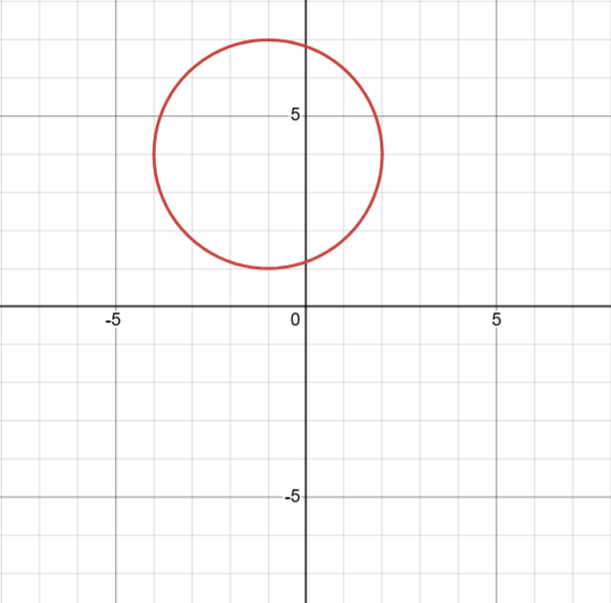
3. 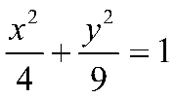  Center is ( 0 , 0 )  The major axis is parallel to the y-axis  The length of the major axis is 6.  The length of the minor axis is 4.  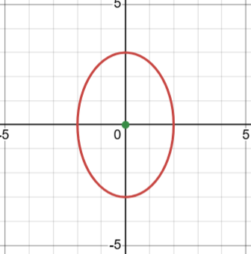 | 4. 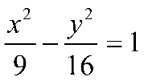  center is ( 0 , 0 )  Asymptotes are 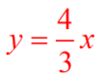& 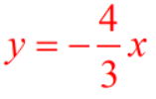  Vertices are ( 3 , 0 ) & ( -3 , 0 )  