Conic Sections Practice Problems
1. 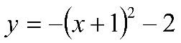  Vertex is (_____, _____); It opens _____.  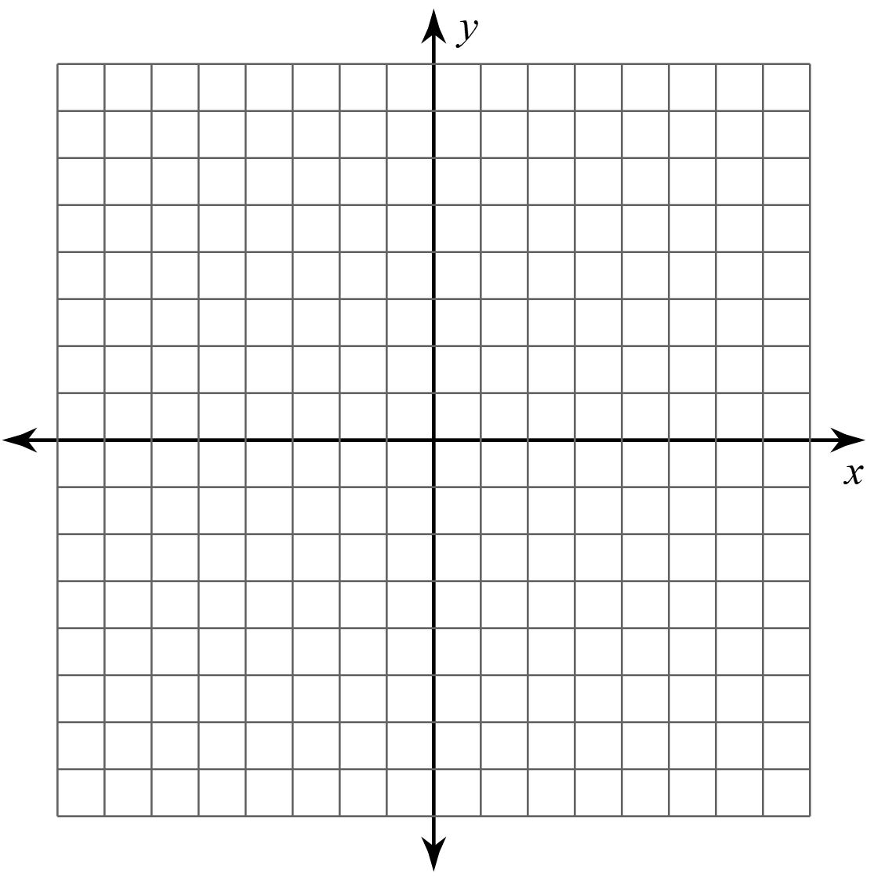 | 2. 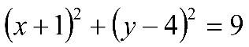  center is (____, ____); radius is ____
3. 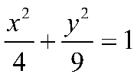  Center is (____, ____)  The major axis is parallel to the ___-axis  The length of the major axis is ______.  The length of the minor axis is ______. | 4. 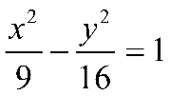  center is (_____, _____)  Asymptotes are ________ & ________  Vertices are (____, ____) & (____, ____)

