COURT CARD (BEOWULF)
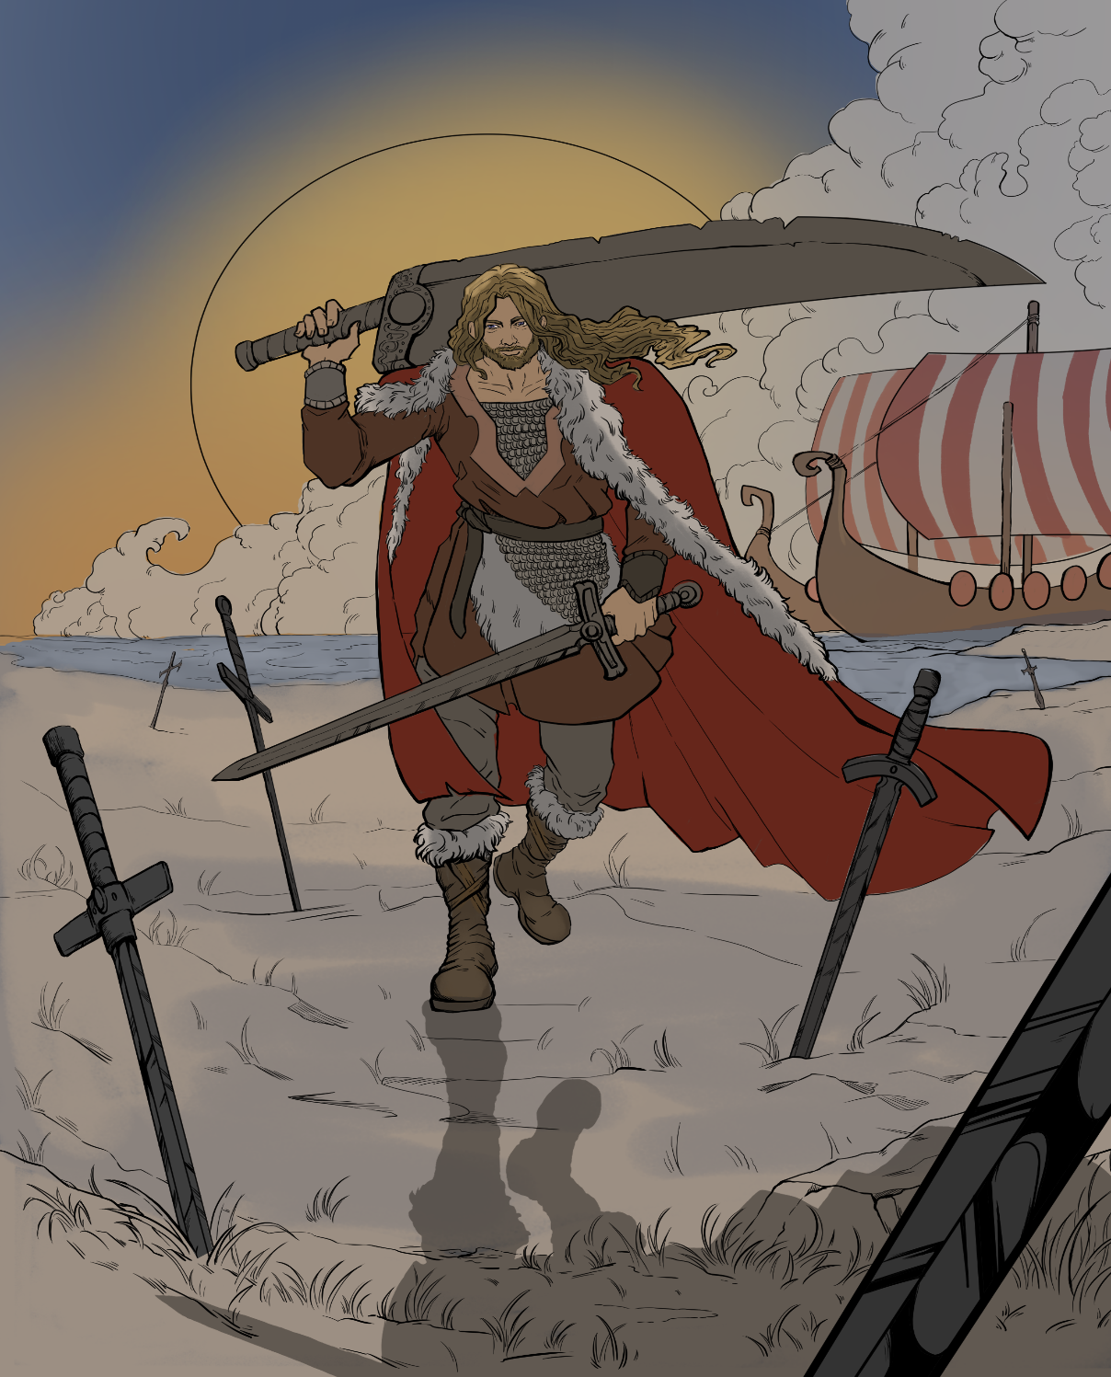

Your client, Beowulf, has been charged with the following crimes:
- Criminal Trespassing
- Public Nudity
- 1st Degree Murder
- Slander and violence against other species with prejudice
DEFENDANTS IN DENMARK

