COURT CARD (HROTHGAR)
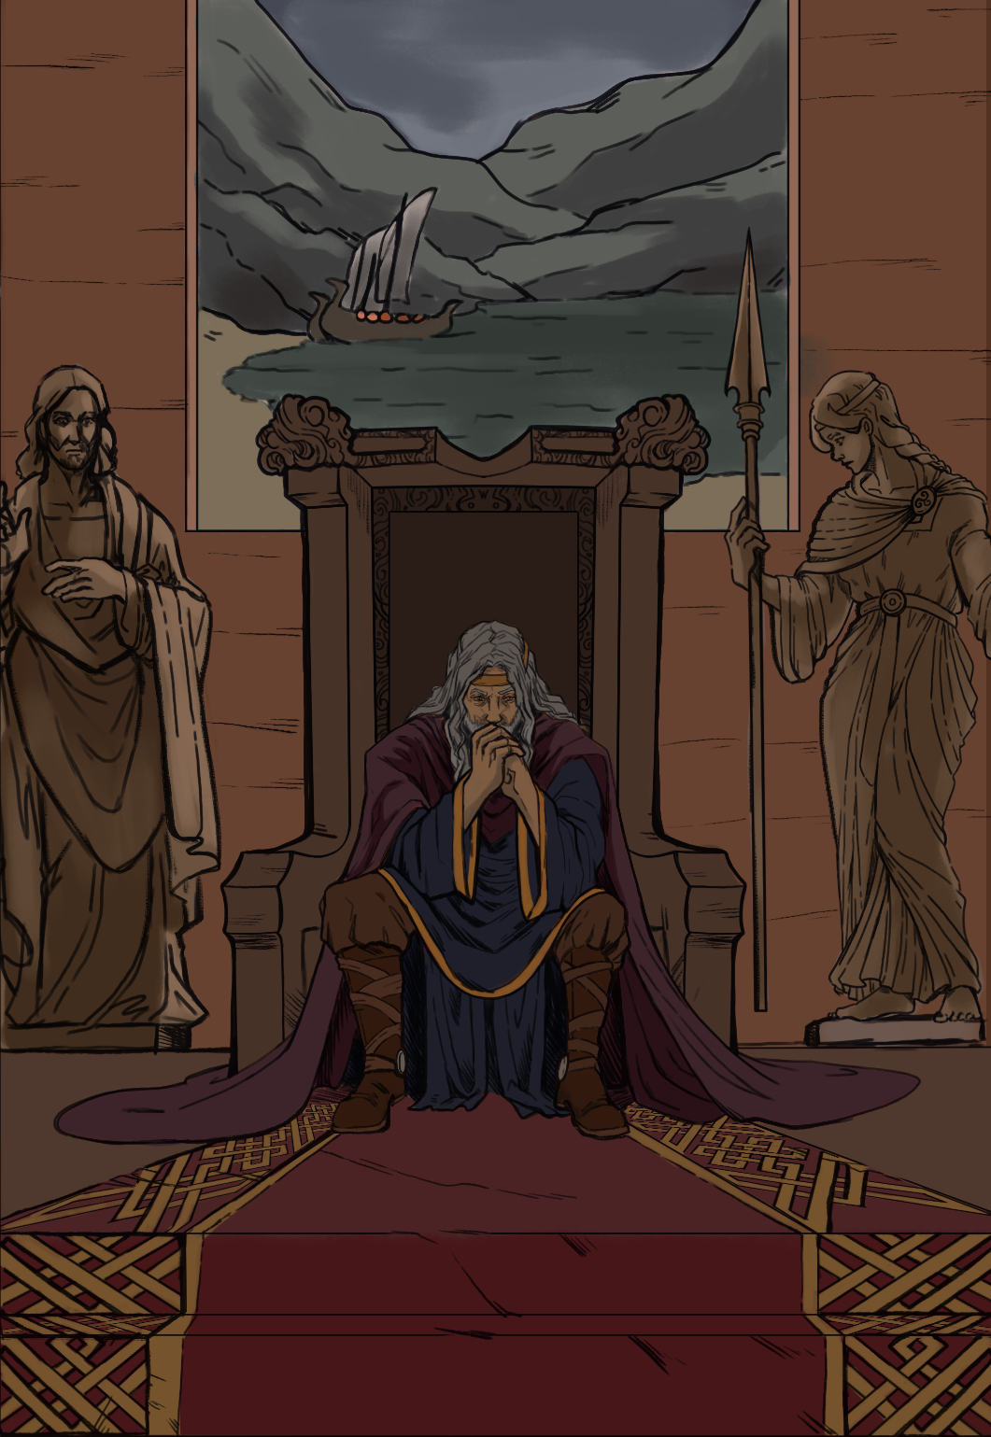

Your client, Hrothgar, has been charged with the following crimes:
- Dereliction of Duty
- Public Intoxication
- Disturbing the Peace
DEFENDANTS IN DENMARK

