JURY ETHOS, LOGOS, PATHOS – GRENDEL
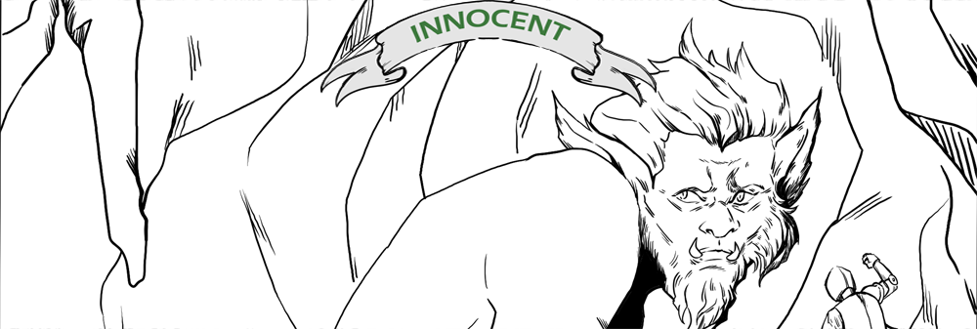
Ethos | Logos | Pathos | Diction

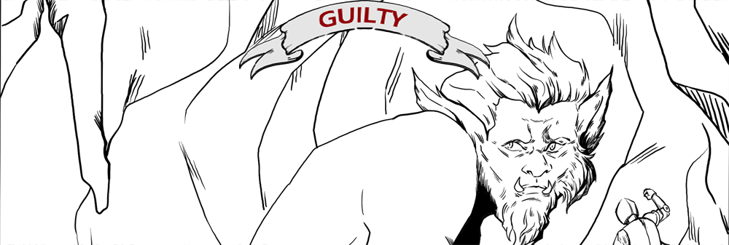
Ethos | Logos | Pathos | Diction

