JURY ETHOS, LOGOS, PATHOS - HROTHGAR
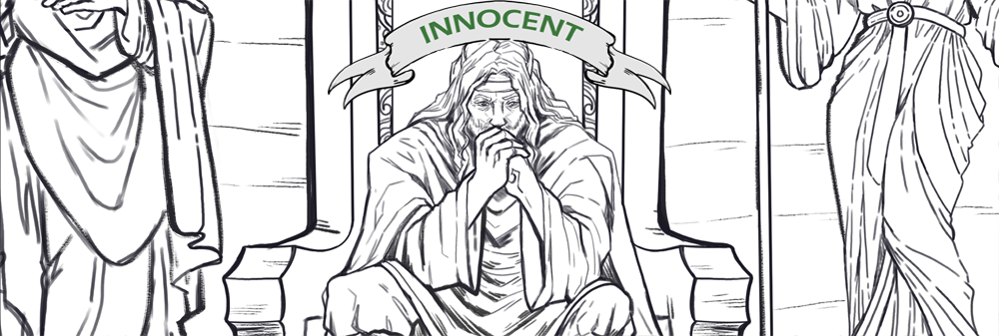
Ethos | Logos | Pathos | Diction

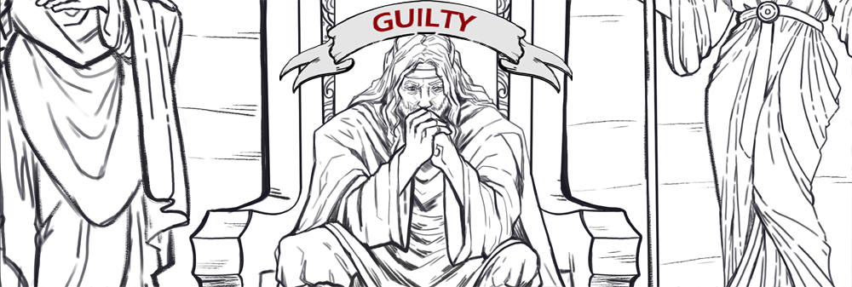
Ethos | Logos | Pathos | Diction

