U.S. POLITICAL SPECTRUM: left and right

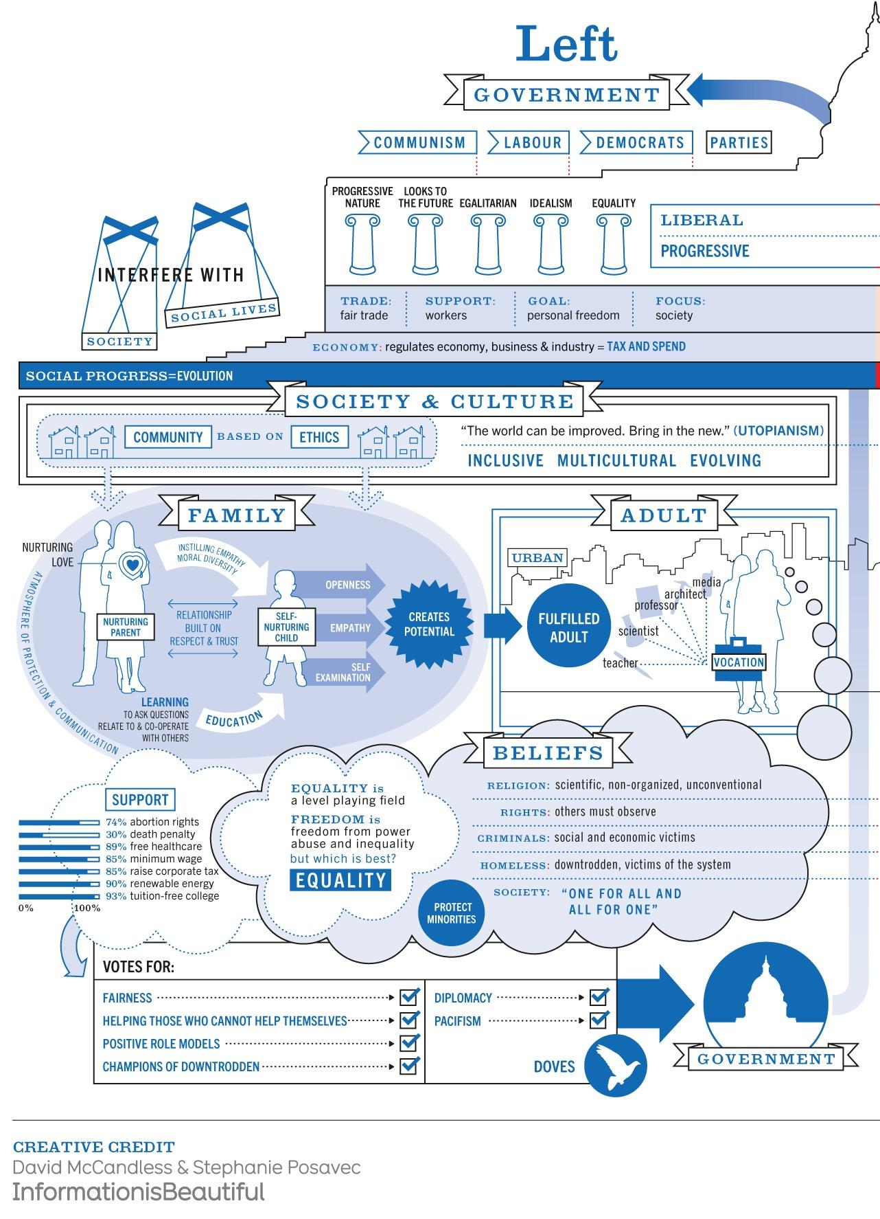

Source: McCandless, D., & Posavec, S. (2024). Left vs. Right (US) [Infographic]. Information is Beautiful. <https://informationisbeautiful.net/visualizations/left-vs-right-us/>