Exploring Linear Relationships: 1
Read the scenario, then answer the following questions. Use the space provided to show your work. You will later use your answers to create a poster.

Story
The Green Teens Club at Riverside Middle School is organizing a recycling drive. They had 20 pounds of recyclable materials before the event began. Each day, they collect 5 more pounds.

Table
Create a table showing how many total pounds of recyclable materials have been collected, starting with day 0 and continuing through day 10.
day | 0 | 1 | 2 | 3 | 4 | 5 | 6 | 7 | 8 | 9 | 10
pounds

Graph
Create a graph showing how many total pounds of recyclable materials have been collected, starting with day 0 and continuing through day 10. Think about which is the dependent and independent variable. Use this information to label your graph.
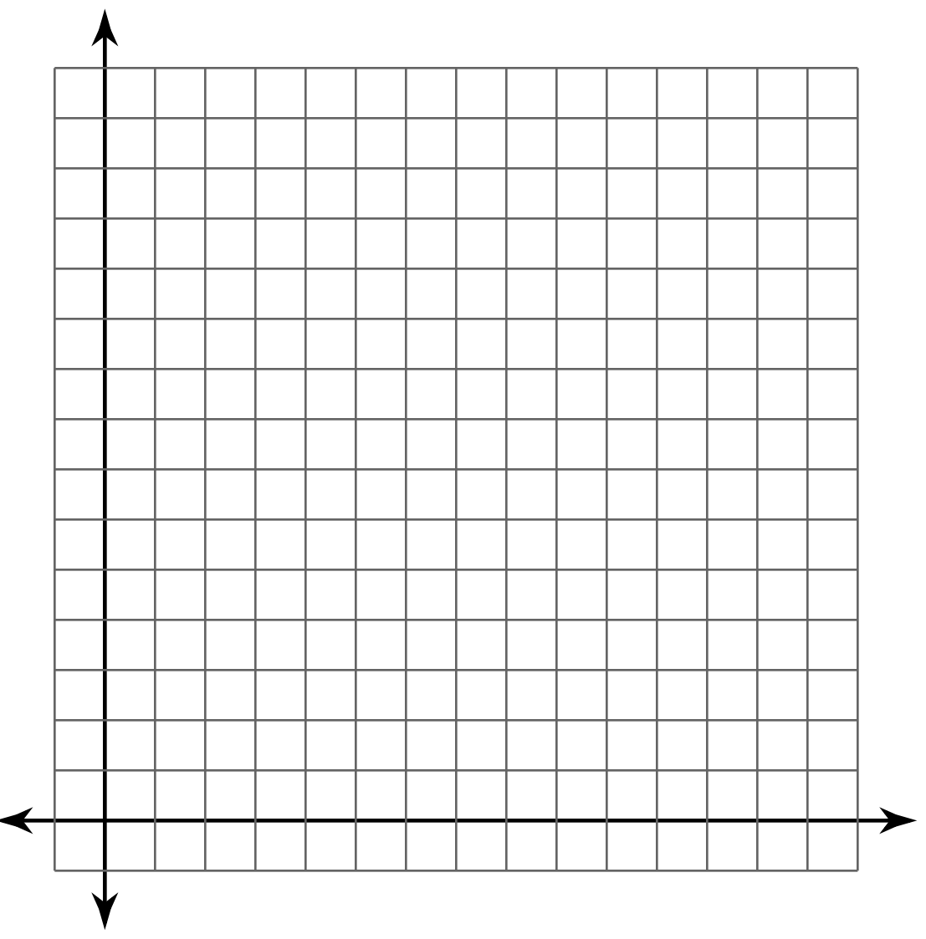

Equation
Write an equation showing how many pounds of recyclable materials have been collected.

Exploring Linear Relationships: 2
Read the scenario, then answer the following questions. Use the space provided to show your work. You will later use your answers to create a poster.

Story
The Green Teens Club at Riverside Middle School is organizing a recycling drive. They had 15 pounds of recyclable materials before the event began. Each day, they collect 5 more pounds.

Table
Create a table showing how many total pounds of recyclable materials have been collected, starting with day 0 and continuing through day 10.
day | 0 | 1 | 2 | 3 | 4 | 5 | 6 | 7 | 8 | 9 | 10
pounds

Graph
Create a graph showing how many total pounds of recyclable materials have been collected, starting with day 0 and continuing through day 10. Think about which is the dependent and independent variable. Use this information to label your graph.

Equation
Write an equation showing how many pounds of recyclable materials have been collected.

Exploring Linear Relationships: 3
Read the scenario, then answer the following questions. Use the space provided to show your work. You will later use your answers to create a poster.

Story
The Green Teens Club at Riverside Middle School is organizing a recycling drive. They had 20 pounds of recyclable materials before the event began. Each day, they collect 4 more pounds.

Table
Create a table showing how many total pounds of recyclable materials have been collected, starting with day 0 and continuing through day 10.
day | 0 | 1 | 2 | 3 | 4 | 5 | 6 | 7 | 8 | 9 | 10
pounds

Graph
Create a graph showing how many total pounds of recyclable materials have been collected, starting with day 0 and continuing through day 10. Think about which is the dependent and independent variable. Use this information to label your graph.

Equation
Write an equation showing how many pounds of recyclable materials have been collected.

Exploring Linear Relationships: 4
Read the scenario, then answer the following questions. Use the space provided to show your work. You will later use your answers to create a poster.

Story
The Green Teens Club at Riverside Middle School is organizing a recycling drive. They had 16 pounds of recyclable materials before the event began. Each day, they collect 4 more pounds.

Table
Create a table showing how many total pounds of recyclable materials have been collected, starting with day 0 and continuing through day 10.
day | 0 | 1 | 2 | 3 | 4 | 5 | 6 | 7 | 8 | 9 | 10
pounds

Graph
Create a graph showing how many total pounds of recyclable materials have been collected, starting with day 0 and continuing through day 10. Think about which is the dependent and independent variable. Use this information to label your graph.

Equation
Write an equation showing how many pounds of recyclable materials have been collected.

Exploring Linear Relationships: 5
Read the scenario, then answer the following questions. Use the space provided to show your work. You will later use your answers to create a poster.

Story
The Green Teens Club at Riverside Middle School is organizing a recycling drive. They had 25 pounds of recyclable materials before the event began. Each day, they collect 5 more pounds.

Table
Create a table showing how many total pounds of recyclable materials have been collected, starting with day 0 and continuing through day 10.
day | 0 | 1 | 2 | 3 | 4 | 5 | 6 | 7 | 8 | 9 | 10
pounds

Graph
Create a graph showing how many total pounds of recyclable materials have been collected, starting with day 0 and continuing through day 10. Think about which is the dependent and independent variable. Use this information to label your graph.

Equation
Write an equation showing how many pounds of recyclable materials have been collected.

Exploring Linear Relationships: 6
Read the scenario, then answer the following questions. Use the space provided to show your work. You will later use your answers to create a poster.

Story
The Green Teens Club at Riverside Middle School is organizing a recycling drive. They had 30 pounds of recyclable materials before the event began. Each day, they collect 6 more pounds.

Table
Create a table showing how many total pounds of recyclable materials have been collected, starting with day 0 and continuing through day 10.
day | 0 | 1 | 2 | 3 | 4 | 5 | 6 | 7 | 8 | 9 | 10
pounds

Graph
Create a graph showing how many total pounds of recyclable materials have been collected, starting with day 0 and continuing through day 10. Think about which is the dependent and independent variable. Use this information to label your graph.

Equation
Write an equation showing how many pounds of recyclable materials have been collected.

Exploring Linear Relationships: 7
Read the scenario, then answer the following questions. Use the space provided to show your work. You will later use your answers to create a poster.

Story
The Green Teens Club at Riverside Middle School is organizing a recycling drive. They had 10 pounds of recyclable materials before the event began. Each day, they collect 2 more pounds.

Table
Create a table showing how many total pounds of recyclable materials have been collected, starting with day 0 and continuing through day 10.
day | 0 | 1 | 2 | 3 | 4 | 5 | 6 | 7 | 8 | 9 | 10
pounds

Graph
Create a graph showing how many total pounds of recyclable materials have been collected, starting with day 0 and continuing through day 10. Think about which is the dependent and independent variable. Use this information to label your graph.

Equation
Write an equation showing how many pounds of recyclable materials have been collected.

Exploring Linear Relationships: 8
Read the scenario, then answer the following questions. Use the space provided to show your work. You will later use your answers to create a poster.

Story
The Green Teens Club at Riverside Middle School is organizing a recycling drive. They had 18 pounds of recyclable materials before the event began. Each day, they collect 6 more pounds.

Table
Create a table showing how many total pounds of recyclable materials have been collected, starting with day 0 and continuing through day 10.
day | 0 | 1 | 2 | 3 | 4 | 5 | 6 | 7 | 8 | 9 | 10
pounds

Graph
Create a graph showing how many total pounds of recyclable materials have been collected, starting with day 0 and continuing through day 10. Think about which is the dependent and independent variable. Use this information to label your graph.

Equation
Write an equation showing how many pounds of recyclable materials have been collected.

Exploring Linear Relationships: 9
Read the scenario, then answer the following questions. Use the space provided to show your work. You will later use your answers to create a poster.

Story
The Green Teens Club at Riverside Middle School is organizing a recycling drive. They had 18 pounds of recyclable materials before the event began. Each day, they collect 3 more pounds.

Table
Create a table showing how many total pounds of recyclable materials have been collected, starting with day 0 and continuing through day 10.
day | 0 | 1 | 2 | 3 | 4 | 5 | 6 | 7 | 8 | 9 | 10
pounds

Graph
Create a graph showing how many total pounds of recyclable materials have been collected, starting with day 0 and continuing through day 10. Think about which is the dependent and independent variable. Use this information to label your graph.

Equation
Write an equation showing how many pounds of recyclable materials have been collected.

Exploring Linear Relationships: 10
Read the scenario, then answer the following questions. Use the space provided to show your work. You will later use your answers to create a poster.

Story
The Green Teens Club at Riverside Middle School is organizing a recycling drive. They had 21 pounds of recyclable materials before the event began. Each day, they collect 3 more pounds.

Table
Create a table showing how many total pounds of recyclable materials have been collected, starting with day 0 and continuing through day 10.
day | 0 | 1 | 2 | 3 | 4 | 5 | 6 | 7 | 8 | 9 | 10
pounds

Graph
Create a graph showing how many total pounds of recyclable materials have been collected, starting with day 0 and continuing through day 10. Think about which is the dependent and independent variable. Use this information to label your graph.

Equation
Write an equation showing how many pounds of recyclable materials have been collected.

