“The study of geography is about more than just memorizing places on a map. It's about understanding the complexity of our world, appreciating the diversity of cultures that exists across continents. And in the end, it's about using all that knowledge to help bridge divides and bring people together.”—Barack Obama

  - Barack Obama Quote. (n.d.). Retrieved from https://www.azquotes.com/quote/1399633

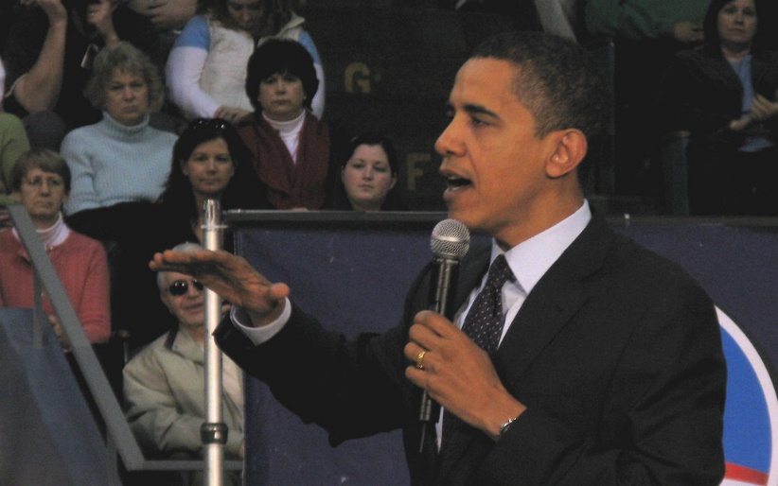

BARACK OBAMA
44TH PRESIDENT OF THE UNITED STATES

  - Tacroy47. (2008, March 23). Mad DJ. [Digital image]. Retrieved from https://www.flickr.com/photos/80685252@N00/2356330904
  - Photo Source: "Mad DJ" by tacroy47 is licensed under CC BY-NC-SA 2.0

“It is impossible to understand history, international politics, the world economy, religions, philosophy, or ‘patterns of culture’ without taking geography into account.”—Kenneth C. Davis
  - Kenneth C. Davis Quote. (n.d.). Retrieved from https://www.azquotes.com/quote/935368

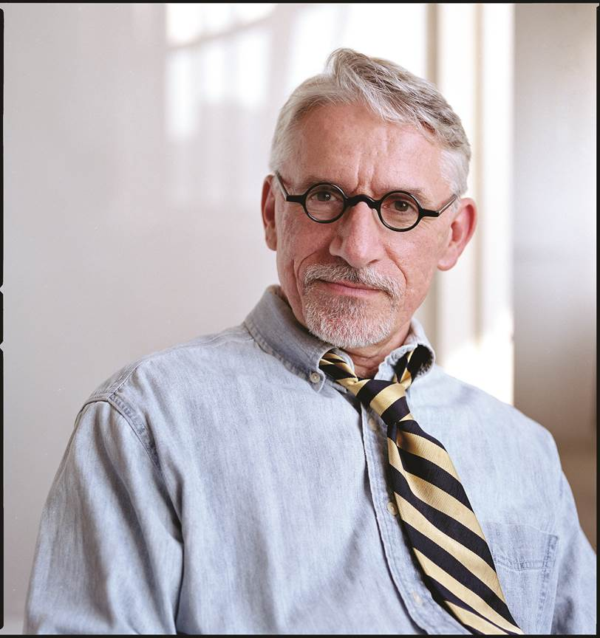

KENNETH C. DAVIS
AMERICAN HISTORIAN

  - Subin, N. (n.d.). [Digital image]. Retrieved from https://dontknowmuch.com/wp-content/uploads/2017/08/image.jpg
Copyright Nina Subin, reused by permission of dontknowmuch.com
“Without geography, you’re nowhere.”—Jimmy Buffet

  - Jimmy Buffett Quote. (n.d.). Retrieved from https://www.azquotes.com/quote/434168

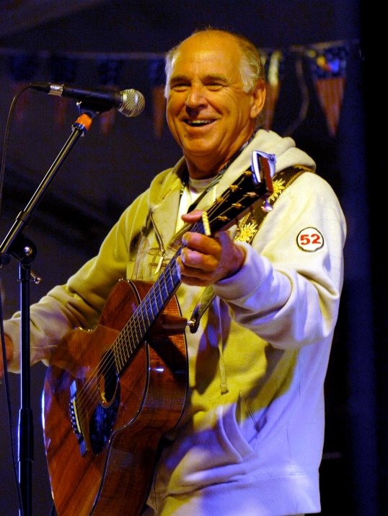

JIMMY BUFFET
AMERICAN SINGER/SONGWRITER

  - Pendergrass, M. (2008). Jimmy Buffett. [Digital image]. Retrieved from https://en.wikipedia.org/wiki/Jimmy_Buffett#/media/File:Jimmy_Buffett_1.jpg
“What makes a nation in the beginning is a good piece of geography.”—Robert Frost
  - Robert Frost Quote. (n.d.). Retrieved from https://www.azquotes.com/quote/1223829

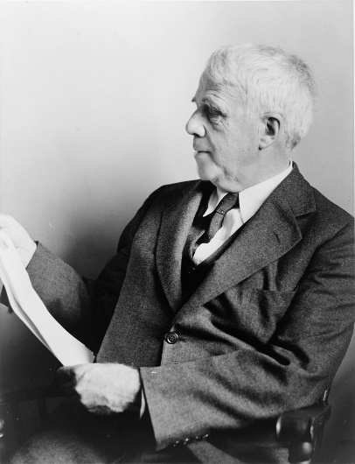

ROBERT FROST
AMERICAN WRITER

  - Palumbo, F. (1940). Robert Frost. [Digital image]. Retrieved from https://en.wikipedia.org/wiki/Robert_Frost#/media/File:Robert_Frost_NYWTS.jpg

“We should know more about basic geography than we know about the personal lives of actors.”—Author Unknown

  - We should know more about basic geography than we know about the personal lives of actors. (n.d.). Retrieved from http://emilysquotes.com/we-should-know-more-about-basic-geography-than-we-know-about-the-personal-lives-of-actors/

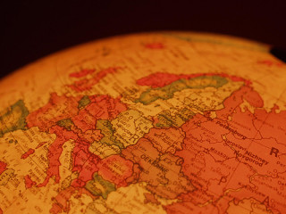

AUTHOR UNKNOWN

  - Globalicious. (2008, September 05). OpenDemocracy. [Digital image]. Retrieved from https://www.flickr.com/photos/14071207@N00/2831189640
  - Photo source: "Globalicious" by openDemocracy is licensed under CC BY-SA 2.0
“Culture makes people understand each other better. And if they understand each other better in their soul, it is easier to overcome the economic and political barriers. But first they have to understand that their neighbor is, in the end, just like them, with the same problems, the same questions.”—Paulo Coelho

  - Paulo Coelho Quotes. (n.d.). Retrieved from https://www.brainyquote.com/quotes/paulo_coelho_620592?src=t_culture
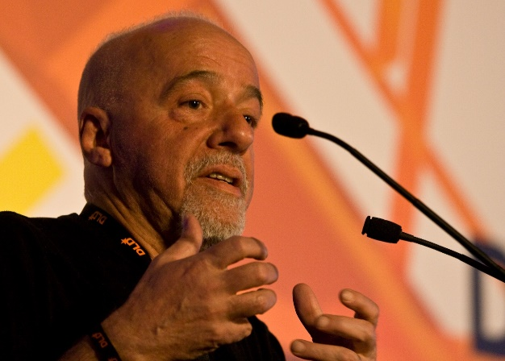

PAULO COELHO
BRAZILIAN SONGWRITER/NOVELIST

  - File:Paulo Coelho nrkbeta.jpg. [Digital image]. (n.d.). Retrieved from https://commons.wikimedia.org/w/index.php?curid=5967299
  - Photo source: “Paulo Coelho” by nrkbeta is licensed under CC BY-SA 2.0

“Sooner or later, we will have to recognise that the Earth has rights, too, to live without pollution. What mankind must know is that human beings cannot live without Mother Earth, but the planet can live without humans”—Evo Morales
  - Evo Morales Quotes. (n.d.). Retrieved from https://www.brainyquote.com/quotes/evo_morales_482008?src=t_environmental

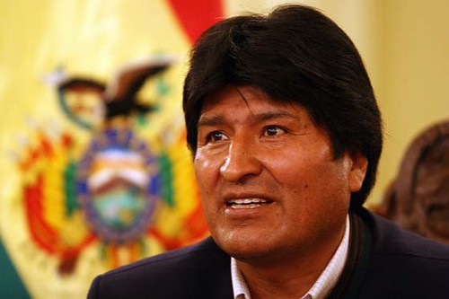

EVO MORALES
PRESIDENT OF BOLIVIA

  - Alcubilla, J. P. Evo-morales. [Digital image]. (2010, April 22). Retrieved from https://www.flickr.com/photos/46205613@N04/4543782586
  - Photo Source: "evo-morales" by Erprofe is licensed under CC BY-NC 2.0

“Saving our planet, lifting people out of poverty, advancing economic growth...these are one and the same fight. We must connect the dots between climate change, water scarcity, energy shortages, global health, food security and women's empowerment. Solutions to one problem must be solutions for all.”—Ban Ki-moon
  - Ban Ki-moon Quotes. (n.d.). Retrieved from https://www.brainyquote.com/quotes/ban_kimoon_643813?src=t_environmenal

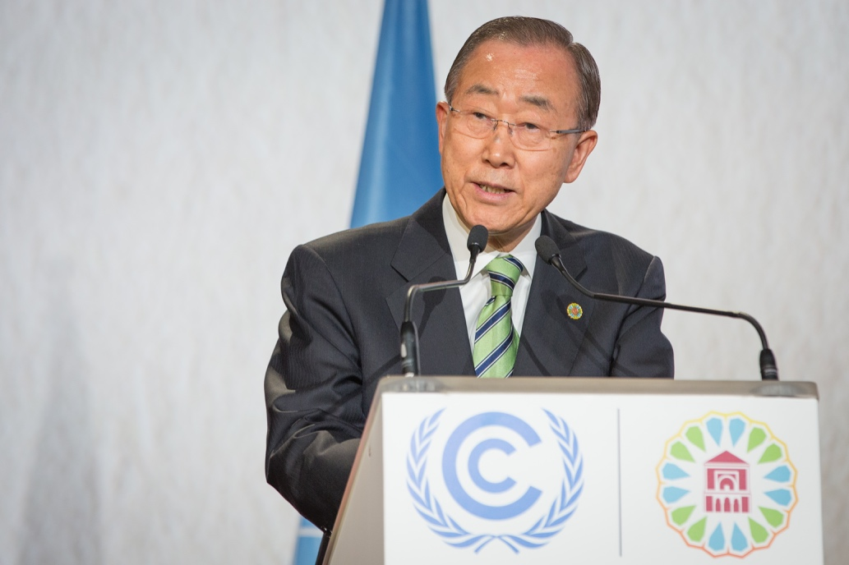

BAN KI-MOON
UNITED NATIONS SECRETARY GENERAL
2007-2016

  - File: Ban Ki-moon at COP22.jpg. [Digital image]. (n.d.). Retrieved from https://commons.wikimedia.org/wiki/File:Ban_Ki-moon_at_COP22.jpg
  - Photo Source: "Ban Ki-moon at COP22" by Unclimatechange is licensed under CC BY-NC 2.0

