Double Bubble Map—Death Penalty versus Life in Prison
Complete the Double Bubble Map below to compare and contrast thoughts and ideas on the death penalty and life in prison.

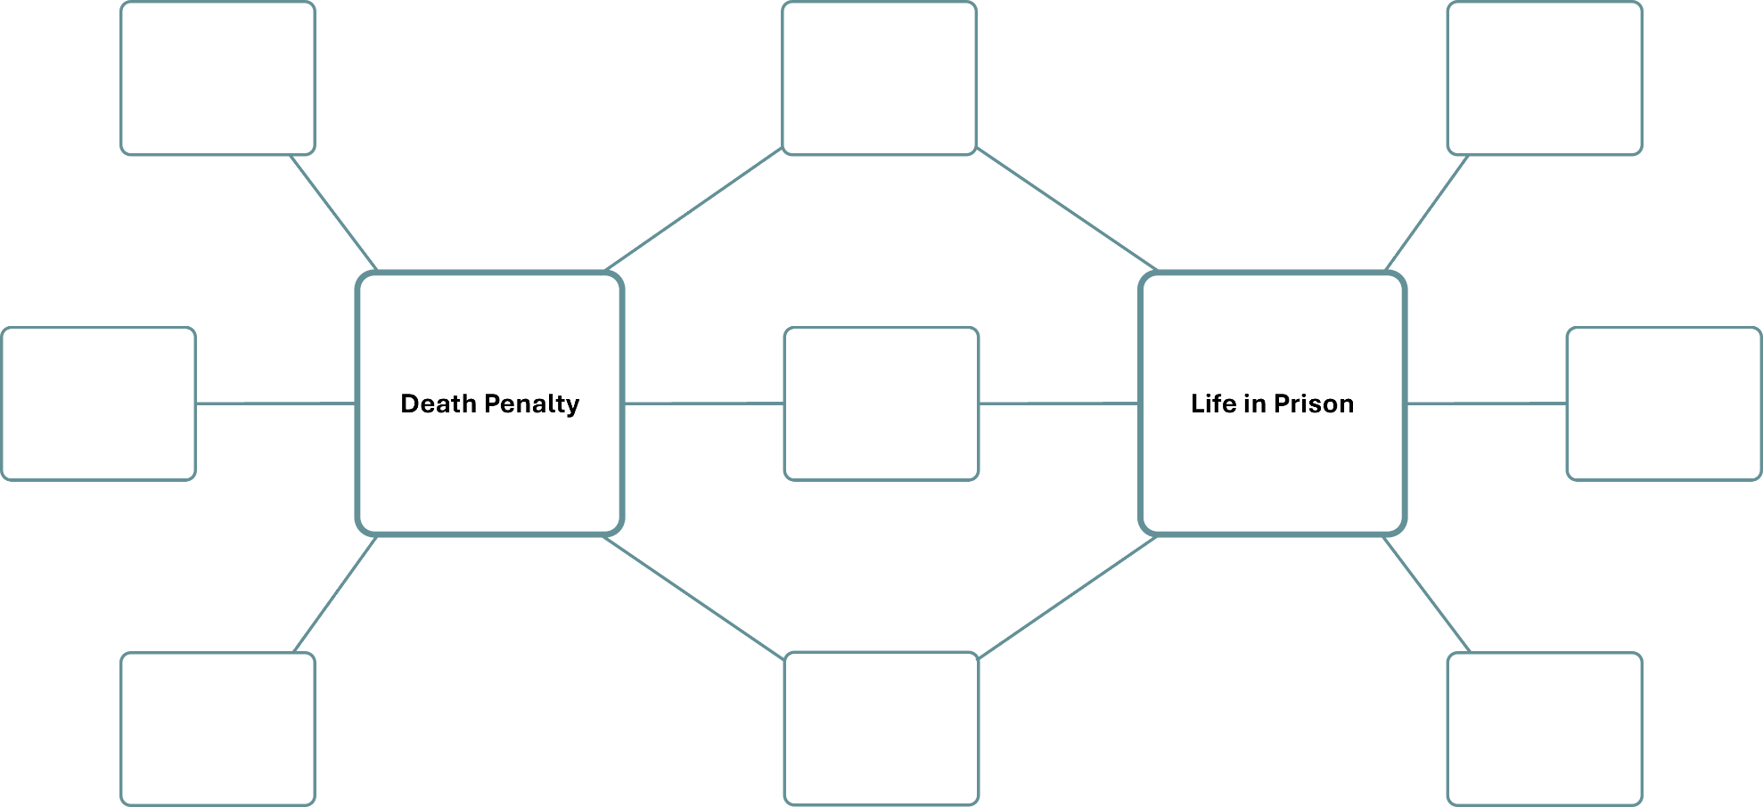

Double Bubble Map—Material Wealth versus Freedom
Complete the Double Bubble Map below to compare and contrast thoughts and ideas about material wealth and freedom.

