PRIMARY SOURCE DOCUMENT
“Bloody Massacre Perpetrated in Kings Street in Boston” by Paul Revere (March 1770)

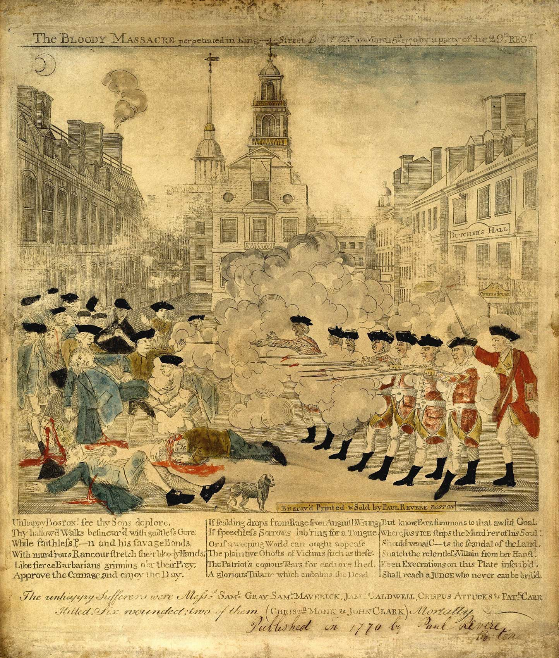
“Bloody Massacre Perpetrated in Kings Street in Boston” by Paul Revere (March 1770)
Public Domain image retrieved from http://www.paul-revere-heritage.com/boston-massacre-engraving.html

