GRABADO DE LA MASACRE DE BOSTON

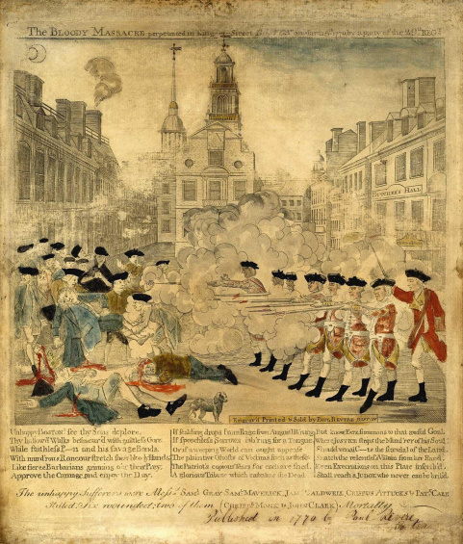
Documento de fuente primaria
La sangrienta masacre perpetrada en King Street, Boston por Paul Revere, marzo de 1770

Revere, P. (1770). Bloody massacre perpetrated in Kings Street in Boston [Grabado]. Paul Revere Heritage Project. http://www.paul-revere-heritage.com/boston-massacre-engraving.html

